Title:Operational Safety Tactics

Recommended Time: 2 hours *(not including possible scenario-based training exercise)*

Primary Audience: Patrol Officers

Module Goal: Through classroom instruction, discussion, exercises, and a video case study, the student will learn additional skills to safely and effectively respond to and resolve critical incidents involving subjects not armed with a firearm. Using the Critical Decision-Making Model, students will explore pre-response, response, and post-response considerations, and focus on both their individual actions and teamwork. *(Note: agencies may also choose to run a scenario-based training exercise at the end of this module or as part of Module 6, Integration and Practice.)*

Required Materials: Digital presentation (Power Point); lesson plan; easel pad and markers (For scenario-based training, safety equipment/weapons and role player)

Learning Objectives: At the completion of this course, students will be able to:

* + Demonstrate critical pre-response and response requirements for critical incidents.
  + Explain use of the Critical Decision-Making Model (CDM) in responding to and managing a critical incident.
  + Demonstrate and explain key tactical expectations and roles when responding to a critical incident as a team.
  + Explain concepts such as “tactical pause,” “distance + cover = time,” and “tactical repositioning.”
  + Participate in an effective after-action review of a critical incident.
  + Use the CDM to explain key post-response expectations following a critical incident.

|  |  |  |
| --- | --- | --- |
| Recommended Time Allocation | | |
|  | Unit | Recommended Time  (minutes) |
| 1 | Learning Activity–1 (Assessment) | 20 |
| 2 | Pre-Response Considerations | 15 |
| 3 | Effective Response Tactics | 30 |
| 4 | Learning Activity–2 (Video Case Study) | 30 |
| 5 | Post-Response Considerations | 15 |
| 6 | Learning Activity–3 (Scenario) *– Optional\** |  |
| 7 | Recap and Discussion | 10 |
| Total | | 120 |

*\* These estimates do not include the time needed to conduct a scenario-based training exercise. Agencies that choose to run a scenario at the end of this module (as opposed to running all of their scenarios in Module 6) will need to budget in additional time here.*

Table of Contents

1. Learning Activity–1 (Assessment) 4
2. Pre-Response Considerations 5
3. Effective Response Tactics 9
4. Learning Activity–2 (Video Case Study)13
5. Post-Response Considerations 16
6. Learning Activity–3 (Scenario #2) – *Optional* 19
7. Recap and Discussion 19

# Overview: Responding to and successfully resolving critical incidents require not only strong crisis recognition/response and communications skills, but also sound tactics and teamwork. All three must work in unison. Good crisis intervention and communications skills coupled with flawed tactics, or sound tactics paired with poor crisis intervention/ communications, are unlikely to produce the desired result of a safe resolution through voluntary compliance.

# Particularly in situations involving persons in crisis, tactics must support, complement, and enable the crisis intervention and communications approaches to take hold and succeed. It is also critical that officers work as a team in these situations. Team members must be willing to take on specific roles and ensure they are supporting (and not interfering with) the roles of other team members.

Because every incident is different, teaching specific tactics for situations that are so unique and context-dependent is impossible. There is no detailed, one-size-fits-all approach. This module focuses on a number of *sound tactical considerations that can be applied to most incidents that do not involve an immediate firearm threat.* While the nature of the threat may require immediate action in some circumstances, defusing the situation and gaining voluntary compliance should be the goals in all other situations.

Instructor Notes

SLIDE #1

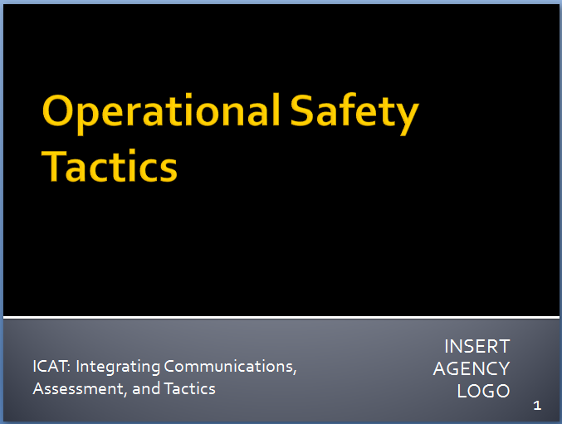

SLIDE #2

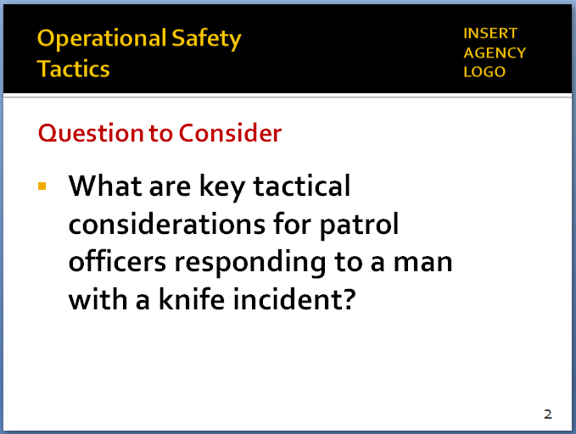

# Learning Activity – 1 (Assessment)

Activity:Assessment Group Project

Activity Time: 30 minutes

Activity Learning Objective: An assessment exercise that serves as an introduction to the Operational Safety Tactics module

Required Equipment: Easel pads, markers

Facilitator Instruction: Break the class into small groups. Provide each group with markers and easel pads. Each group will have 10 minutes to brainstorm and chart some of the key tactical considerations and teamwork approaches of patrol officers responding to a critical incident that involves a man with a knife. What are the key things you want to know heading to the scene and the steps you plan to take once you arrive? *(You can use the St. Louis video from Module #1 as an example.)* Each group will delegate a spokesperson who will present the findings to the class.

1. Pre-Response Considerations

Instructor Notes

SLIDE #3

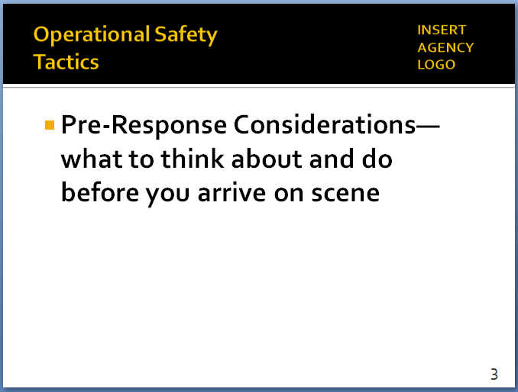

SLIDE #4

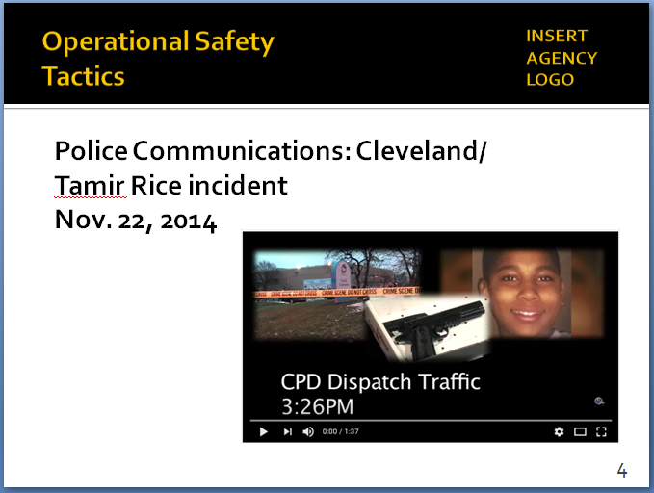

[*https://www.youtube.com/watch?v=epfXeDxftQA*](https://www.youtube.com/watch?v=epfXeDxftQA) *and* [*https://www.youtube.com/watch?v=kqBqg43WN34*](https://www.youtube.com/watch?v=kqBqg43WN34)

SLIDE #5

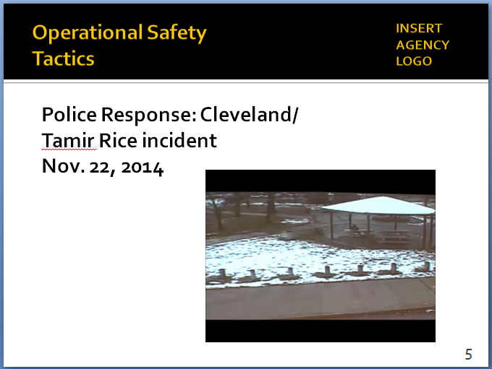

[*https://www.youtube.com/watch?v=q-0PboFDvb8*](https://www.youtube.com/watch?v=q-0PboFDvb8)

Information is the life’s blood of any tactical response. As detailed in Step 1 of the Critical Decision-Making Model (see Module 2), it is essential that responding officers collect as much information as possible (from Dispatch and others) while en route to a critical incident. It’s also important for responding officers and supervisors to share information among themselves, establish a team mindset, and develop a game plan ahead of time, whenever possible. Of course, circumstances will always dictate tactics, and officers must be prepared to act immediately if needed. But if they have the chance to “slow the situation down,” officers should use that time to their tactical advantage.

# *Note*

# *This primary purpose of the following two videos is to illustrate how the information collected and transmitted during the pre-response phase—before officers arrive on scene—can impact how officers respond.*

# *Remind students that these videos are not meant to judge or second-guess the officers’ actions or render a grade. Rather the videos illustrate the real-world challenges that officers face. The videos are intended to generate discussion on how these challenges can be handled as safely and effectively as possible.*

# *There will be tactical elements in both videos that students will likely have issues with. Allow students to air their concerns, but try to keep the discussion focused on how information affects the initial response.*

# 

* 1. Following are video clips of two incidents that illustrate the importance of information collection during the pre-response phase
     1. Play audio from Cleveland (Tamir Rice incident: 9-1-1 call and radio traffic to responding units – 11/22/14)
     2. Show video of responding officers
     3. Play audio from Parma (OH) incident (2 juveniles with possibly fake guns in the park): 9-1-1 call and radio traffic to responding units (2/21/16)
     4. Show video of responding officer
     5. Discuss the videos: *What happened differently? Why?*
        1. Information from Dispatch
     6. In Cleveland, dispatchers never relayed information that gun might be fake
     7. In Parma, information that gun might be fake was collected/relayed to responding officer
     8. Officers should treat all realistic looking weapons as if they were real
     9. But knowing that a weapon *may be* a replica is important information to have when approaching a scene
        1. Approach *(based in part on information officers had)*
     10. Cleveland: officers pulled right up on subject and engaged immediately
     11. Parma: created distance and cover, initiated communications – juveniles complied
         1. Speed
     12. Cleveland: rushed in
     13. Parma: slowed things down – created options
  2. First pre-response consideration: Collect information

Instructor Notes

SLIDE #6

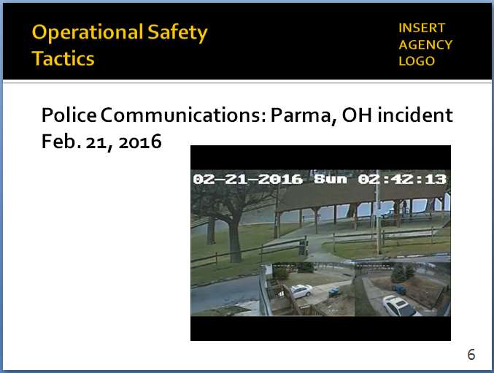

[*http://www.cleveland.com/parma/index.ssf/2016/02/listen_to_911_caller_describe.html*](http://www.cleveland.com/parma/index.ssf/2016/02/listen_to_911_caller_describe.html)

SLIDE #7

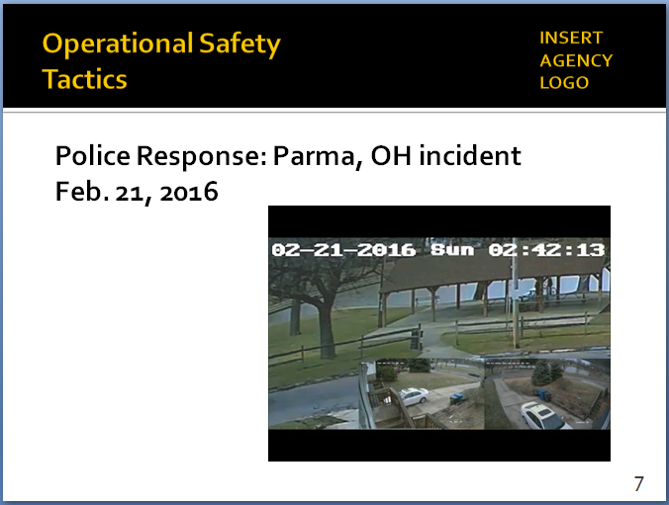

[*https://www.youtube.com/watch?v=Cz0fH_aLDaQ*](https://www.youtube.com/watch?v=Cz0fH_aLDaQ)

*For a side-by-side comparison of the two cases, see* [*http://www.cleveland.com/metro/index.ssf/2016/02/the_tamir_rice_effect_parma_po.html#0*](http://www.cleveland.com/metro/index.ssf/2016/02/the_tamir_rice_effect_parma_po.html#0)

*Prosecutor cited dispatch errors as a “significant” factor in Rice shooting:* [*http://www.cleveland.com/metro/index.ssf/2015/12/errors_by_police_radio_workers.html*](http://www.cleveland.com/metro/index.ssf/2015/12/errors_by_police_radio_workers.html)

SLIDE #8

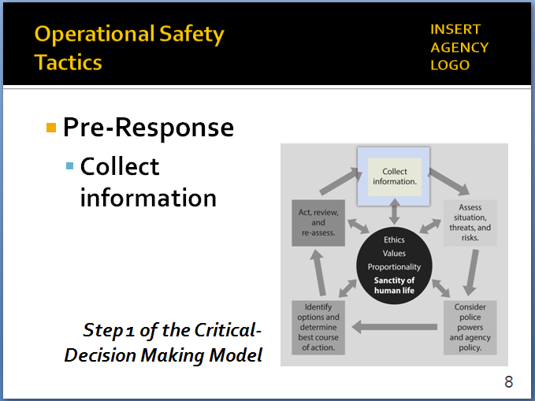

*“Tactical pause” is a concept developed by the Palm Beach County Sheriff’s Office; for more background, see* [*http://www.policeforum.org/assets/guidingprinciples1.pdf*](http://www.policeforum.org/assets/guidingprinciples1.pdf)*, p. 55.*

SLIDE #7

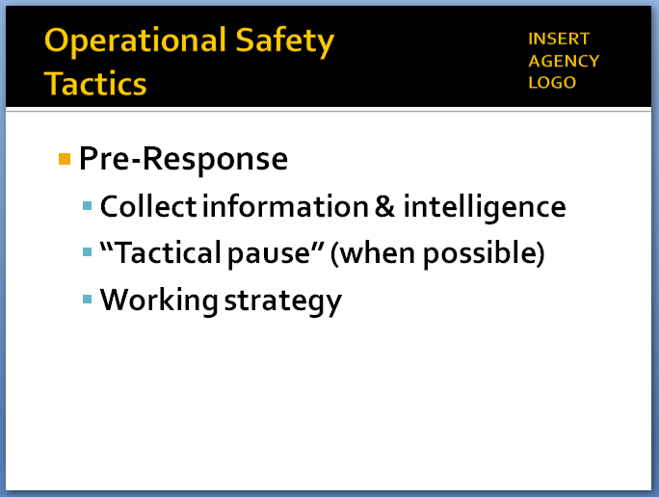

* + 1. Step 1 of the Critical Decision-Making Model
       1. Information from Dispatch
       2. From fellow officers/supervisors
       3. From your own training and experience
       4. Trying to separate facts from assumptions
    2. Begin to think through your response before entering the scene

Instructor Notes

SLIDE #9

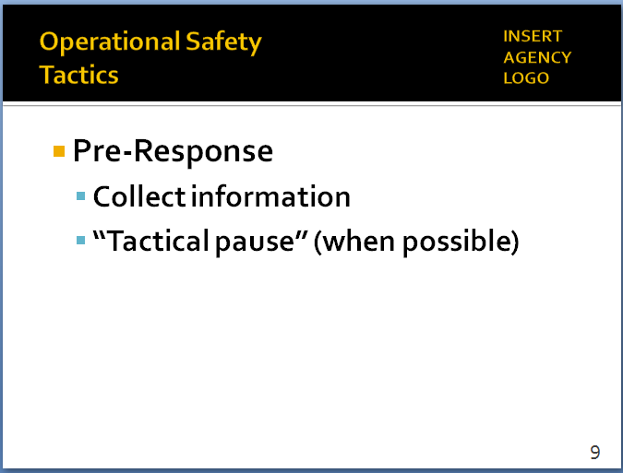

*“Tactical pause” is a concept developed by the Palm Beach County (FL) Sheriff’s Office. For more background, see* [*https://policeforum.org/assets/guidingprinciples1.pdf*](https://policeforum.org/assets/guidingprinciples1.pdf)*, p. 55.*

*For some agencies, this may require a shift in priorities – from an emphasis on response time to ensuring a more planned and coordinated approach (even if it takes a little longer).*

SLIDE #10

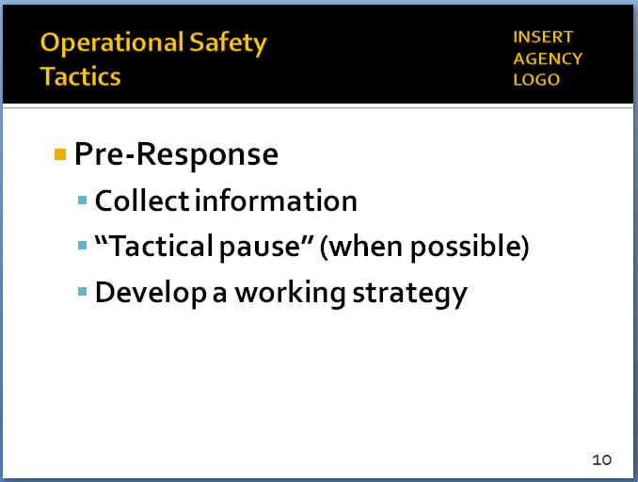

* + - 1. Reinforces readiness – guards against complacency (officer safety issue)
      2. Helps officers “transition in their mindset”
      3. Begins to place you in a winning situation

1. Ensure your equipment is ready–lethal and less-lethal
   1. Take a “tactical pause” (when possible)
      1. In general, time is on the side of first responders
         1. Some incidents will require immediate response
         2. Nothing prevents you from doing that
      2. When immediate response is not needed … “tactical pause” allows responding officers to huddle up (in person or over the radio), share information and begin developing a strategy (including team roles)
         1. If supervisor is available, even better
         2. Create the team mindset before you get on scene
         3. Begin to establish team roles – contact and cover, “eyes on,” etc.
2. Allows you to think more clearly and objectively
3. Approach the situation more methodically
   1. Begin developing a working strategy
      1. Step 2 in the CDM
      2. Playing out “what if?” scenarios
      3. Three possible outcomes on any encounter that you need to be prepared for:
         1. Fight
         2. Flight
         3. Voluntary compliance through communication – this should be your goal whenever possible
      4. Think about how to minimize risks, maximize safety
4. Prepare/manage yourself

Instructor Notes

SLIDE #11

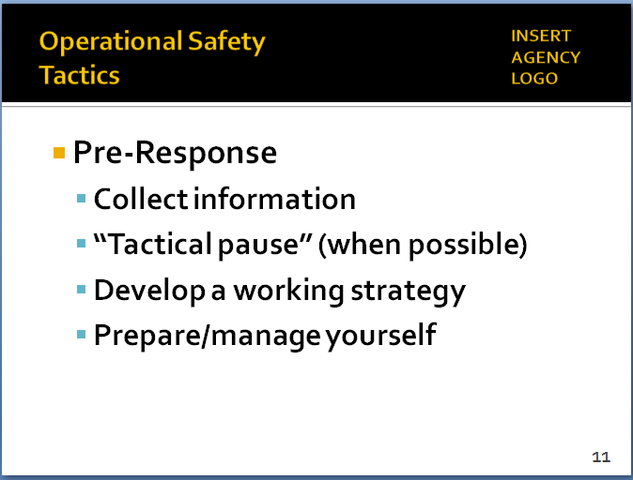

*See also, Module 3, p. 19 for additional information on this topic.*

*Some observable effects of fear-induced psychophysical arousal:*

* *Increased muscle tension, especially in neck and shoulders*
* *Increased breathing rate; shallower breaths*
* *Rapid eye movements; eyes are opened wide and have a flattened appearance – “tunnel vision”*
* *Auditory exclusion*
* *Perspiration; skin flushed, especially in the face*
* *Tremors (shaking); loss of fine-motor skills*
* *Rapid, pressured speech; yelling or frequently interrupting*
* *Teeth clenched, jaw set*
* *Dry mouth, repeatedly licking lips*
* *Amygdala Hijack (emotional redlining)*

*Some agencies use the Zen concept of* **Mushin** *(“mindless” or “mind like water”) in their training. For background, see*

[*http://www.mineralogicalrecord.com/wilson/pdfs/Concepts--Mushin%20and%20Zanshin.pdf*](http://www.mineralogicalrecord.com/wilson/pdfs/Concepts--Mushin%20and%20Zanshin.pdf) *or* [*https://aikidonosekai.wordpress.com/2014/03/23/aikido-mushin-no-mind/*](https://aikidonosekai.wordpress.com/2014/03/23/aikido-mushin-no-mind/)

*The New Orleans Police Department has a model peer intervention program called EPIC: Ethical Policing Is Courageous. Agencies may consider incorporating EPIC as an additional module in ICAT. For information, contact the New Orleans Police Department.*

* 1. Need to manage yourself before you can manage others
     1. By successfully controlling your own thoughts and behaviors, you can positively affect the outcome of many situations
     2. Understand that your emotions/reactions can cause some situations to escalate – check your ego
     3. Separate your reactions from those of others
     4. When you become angry or escalate unnecessarily, you lose credibility and control
     5. Maintaining control of yourself = maintaining control of the situation
  2. Understand how your body will react in a stressful situation (subject may be experiencing same reactions)
  3. Helps you prepare
  4. Helps you de-escalate
  5. Can help save your life and the lives of others

1. State of awareness
   1. A physical *and* mental process
   2. Combines tactical awareness (mechanical) + state of mind (mental)
   3. As your focus on the threat intensifies, your awareness tends to decline
   4. Mental conditioning to maintain awareness
2. Watch out for your partners too
   1. Be aware of their reactions to stressful situations
   2. Be prepared to intervene if necessary
3. Effective Response Tactics

Instructor Notes

SLIDE #12

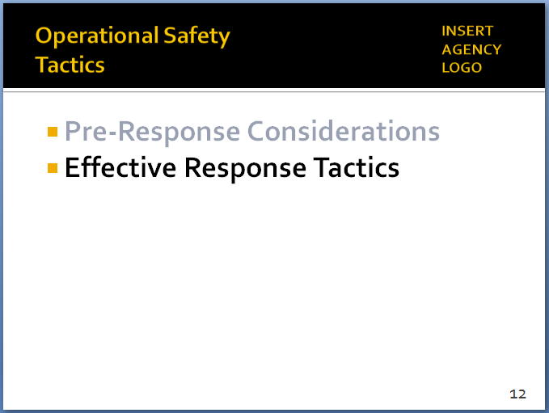

SLIDE #13

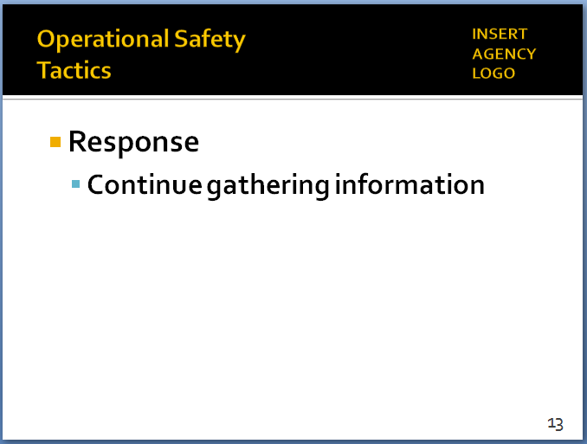

*Remember, active listening and open-ended questions.*

SLIDE #14

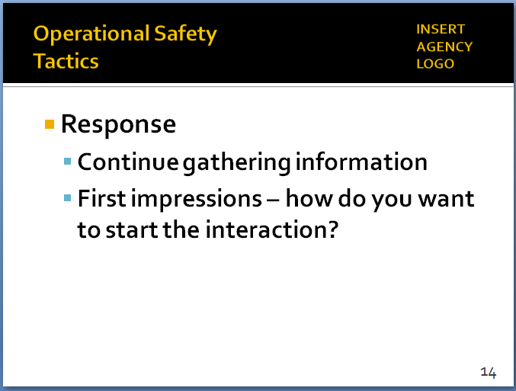

SLIDE #13

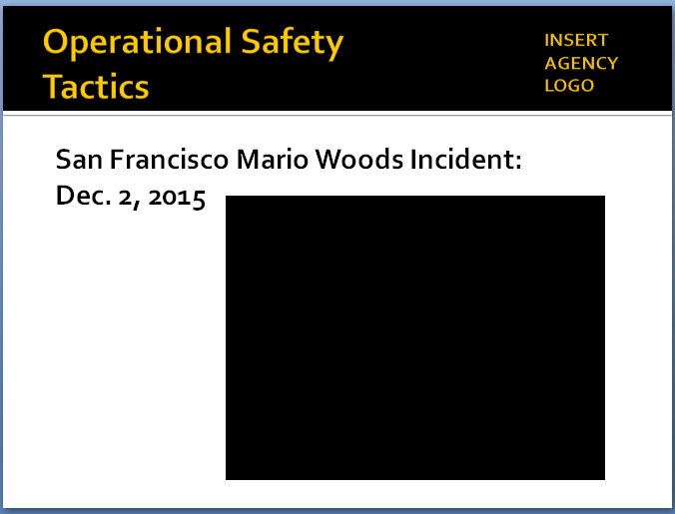

*Video at* [*https://www.youtube.com/watch?v=BolqWQ4iIY4*](https://www.youtube.com/watch?v=BolqWQ4iIY4)

Circumstances always dictate tactics. That’s why it’s important to take the time to accurately analyze and understand the circumstances you face. A person with a knife or blunt object attacking someone will trigger one set of tactics designed to quickly neutralize the threat. The same person with the same knife or blunt object pacing up and down and not actively threatening anyone presents a different set of circumstances, which will require a different response. Information gathering, teamwork and flexibility in considering different options are key to identifying and executing the most effective and safest tactical response.

* 1. Continue gathering information
     1. From …

1. Victims and witnesses
2. Your own observations
3. The subject (often the best source of information about what is going on)
   * 1. Information collection is an ongoing process that helps you refine your threat assessment
4. Analyze subject’s means, ability, opportunity, intent
5. When all four elements are present with an immediate danger and no escape = jeopardy.
6. Negating one or more those elements of the threat should be the goal
   1. First impressions
      1. How do you want to start the interaction?
      2. Circumstances and the nature of the threat will dictate your initial response
      3. If possible and appropriate, start “low”
         1. Easier to “move up” if necessary
         2. More difficult to de-escalate if you start “high”
   2. Respond as a team

Instructor Notes

SLIDE #15

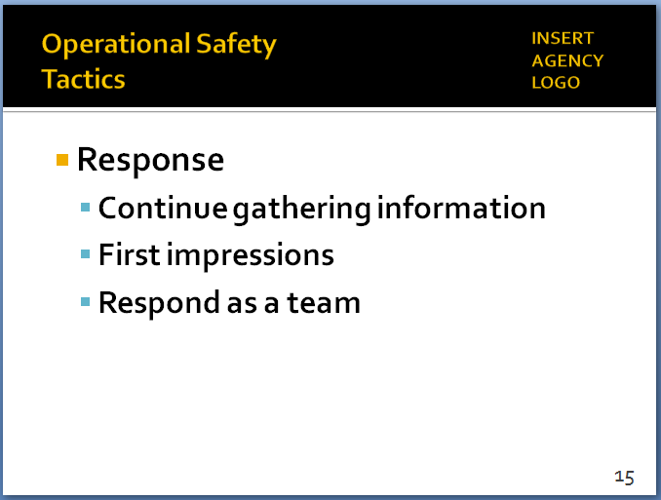

SLIDE #16

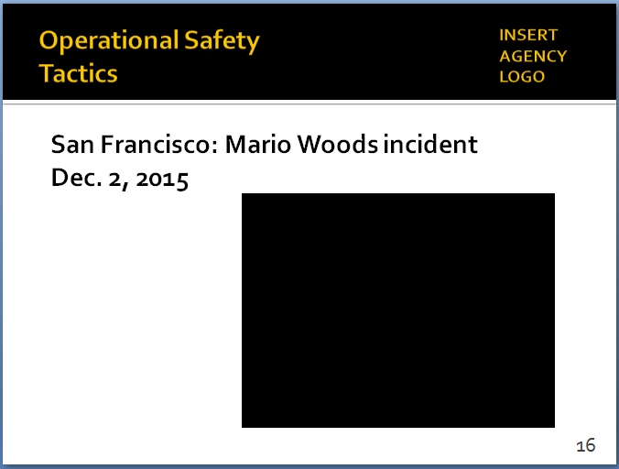

*Also available at* [*https://www.youtube.com/watch?v=v0ju6RQkNs8*](https://www.youtube.com/watch?v=v0ju6RQkNs8)

1. Everyone has a role – everyone plays that role
2. If only two officers
   1. Establish contact and cover roles
   2. Identify these roles ahead of time, when possible
   3. Stay in your lane
      1. One officer speaks
      2. Otherwise, confusing for the subject and the team
   4. Be flexible – situations are dynamic, so be prepared to switch roles
3. If additional officers, then additional roles:
   1. Less-lethal cover
   2. Inner/outer perimeter
   3. Scene management/containment
   4. Internal communications, coordination
   5. Scribe
4. If no supervisor, then senior officer needs to step up
5. San Francisco: Mario Woods incident
   1. Set up video
      1. December 2, 2015
      2. Mario Woods, age 26, suspected in stabbing earlier in the day
      3. Ignored commands to drop knife
      4. Shot several times with a bean bag shotgun (SFPD doesn’t authorize electronic control weapons) and OC spray
   2. Show video
   3. Discuss tactical issues

Instructor Notes

*Ask participates why do they believe every officer had their gun drawn and pointed at the suspect? Do these incidents demand better communication, establishment of roles, someone taking charge?*

*Some of the video was shot by middle school children riding a public bus.*

SLIDE #17

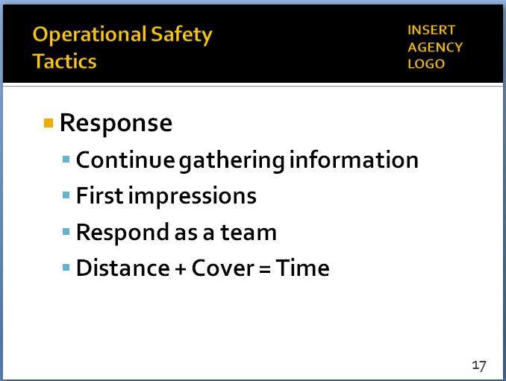

*Spend some time emphasizing the importance of D+C=T. Many of the most questionable shootings involve officers who closed the distance, didn’t use cover, and didn’t take advantage of time.*

*Concern of many patrol officers: we don’t have “all day.” Agencies need to adjust policies and priorities to give officers time to manage these situations and attain a safe and successful outcome. At a minimum, patrol officers should be encouraged to “buy” enough time to allow for other, specialized resources to arrive on scene.*

* + 1. Lack of supervision – who’s in charge?
    2. Lack of a game plan – instead, firing squad approach
    3. Threat assessment – what was he doing with the knife? Who was he threatening?
    4. Communications – who was the contact officer?
    5. Internal communications among officers
    6. Did “crowding” the subject cause him to start walking?
    7. Scene/crowd management
  1. Distance + Cover = Time
     1. Key benefits
        1. Officer safety – distance and cover offer you protection
        2. Create time to consider options
           1. In close quarters, you have very few options (Tamir Rice shooting in Cleveland)
           2. When pressed for time, you have fewer options
           3. But when you have distance, cover and time, you have more options available, plus more time to evaluate and execute them
     2. “Dynamic inactivity” – pushing the “pause” button
        1. When there is no reason to rush in and take action
        2. Use that time to communicate, strategize, get more resources
     3. How long will we let this situation go? As long as it takes barring an immediate threat that must be addressed
  2. Tactical positioning/repositioning

Instructor Notes

SLIDE #18

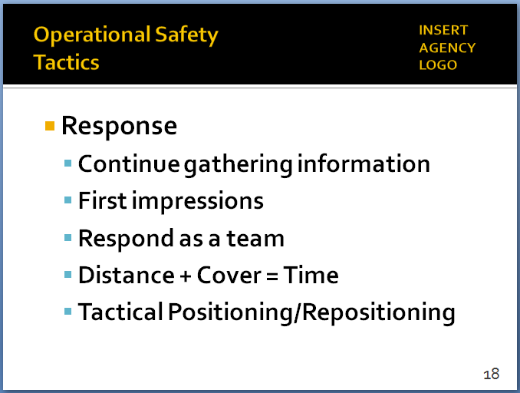

*Get on the balcony so you can observe the dance floor.*

*For edged weapon offenders, Police Scotland uses an approach called CUTT:*

* *Create distance*
* *Use cover*
* *Transmit information (to Dispatch)*
* *Tactically reposition as needed*

*You may get pushback from some students about “retreating.” Emphasize that we’re not talking about running away, but rather getting to a safer position with distance and cover. You’re still in charge – just from a safer position.*

* + 1. Individual officer
       1. Presence/stance/posture
       2. Don’t “draw a line in the sand” (unless public safety imperatives absolutely demand it)
       3. Maintaining a position of advantage (using distance and cover) – even if that means repositioning
       4. “Reaction gap” or “zone of safety”
          1. Not an arbitrary number (e.g., no “21-foot rule”) – will always depend on circumstances
          2. Regardless of the size of the “reaction gap,” maintaining it supports officer safety, gives you more options to resolve the situation

1. May need to increase the gap to provide more reaction time
2. Unnecessarily closing the gap can reduce your options, put you at risk
   * 1. “Ebb and flow” of the team
        1. As the situation evolves, the team may need to reposition as well (NYPD calls this the “Tactical Mambo”)
        2. Coordination, teamwork and discipline are critical
        3. Be careful about not back up into a corner – be tactically sound at all times
        4. Properly “containing” the scene will eliminate the risk of unassociated person(s) making a static scene “dynamic” due to intrusion
        5. Continue to communicate with the subject even as you reposition
   1. Put yourself in a winnable situation

Instructor Notes

SLIDE #19

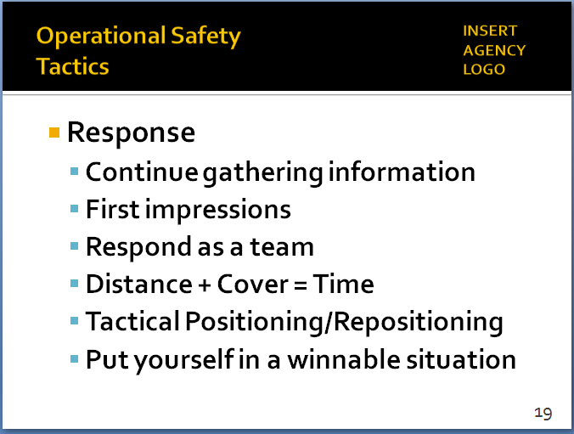

*The idea of “spinning” the Critical Decision-Making Model is important here. If the initial plan doesn’t work, then that information becomes part of your decision-making during the next spin of the model. See Module 2, p. 12, for more on “spinning the model.”*

* + 1. Isolate, contain, hold, assess
    2. Call out for additional resources
    3. Use tactical communications
    4. Identify options and develop a plan
    5. Intervene only if there is an immediate threat to life/safety
    6. Remember: you don’t have to succeed on first try – multiple opportunities for success
    7. Another way to look at this: don’t put yourself in an unwinnable situation through your actions (such as closing the distance or rushing the action if you don’t have to)

1. Learning Activity–2: Video Case Study   
   *Note*

# *This video case study is to illustrate how one agency used some of the principles covered in this Module to manage a dynamic encounter with a man with a knife. During this case study, try to keep the focus on the tactics of the individual officers and how they operated as a team. Include elements of the Critical Decision-Making Model, as appropriate.*

# *A few reminders:*

# *Set up the video ahead of time; provide background and context.*

# *Remind students that the video is not meant to be a “good” or “bad” video; the purpose is not to judge or second-guess the officer’s actions or render a grade. Rather the video illustrates the real-world challenges officers face. The purpose is to generate discussion on how these challenges can be handled as safely and effectively as possible. We are not suggesting this was the only possible course of action in this case.*

# *With this video in particular, students will likely have issues with specific tactics—especially concerns over the subject being able to enter a building or letting the situation go on too long. Be respectful of those concerns, but address them.*

# *The Instructor Notes includes a news story with officers explaining their actions. Use their words as much as possible to discuss the tactical decisions those officers made.*

* 1. Set up the video

Instructor Notes

SLIDE #20

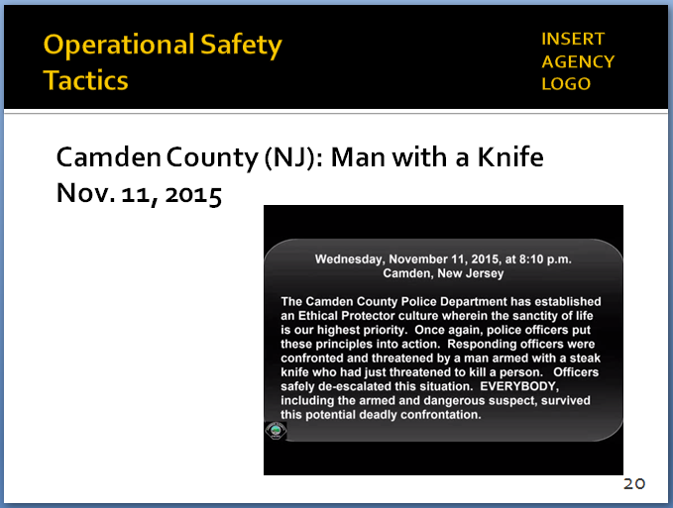

[*https://www.youtube.com/watch?v=MqH4E9UXX1o*](https://www.youtube.com/watch?v=MqH4E9UXX1o)

*This news report (audio file) includes comments from some of the responding officers:* [*http://www.newsworks.org/index.php/local/new-jersey/98779-acting-as-guardians-not-warriors-camden-police-defuse-potentially-deadly-encounter-*](http://www.newsworks.org/index.php/local/new-jersey/98779-acting-as-guardians-not-warriors-camden-police-defuse-potentially-deadly-encounter-)

*Steps 1 and 2 of the Critical Decision-Making Model*

*“When I got out of my patrol vehicle, he looked at me and I could see his face, his eyes were bugged out of his head, and I could see that he wasn’t mentally stable.” (Officer Chris Devlin)*

*– Example of good crisis recognition—officer used that information to help guide the response.*

*“One of my concerns, and I know some of the other officers, was, there’s people in these stores. If he turns and goes into these stores, with these people and the knife, then we have a hostage situation.” (Officer Chris Devlin)*

*Officers from multiple jurisdictions responded; some attempted to engage the suspect more forcefully. Camden County PD (lead agency) had to direct those officers to stand down, take a supporting role.*

*Beyond directing the subject to drop the knife, officers never really engaged in any type of alternative communications strategy. Not sure that would have worked with this subject, but they never tried.*

* + 1. Camden, NJ – sparsely populated downtown area
    2. Nov. 11, 2015 – 8:10 p.m.
    3. Report of a man with a knife who had been threatening people inside a fast-food restaurant
    4. Camden had recently adopted an initiative called Ethical Protector centering on the sanctity of life
  1. Start the video
     1. Stop at 1:00

1. What do we have so far?  
   *(Call about a man with a knife. Left restaurant and walking down the street. Mental illness perhaps?)*
2. What are the threats/risks?   
   *(Knife is visible. What’s he doing with the knife? Any aggressive movements? Not responding to verbal commands.)*
3. How did the officer start the encounter?  
   *(Strong verbal commands. But didn’t “draw a line in the sand.” Patience—didn’t force the issue.)*
   * 1. Restart – stop at 3:20
4. Has the threat/risk changed?  
   *(He’s now mobile—need to consider others in the area. But plenty of officers on scene.)*
5. Teamwork   
   *(Contact and cover? Lethal and less-lethal cover. Tactical repositioning. Securing the area ahead of the subject.)*
6. Distance and cover   
   *(Was it adequate, given the threat?)*
7. Communications  
   *(By contact officer? Officer-to-officer?)* 
   * 1. Restart – stop at 4:50

Instructor Notes

*In Police Scotland, officers are trained to distinguish between aggressive and defensive actions with a knife. In this case, the subject appears to be swinging the knife in a defensive manner that says “stay away from me.” U.S. police officers are not typically trained to make these distinctions. Probe how the class feels about this issue.*

*Camden County Police Chief Scott Thomson remarked that before adoption of the Ethical Protector model, officers likely would have shot the subject at some point. The shooting probably would have been justifiable, but would it have been the right thing to do?*

*Chief Thomson on the Ethical Protector mindset: “Our objective is just not to ensure that the officer goes home at the end of the shift, but that everybody goes home and is able to be returned to their loved one. Our officers know that they are not judge, jury or executioner. They are there to stabilize situations and to help people. We are guardians; we are not warriors.”*

*NOTE: You may consider playing this entire news report (6:07) on the Camden incident if it might aid the students’ understanding:*

[*http://www.newsworks.org/index.php/local/new-jersey/98779-acting-as-guardians-not-warriors-camden-police-defuse-potentially-deadly-encounter-*](http://www.newsworks.org/index.php/local/new-jersey/98779-acting-as-guardians-not-warriors-camden-police-defuse-potentially-deadly-encounter-)

1. Taser deployed, but ineffective – now what?  
   *(In many cases when the Taser doesn’t work, the tendency is to go right to lethal force. Would that have been appropriate here?)*
2. Has the threat/risk changed?   
   *(Is subject acting differently? Not really—maybe moving a little faster, but still not being overtly aggressive with the knife.)* 
   * 1. Restart – stop at 5:40
3. Subject turned corner, stumbled, dropped the knife and was tackled.
   * 1. Questions? Comments? Observations?
   1. Positive outcome (no one killed or hurt)—was it worth the time and effort?
   2. Anything you might have done differently? In terms of tactics? Or communications?
   3. Did they put themselves in a winnable position?
4. Post-Response Considerations

Instructor Notes

SLIDE #21

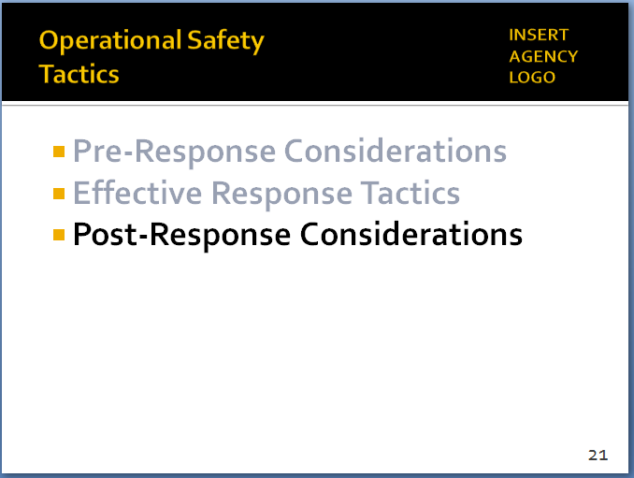

*Note: If your agency has its own AAR process, then it should be covered/emphasized here.*

SLIDE #22

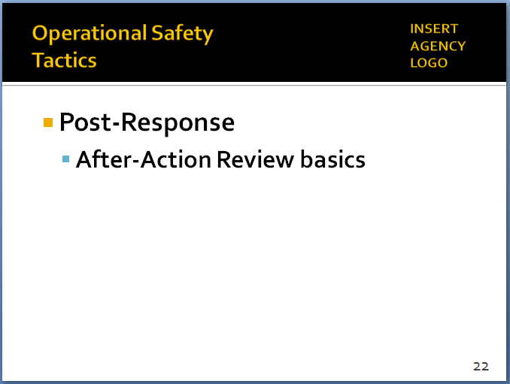

*One caveat from an officer wellness perspective: if the incident was highly traumatic or life-threatening, officers may not benefit from an immediate AAR. In these situations, officers will likely have gaps in memory right away, and they may not be able to be objective or emotionally capable of handling the process. Memories will generally consolidate and the officer will be better able to report on the details of the incident after a night of sleep.*

*Obviously, laws and agency policies governing when officers involved a critical incident provide statements must be respected.*

Critical incidents can involve a number of possible actions and outcomes: voluntary compliance, arrest, referral to mental health treatment, and/or use of some level of force. Accurately describing the incident in detail is crucial for the integrity of the investigation and for transparency with the public. It is important for everyone involved in a critical incident to be part of the After-Action Review (AAR) process. The debriefing should cover not only the actions taken but also the policies/procedures and decision-making behind those actions. By fully capturing both strengths and shortcomings, agencies can continuously improve the response to future incidents. The Critical Decision-Making Model provides a useful structure for the AAR process.

* 1. Basics of After-Action Reviews
     1. In general, AARs are conducted almost immediately after a critical incident (though minor incidents could reviewed the following day at roll call)
     2. AARs focus on incident objectives, policies/ procedures, actions taken, and decision-making
     3. AARs are used to identify strengths and weaknesses exhibited during the incident
     4. AARs are not “Monday morning quarterbacking”
        1. Instead, part of a continuous learning and improvement process
        2. No one, regardless of rank, position or strength of personality has all the answers
        3. AARs maximize the ideas and experiences of a wide range of people

1. Sole purpose of AARs is to improve future performance – they do not grade past “success” or “failure”
   1. Some AAR ground rules

Instructor Notes

SLIDE #23

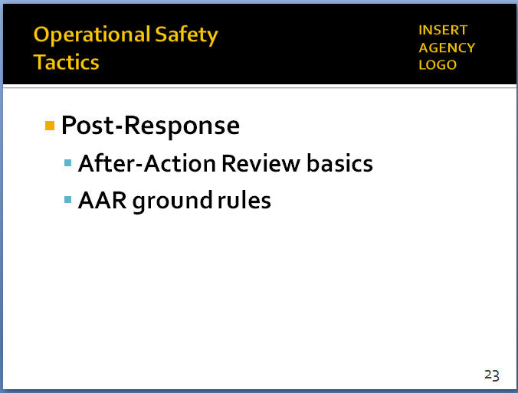

*Agencies should be flexible in how and when they conduct AARs, and the AARs should be proportional to the nature of the incident being reviewed. If the incident is relatively minor, the AAR could be conducted the next day during roll call. If the incident is more serious, the AAR should be conducted immediately afterwards, before the personnel involved leave the scene. Specialized units and patrol may have their own separate “hot washes” later on, but the full group should meet and conduct an AAR right away.*

SLIDE #24

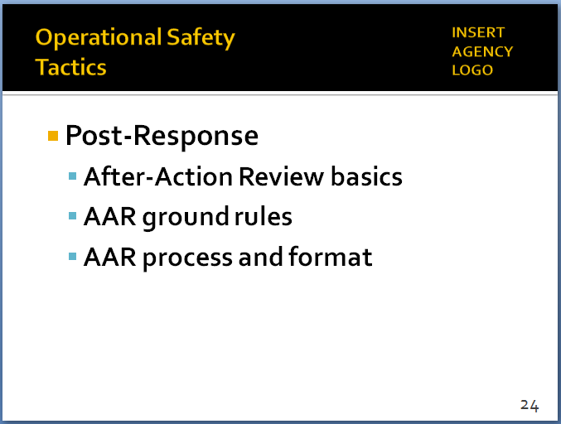

*Again, exposure to this information could be a “trauma trigger” for officers who were involved in a very traumatic incident. It may not necessarily be productive to force officers to listen/watch and relive the incident right away.*

* + 1. The process must be inclusive
       1. Anyone who has an insight, observation or question
       2. Any information that can identify and correct deficiencies and/or sustain strengths
    2. Facilitators are central to the process
       1. Ask open-ended questions to elicit information
       2. Still, the AAR belongs to the users, not the Facilitator
    3. Leave egos out of the AAR process
       1. No “thin skins”
       2. Participants must feel free to express honest opinions
       3. Articulated in a professional and respectful manner
    4. Professional disagreement during the AAR process is not only expected, but encouraged
  1. AAR process and format

1. Facilitator reviews incident objectives
2. Facilitator guides participants through chronological sequence of what occurred
   1. Establishes what information the participant had prior to beginning of the incident
   2. Establishes “ground truths” for what occurred (understanding that participants’ perceptions may be skewed by other inputs during the incident)
   3. If possible, participants should access video, CAD/radio files and other objective information
3. Using open-ended questions, Facilitator engages participants in a discovery learning process

Instructor Notes

*Another caveat: Officers involved in a traumatic/life-threatening situation should have mental health services available during the AAR, and hopefully a trusted peer support officer, police psychologist or other mental health professional to provide support if the AAR leads officers to struggle with their role in the incident.*

SLIDE #25

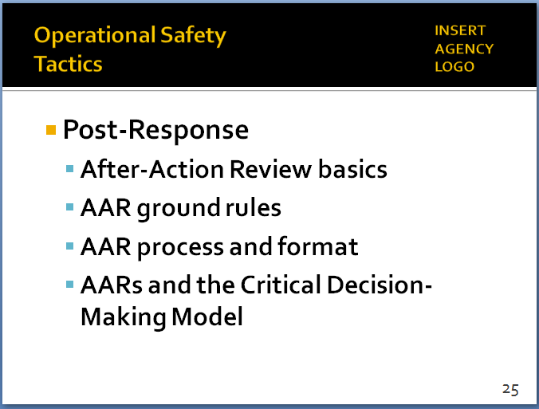

* 1. What actions were taken and why?
  2. What was done well?
  3. What could have been done better?

1. Summarize and next steps
   1. Major learning points
   2. Additional individual training (if any)
   3. Institutional retraining (if any)
   4. Possible policy changes
   5. AARs and the CDM
2. The Critical Decision-Making Model is a useful tool for examining the decision-making behind actions taken during critical incidents
   1. What information did the officers ask for and receive? Was information collection ongoing throughout the event? (Step 1)
   2. How did officers assess the situation, threats and risks? Did that assessment change as new information came in? (Step 2)
   3. Did the officers consider their police powers and agency policies? What adjustments, if any, did they make? (Step 3)
   4. How did the officers identify and narrow their options? Did they select the best course of action? (Step 4)
   5. After acting, did the officers review and re-assess? Did they “spin the model” if needed? (Step 5)
3. In the context of AARs, the CDM is an important documentation and learning tool – not a punitive or disciplinary system.
4. Learning Activity–3 (Scenario #2) *– Optional*

Instructor Notes

SLIDE #26

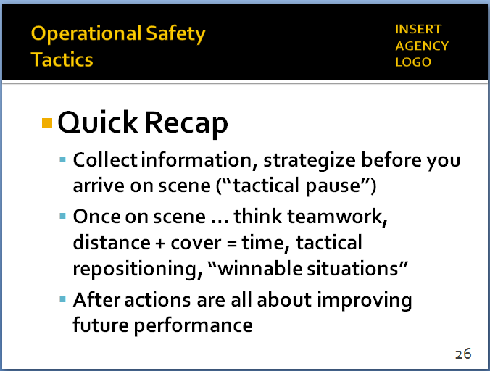

SLIDE #27

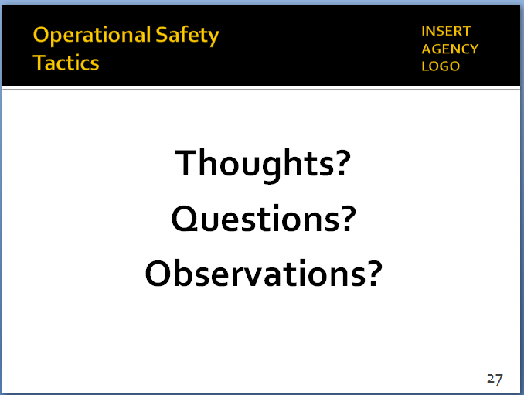

*You could go back to the information collected in Learning Activity–1 and ask the class if they have any different thoughts on what makes a good tactical response.*

# *If the timing and sequencing of your class allow, consider running Scenario #2 at this time. Detailed instructions are in Module 6, pp. 14-17. Otherwise, the scenario can be run later.*

Activity: **Tactical Response** Scenario-Based Exercise

Activity Time: 60-120 minutes (depending on the number of students)

Activity Learning Objective: Utilize and apply the tactical response skills covered in Module 5, plus the concepts and skills from earlier modules

# Recap and Discussion

* 1. Quick Recap
     1. Key pre-response considerations – before you arrive…
  2. Collect information – know what you’re getting into
  3. “Tactical pause” – use time to strategize
  4. Prepare/manage yourself – and your partners
     1. Once on scene …
        1. Consider first impressions – start low if possible
        2. Work as a team – have a role, play that role
        3. Distance + cover = time – time = options
        4. Tactical repositioning – creating a reaction gap
        5. Put yourself in a winnable situation
     2. After action reports are about improving future performance, not judging past actions
  5. Any final lessons learned? (can record on easel pad)

1. Ask each student to identify one new thing learned
2. Or, one skill set he or she plans to focus on in the future
   1. Review any specific agency policy considerations not previously discussed (as appropriate)
   2. Distribute class evaluations of the module (if appropriate)