Title: Tactical Communications
Recommended Time: 2 hours (not including possible scenario-based training exercise)
Primary Audience: Patrol Officers
Module Goal: Through classroom instruction, discussion, exercises, and a video case study, the student will learn basic principles and concepts of crisis response using tactical communications, and developing the necessary skills to safely and effectively communicate during many critical incidents. The student will learn key active listening and verbal and non-verbal skills that are especially valuable for defusing tense situations and gaining voluntary compliance from subjects. (Note: agencies may also choose to run a scenario-based training exercise at the end of this module or as part of Module 6, Integration and Practice.)
Required Materials: Digital presentation (Power Point and video); lesson plan; easel pad and markers (For scenario-based training, safety equipment/weapons and role player)
Learning Objectives: At the completion of this course, students will be able to:
  - Use a range of communications skills to their tactical advantage.
  - Explain the concepts and importance of active listening and demonstrate the use of key active listening skills.
  - Explain how non-verbal communications affect interactions with others and demonstrate the use of key non-verbal communications skills.
  - Demonstrate key verbal communications skills that are critical to defusing tense situations and gaining voluntary compliance.
  - Develop and use a variety of alternatives to shouting “drop the knife” if that command does not generate compliance after repeated uses.

Recommended Time Allocation
 | Unit | Recommended Time  (minutes)
1 | Introductory Video | 5
2 | Learning Activity–1 (Assessment) | 10
3 | Responding to Someone in Crisis | 30
4 | Learning Activity – 2 (Video Case Study) | 15
5 | Learning Activity – 3 (Video Case Study) – Optional* | 15*
6 | Active Listening Skills | 10
7 | Non-Verbal Communication Skills | 15
8 | Verbal Communication Skills | 15
9 | Learning Activity–4 (Video Case Study) | 25
10 | Learning Activity–5 (Communication Exercise) | 20
11 | Recap and Discussion | 10
Total |  | 155-170*

* These estimates do not include the time needed to conduct a scenario-based training exercise. Agencies that choose to run a scenario at the end of this module (as opposed to running all of their scenarios in Module 6) will need to budget in additional time here.

Table of Contents

- Introductory Video 4
- Learning Activity–1 (Assessment) 4
- Responding to Someone in Crisis 5
- Learning Activity 2 (Video Case Study) 8
- Learning Activity 3 (Video Case Study) Optional 12
- Active Listening Skills 14
- Non-Verbal Communication Skills 18
- Verbal Communication Skills 20
- Learning Activity–4 (Video Case Study) 24
- Learning Activity–5 (Communication Exercise) 27
- Recap and Discussion 28

Overview: Today’s police officers have more and better equipment and technology than ever before. Yet, almost every encounter between police and the public starts and ends with words. Most encounters require a more nuanced approach than the traditional “ask-tell-make” method of communications. Officers are more effective and safer when they can use words and other communications skills to their tactical advantage – to gain voluntary compliance, and thus minimize the need for force. Tactical communications skills are especially important when dealing with persons in mental health or other crises. Many of these skills are adapted from crisis and hostage negotiations training and are backed by science. Although negotiators may have to use these skills only occasionally, patrol officers can apply them every day.
Instructor Notes

SLIDE #1
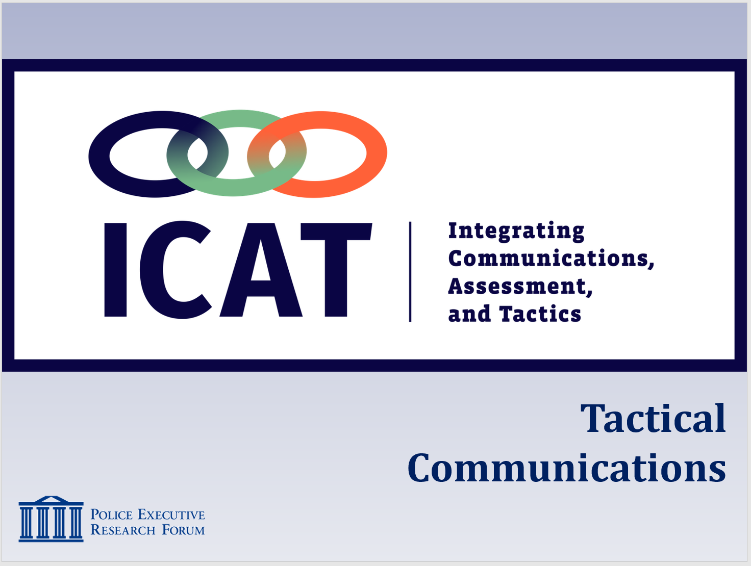

SLIDE #2
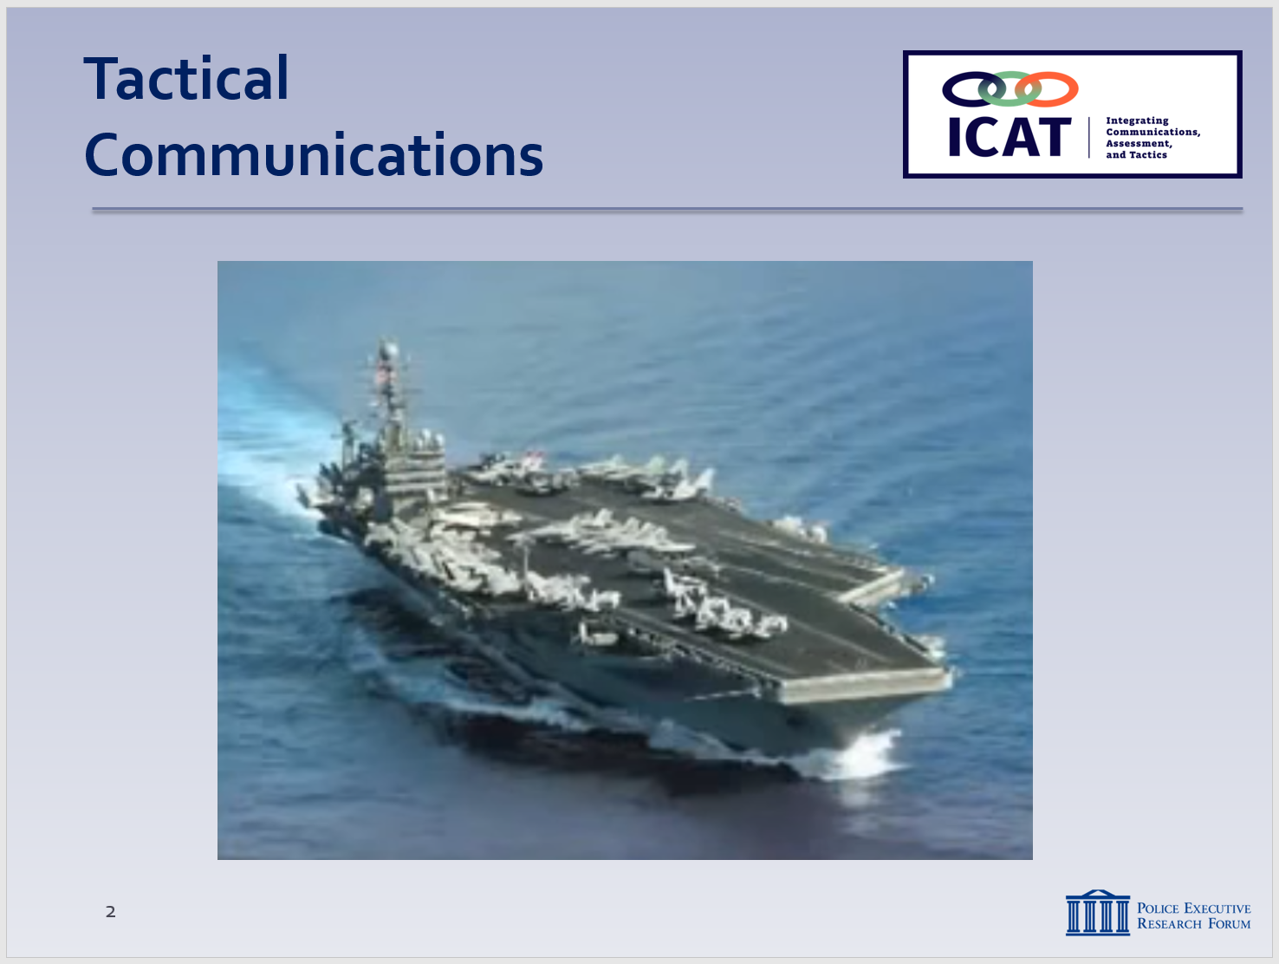
Video can be found at: https://www.youtube.com/watch?v=xkx0MxK-Yl4

SLIDE #3
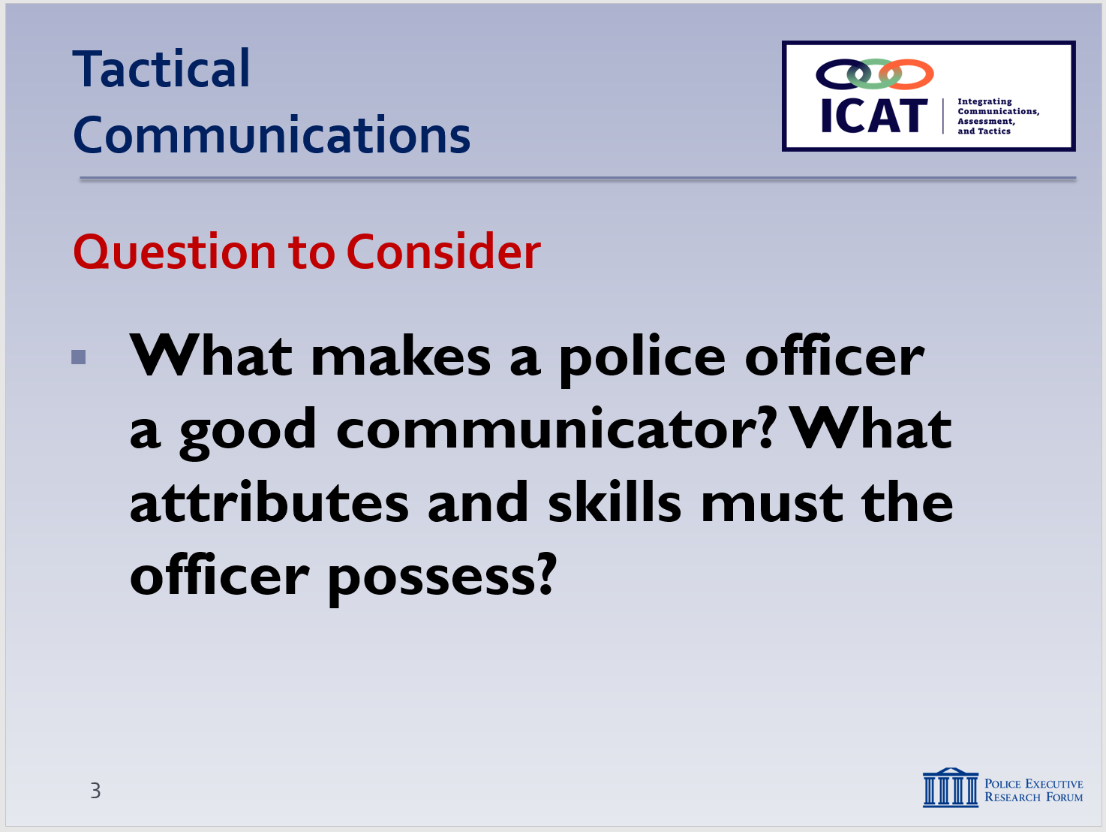

NOTE: The previous module briefly touched on some basic communications concepts in dealing with persons in crisis. This module provides more details and context.

- Introductory Video

  - “Radio Conversation Between the United States Navy and Spain”
    - Notice how the video shows the importance of listening to others, especially when in a position of greater authority.
    - Sound familiar?
    - Ask the class: what about that video rung true in your communications with subjects on the street? Peers? Supervisors? Family members and friends?

- Learning Activity – 1 (Assessment)
Activity: Assessment Group Project
Activity Time: 20 minutes
Activity Learning Objective: An assessment exercise that serves as an introduction to the Tactical Communications module
Required Equipment: Easel pads, markers
Facilitator Instruction: Break the class into small groups. Provide each group with markers and easel pads. Each group will have 10 minutes to brainstorm and record the attributes of a police officer they know who is an effective communicator. Each group will delegate a spokesperson who will present the findings to the class.

Wrap up with a discussion of the points on Slide #4 – Five Universal Truths of Human Interaction. You can ask the class if they agree/disagree with the list, and why or why not.

    - People feel the need to be respected
    - People would rather be asked than be told
    - People have a desire to know why
    - People prefer to have options over threats
    - People want to have a second chance

Encourage the class to keep these ideas in the back of their minds throughout this module.

- Responding to Someone in Crisis
As discussed in Module 3, for the first responding officer on the scene, the mission is not to diagnose the person in crisis or try to counsel him or her to an immediate resolution. Rather, it is to assess the situation and make it safe; attempt to defuse the crisis as much as possible; buy time for specialized resources to arrive; and try to get the subject to a state where he or she can make more rational decisions, resulting in a safe and peaceful resolution through voluntary compliance. Specific tactical skills are covered in future modules. This unit focuses on how to approach the initial response so that effective communications are possible.

  - What is “Crisis Intervention?”
    - A process to assist individuals in finding safe and productive outcomes to unsettling events
    - As first responding officers, you’re one (very important) part of the crisis intervention process
Instructor Notes

SLIDE #4
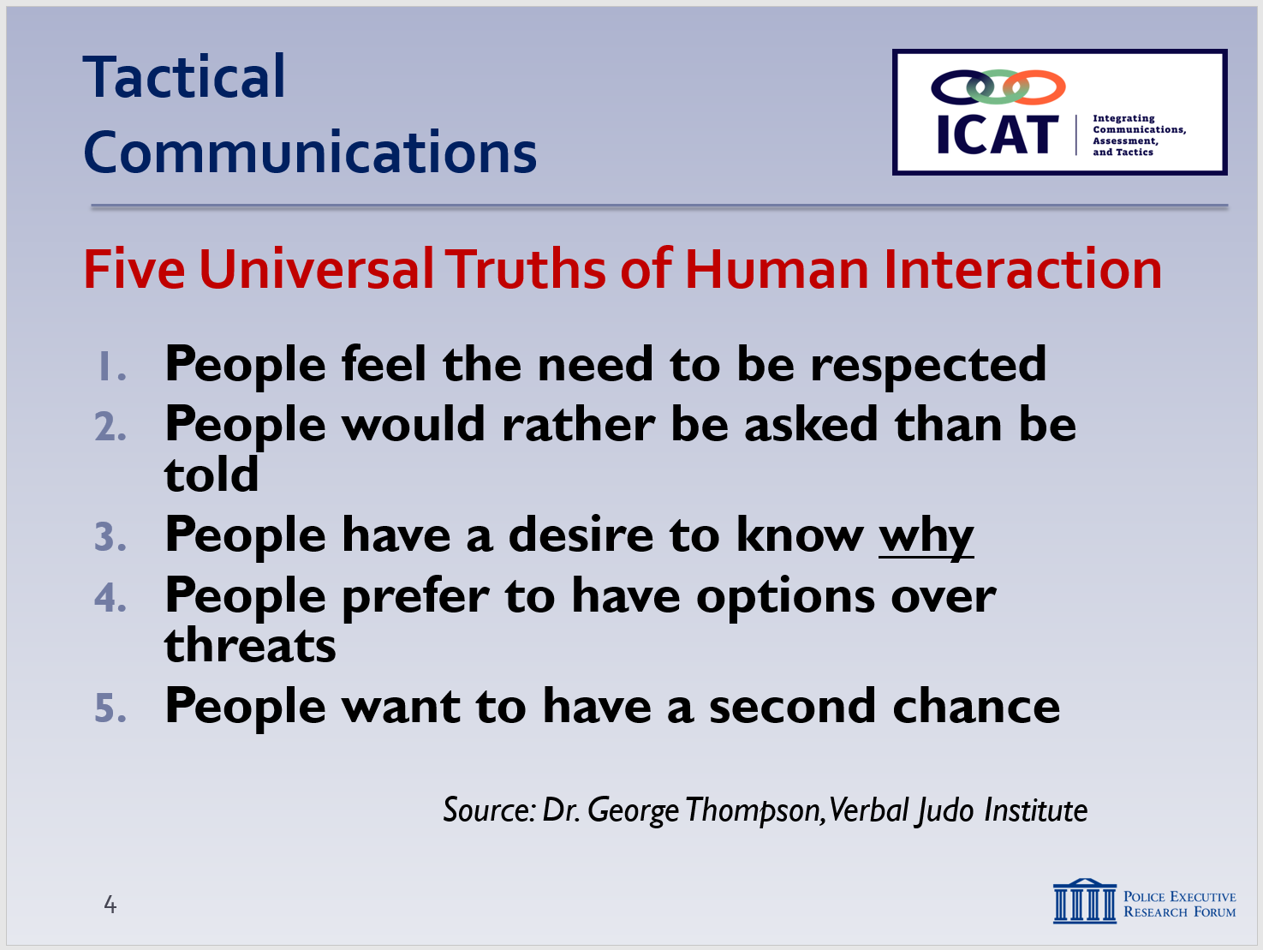
Source: Dr. George Thompson, Verbal Judo Institute; see https://www.policeone.com/communications/tips/2718138-The-5-universal-truths-of-human-interaction/

SLIDE #5
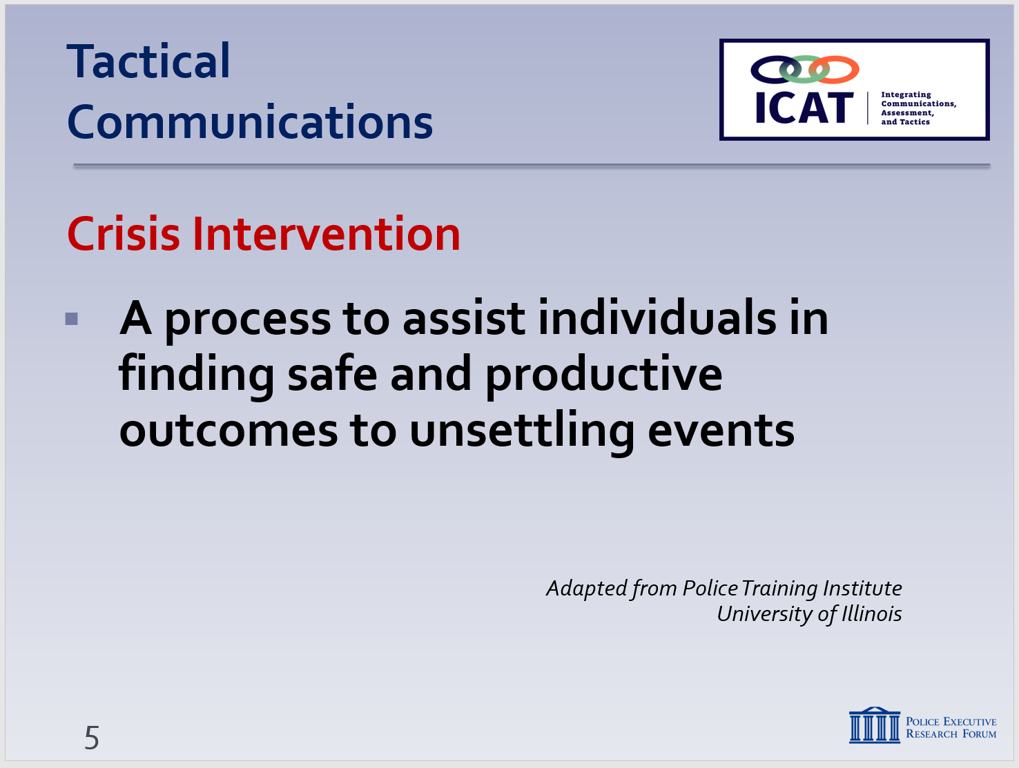

Verbal de-escalation: use of words and actions to reduce a heightened emotional and physical state, in order to facilitate calm, rational interaction (Seattle Police Department)

Note: many of the communication skills touched on here are covered in much more detail in the next Module (Module #4: Tactical Communications).

      - The subject’s first interaction with police is critical
      - You set the tone and help chart the course toward a resolution
    - But you (by yourself) are not the entire process
Instructor Notes

SLIDE #6
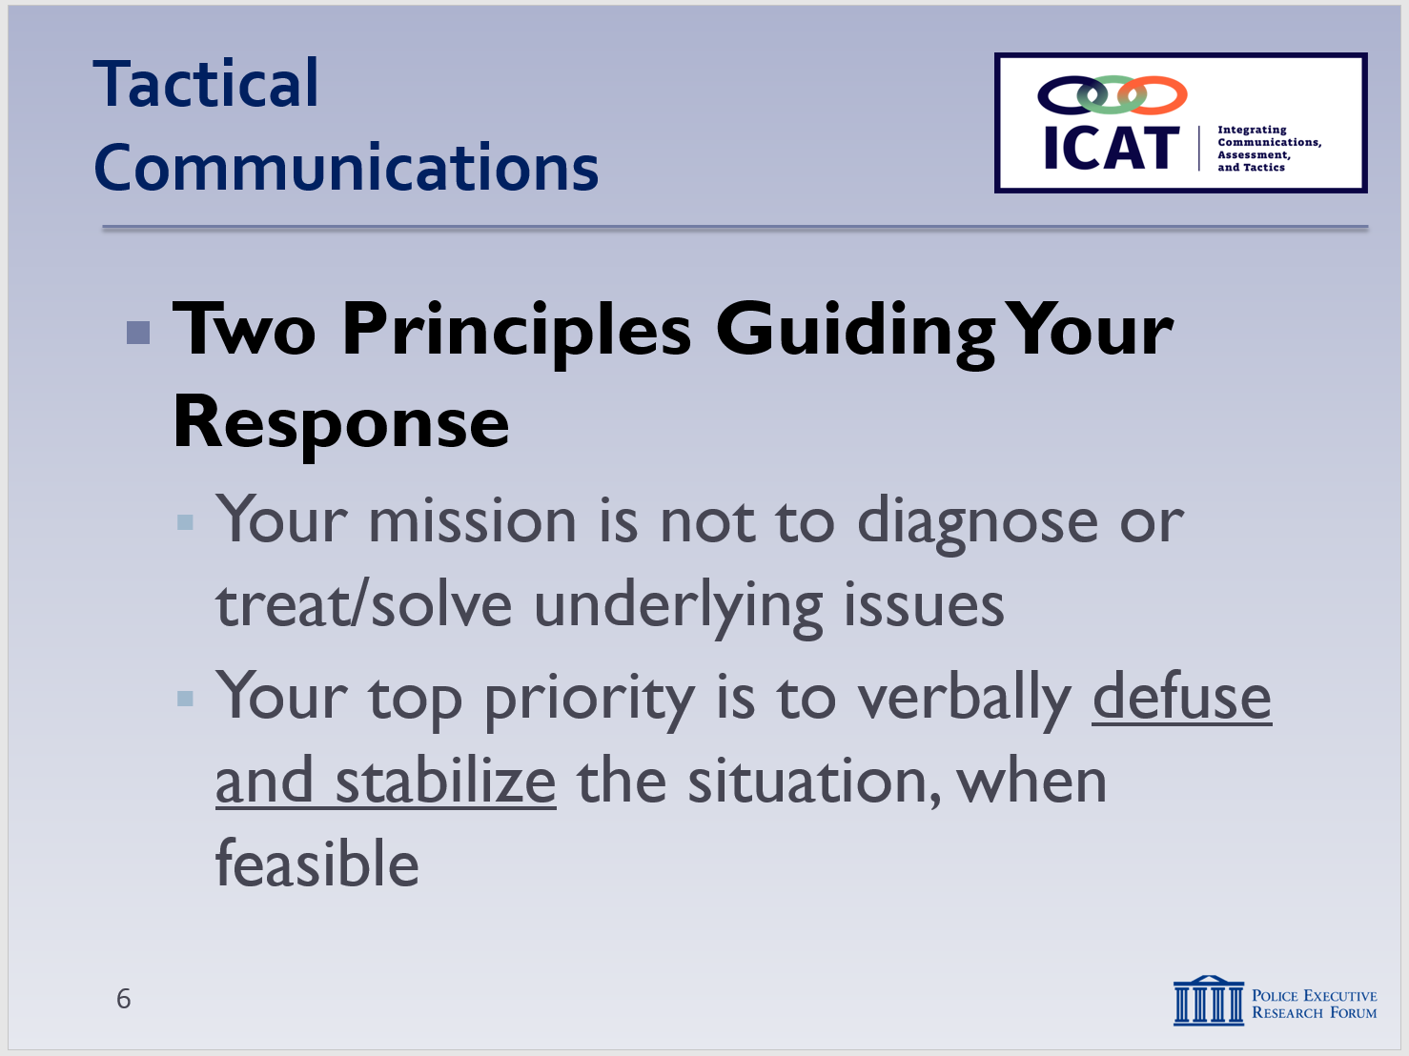

SLIDE #7
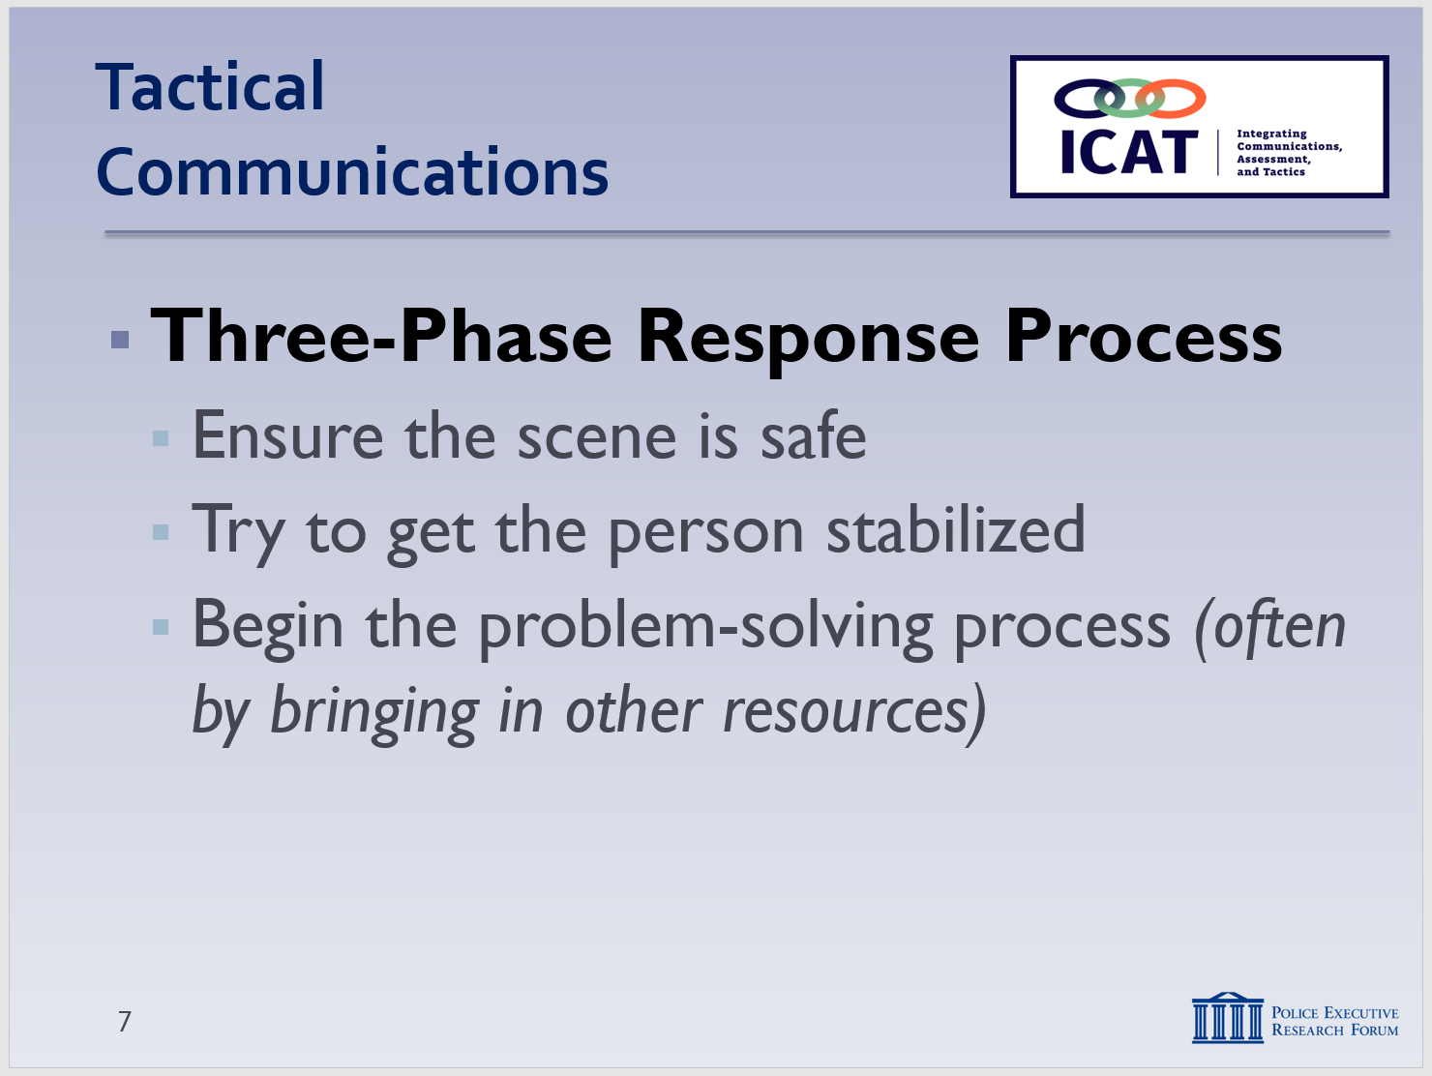

      - Your role is not to “solve” the underlying crisis
      - It is to stabilize the situation, make it safe, help get the person in a frame of mind to find solutions
      - Then, hopefully hand it over to others to provide longer-term care and solutions
  - Two guiding principles to keep in mind:
    - Your mission is not to diagnose the subject or treat/solve the underlying issues
      - Don’t assume you have correctly diagnosed the person
      - Don’t assume you know what to do based on your “diagnosis”
    - Top priority (when feasible) is to verbally defuse and stabilize the situation as much as possible
      - Try to get the person to a state where he or she can function and reason a bit better
      - Where voluntary compliance can be achieved
- Three-phase response process when faced with a person in crisis
    - Safety – of the public, the subject, the police
    - Stability – try to get the person stabilized through verbal and non-verbal de-escalation techniques
    - Problem solving (eventually)
      - As much as possible, try to get the person to a state of rational thinking/decision-making
      - Increases the likelihood of voluntary compliance and incident resolution
      - Again, this may require additional specialized resources – within and outside your agency.

  - Trying to defuse a critical situation does not …
    - Take away or restrict your discretion to make an arrest, where probable cause exists
    - Take away or restrict your ability to use reasonable and proportional force when faced with an imminent threat
    - But these should generally be considered last resorts – when other approaches have been tried and failed
  - How to approach persons in crisis – some practical tips and techniques:
    - Request backup and specialized help
      - CIT-trained officers
      - Local mental health partners
    - Don’t rush into situations (unless immediate action is required)
      - Move slowly
      - Focus on calming the situation
      - Minimize the stress level
    - Continually assess – and re-assess
      - As the subject’s demeanor and actions change, be prepared to adjust your approach
      - “Spin the CDM model”
    - Be aware of …
      - “Hot buttons” (or “Triggers”): topics that may further agitate the subject – avoid them
      - “Hooks”: topics that may help to calm the subject – leverage them to your advantage

Learning Activity 2 – Video Case Study
Note
This exercise is to illustrate how one officer used some of the tips and techniques that are covered in this module to respond to a person in crisis. The video also illustrates some of the important elements of the Critical Decision-Making Model.
Instructor Notes

SLIDE #8
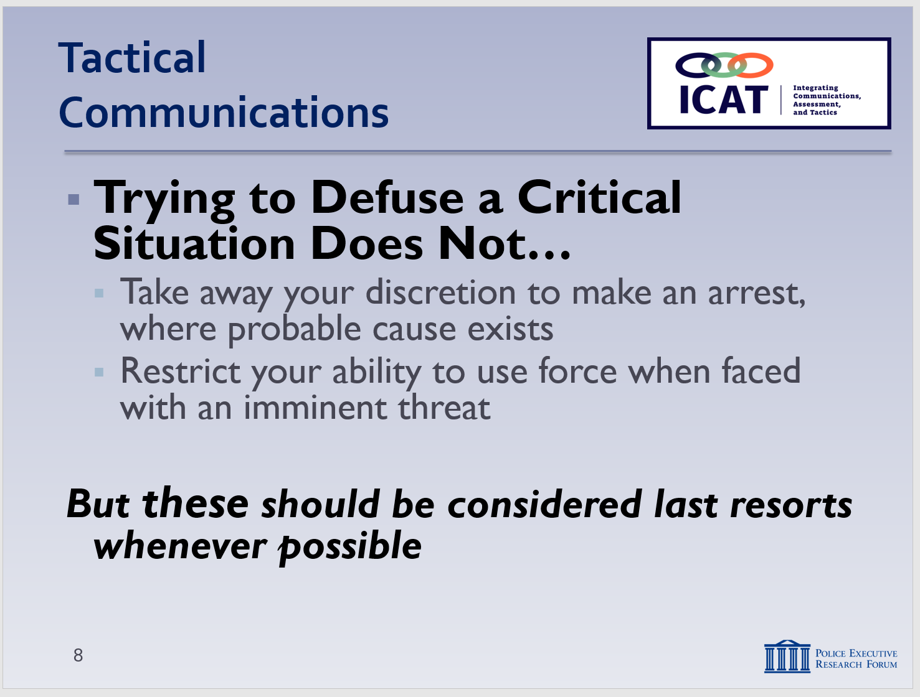

SLIDES #9
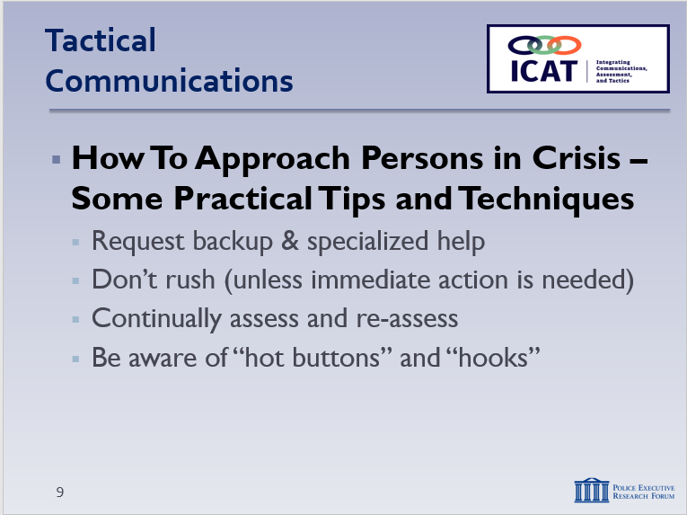
NOTE: These are “build” slides. Each mouse click displays the next bullet.

Tactical tip: It’s also important to make sure you are communicating with your partners and other personnel on the scene.

Hot buttons” and “hooks” are featured prominently in the scenario-based training exercises.

The term “hot buttons” is adapted from FBI and NYPD training.

Instructor Notes

SLIDE #10
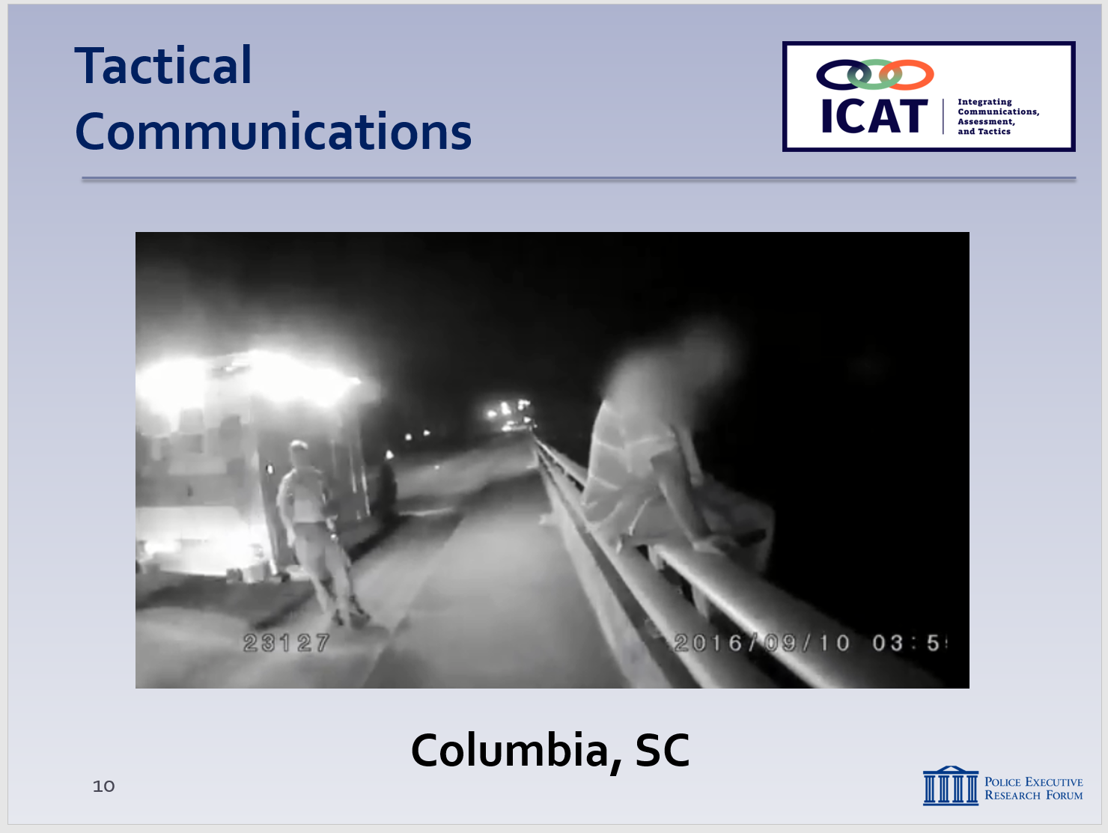
Video can be found at: https://www.youtube.com/watch?v=58FfkuJZRJE

A few reminders:

- Remind students that the video is not “perfect;” the purpose is not to judge or second-guess the officer’s actions or render a grade. Rather the video illustrates the real-world challenges officers face. The purpose is to generate discussion on how these challenges can be handled as safely and effectively as possible. We are not suggesting this was the only possible course of action in this case.
  - Columbia, SC video
    - September 10, 2016 – 0345 hours
    - Officers and EMS workers respond to a man sitting on a bridge guardrail, feet dangling over the highway
    - Show video
    - Lead a brief discussion: possible questions ….
      - What “hot buttons” did the officer encounter?
      - What “hooks” did the officer find?
      - How did the officer leverage those hooks toward a successful outcome of the situation?
      - What else did you notice?
        - Calm, even tone of voice
        - His tone is caring and compassionate
        - Asks open ended questions
        - Body language?
        - Good presence – relaxed but close in case he needed to act
        - Moves slowly
        - Rapport building?
        - Empathetic – “having a bad night tonight.”
Instructor Notes

SLIDE #11
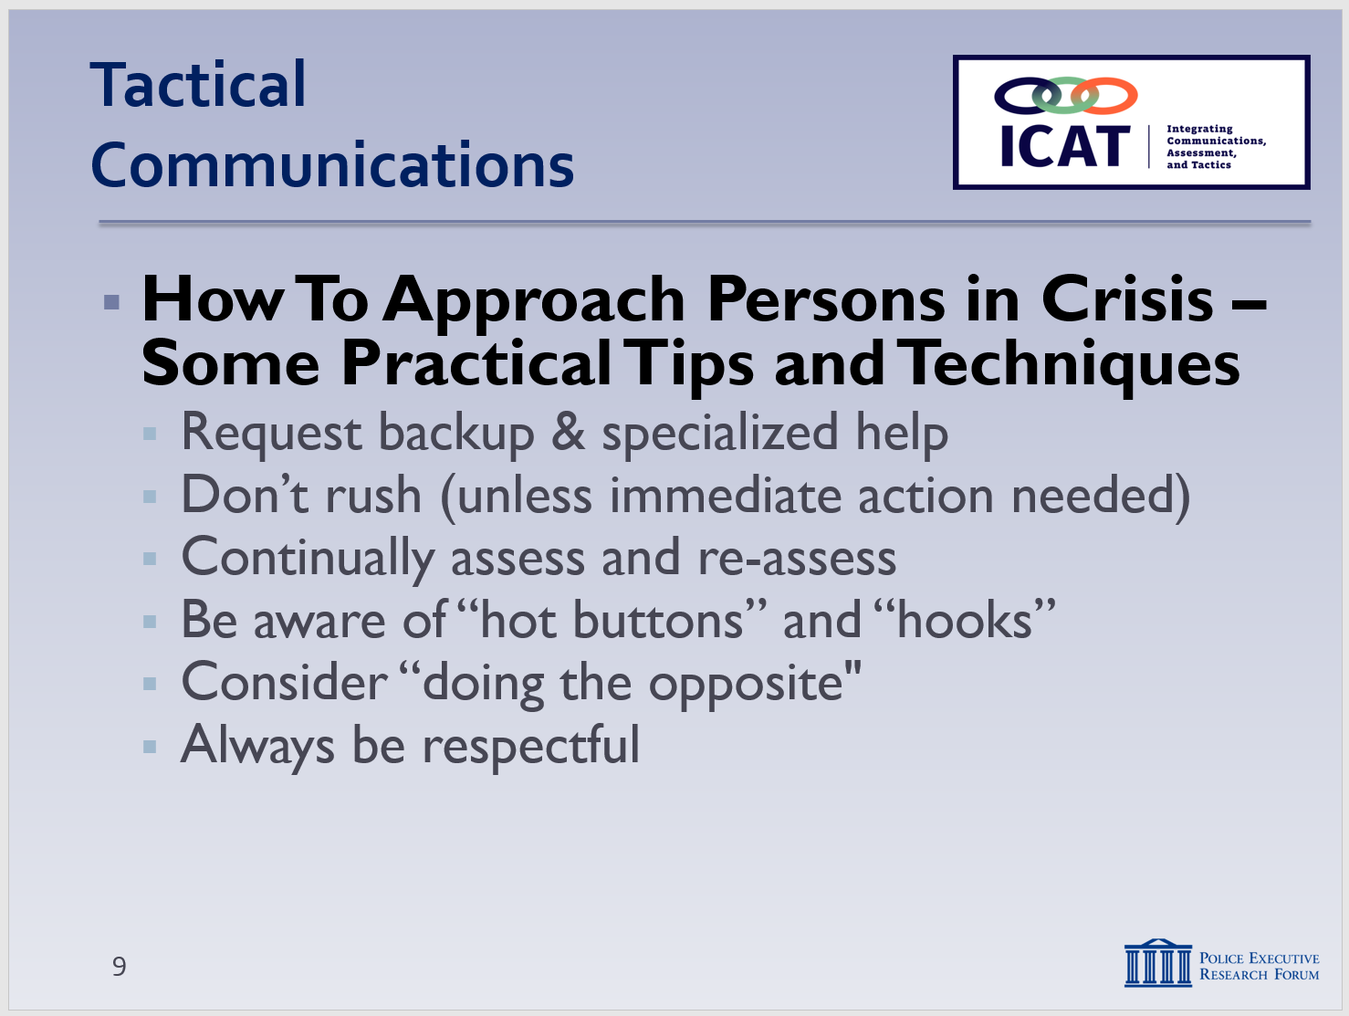

SLIDE #12
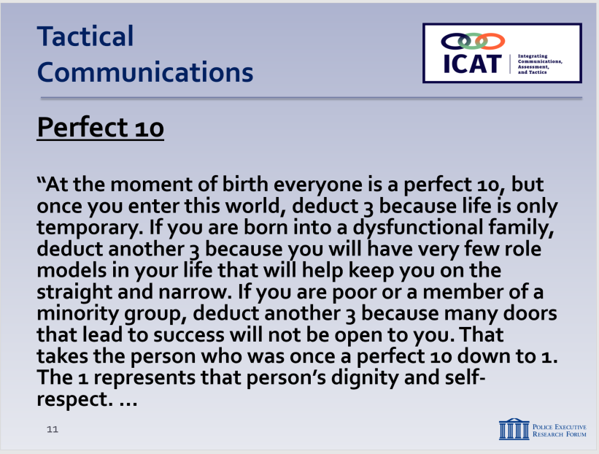

SLIDE #13
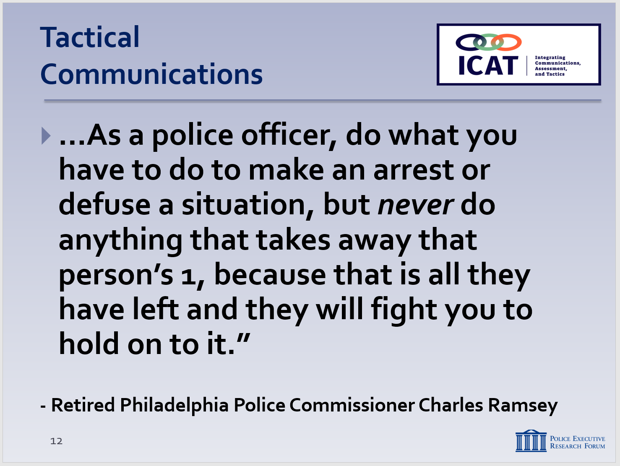

SLIDE #14
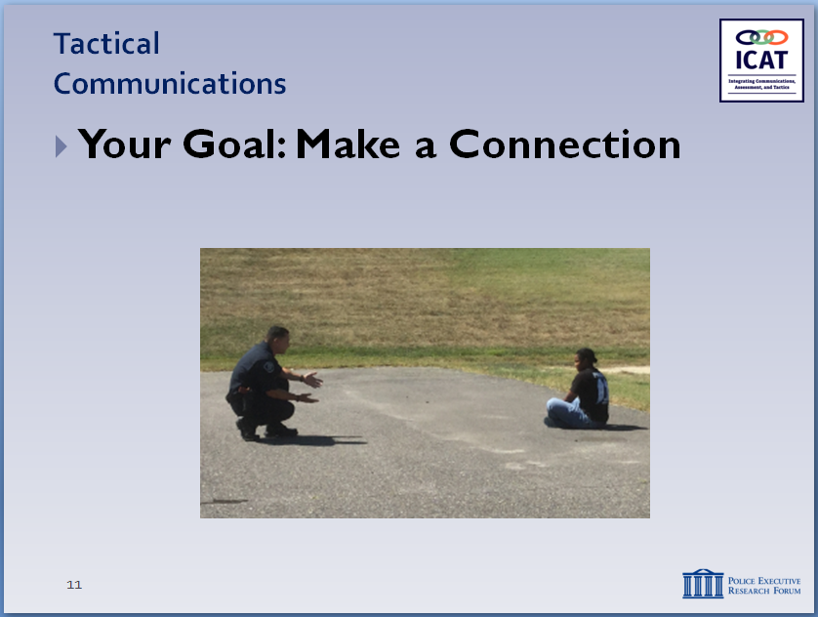

Remember what Paton Blough said: pretend the person you are dealing with is a relative or close friend.

        - ”None of us want you to hurt yourself, bud.”
        - Hopeful – “I’ll be out here riding around [tomorrow night] and I’m going to see you on the street and we’re going to talk about the Gamecocks or Redskins game.”
        - “I [also] hate Dallas”
        - Anything else?

- Responding to Someone in Crisis (continued)
    - If person in crisis is displaying one behavior type, consider doing the opposite
      - If they are yelling, be calm
      - If they are “flat-lining,” be more assertive
    - Always be respectful, never dismissive
      - Don’t say things like “calm down” or “just take your medications”
      - Display ethical leadership
        - You’re in control of the situation
        - Exercise that control with empathy and respect
    - This concept can be embodied by the “Perfect 10” quote, by Retired Philadelphia Police Commissioner Charles Ramsey. (slide #11 & 12)

  - Goal: Make a connection with the subject … so as to work toward voluntary compliance
    - Even in the middle of a crisis, most people respond positively to kindness, patience and respect
    - “Tactical empathy” (not the same as “sympathy”)
      - Never compromise your tactical position
      - But put yourself in a safe position to make that connection
    - Not only can defuse a situation – can also help prevent unnecessary escalation
  - When officers connect, you can influence behavior
    - Behavioral Change Staircase
      - FBI training tool for negotiators
      - Can be used effectively by patrol officers as well – a fancy name for something many of you practice every day
      - Five steps toward voluntary compliance
        - Introduction
        - Empathy
        - Rapport
        - Influence
        - Behavioral change
      - First three steps are about connecting with the subject
      - Last two steps are about problem-solving
      - Active listening is critical throughout the process
  - Some things not to do
    - Don’t join in the subject’s behavior
      - If they’re agitated, you need to remain calm
    - Don’t confuse the subject
      - Issuing multiple commands or complex choices can lead to confusion
      - Keep your communication simple
Instructor Notes

SLIDE #15
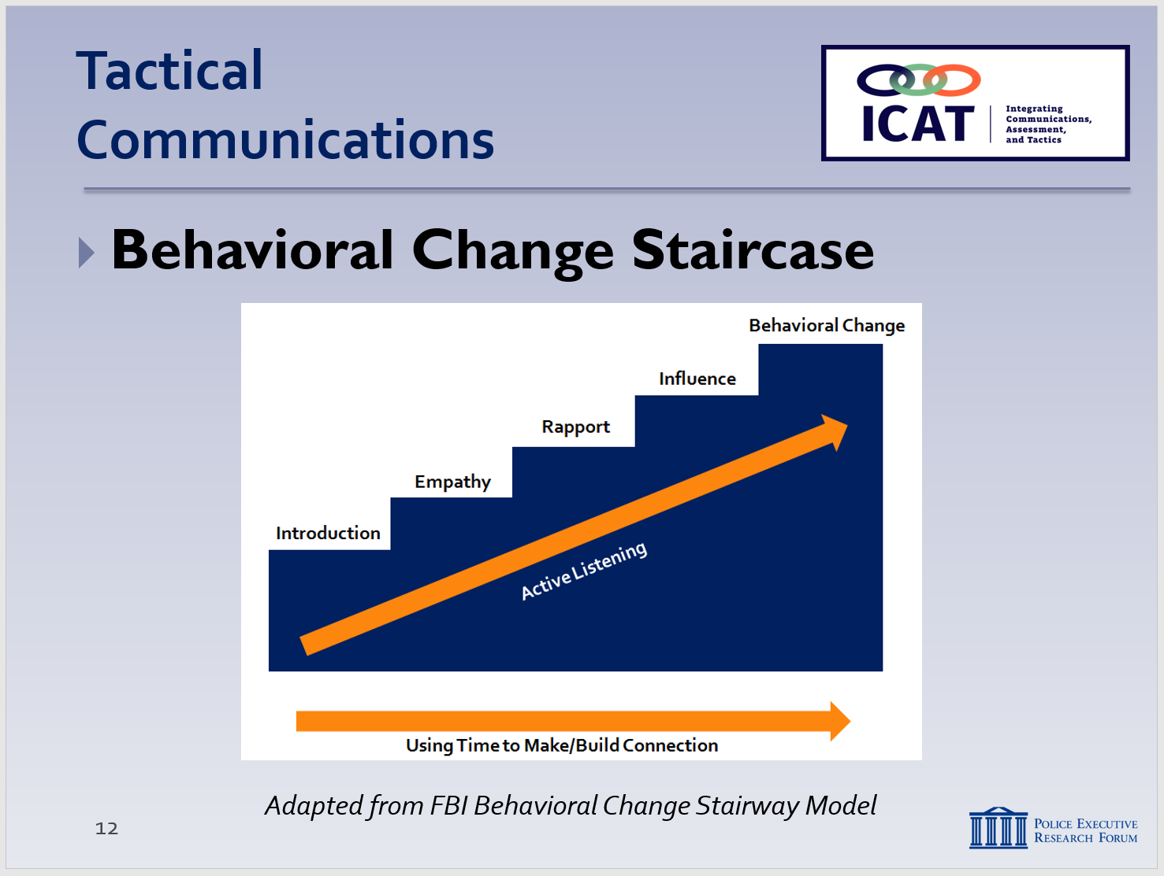
How do you climb a staircase? One step at a time. To get behavioral change (voluntary compliance), be patient and take one step at a time.

Adapted from the FBI Behavioral Change Stairway Model. For more background, see https://viaconflict.wordpress.com/2014/10/26/the-behavioral-change-stairway-model/ and http://www.mediate.com/articles/ThompsonJbl20131304.cfm

Another (somewhat simpler) approach used by the NYPD is the Law Enforcement Negotiation Stairway Model (LENS)

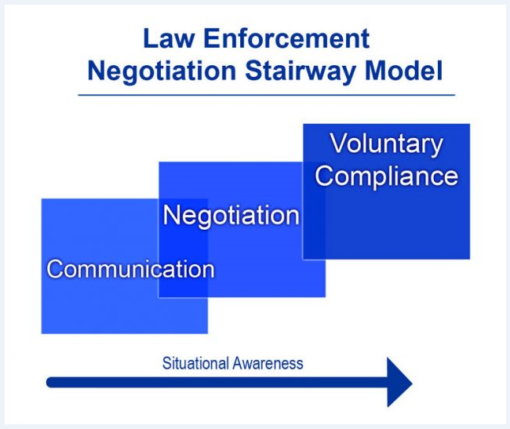

SLIDE #16
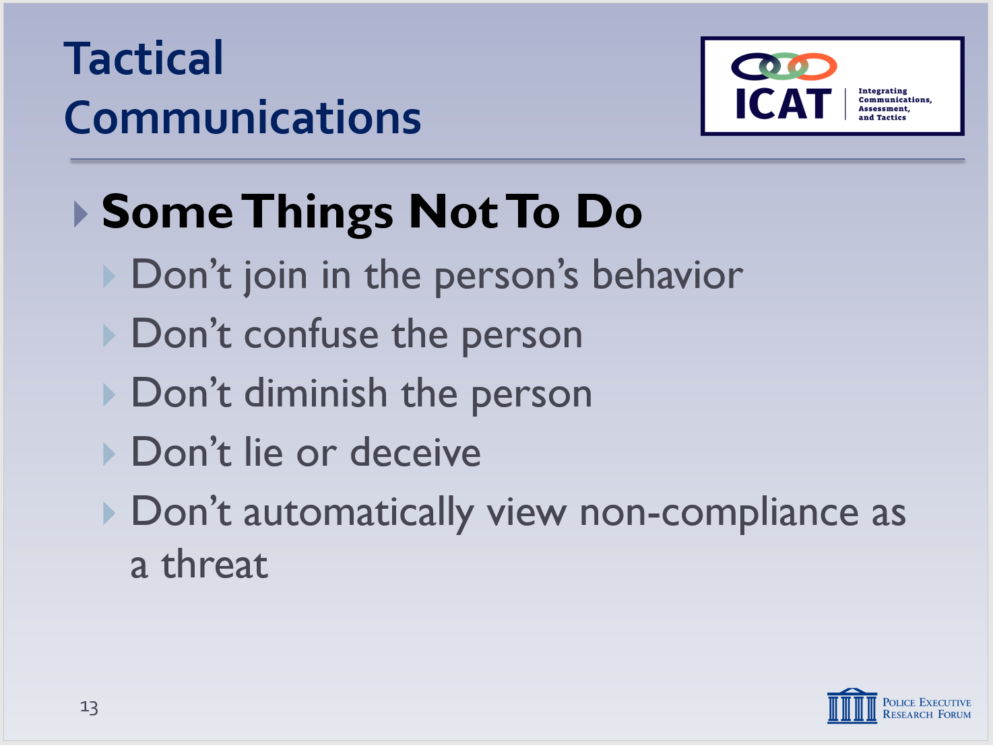
NOTE: This is a “build” slide. Each mouse click displays the next bullet.

.
      - Allow time for answers
    - Don’t diminish the subject
      - By whispering, joking or laughing
Instructor Notes

SLIDE #17
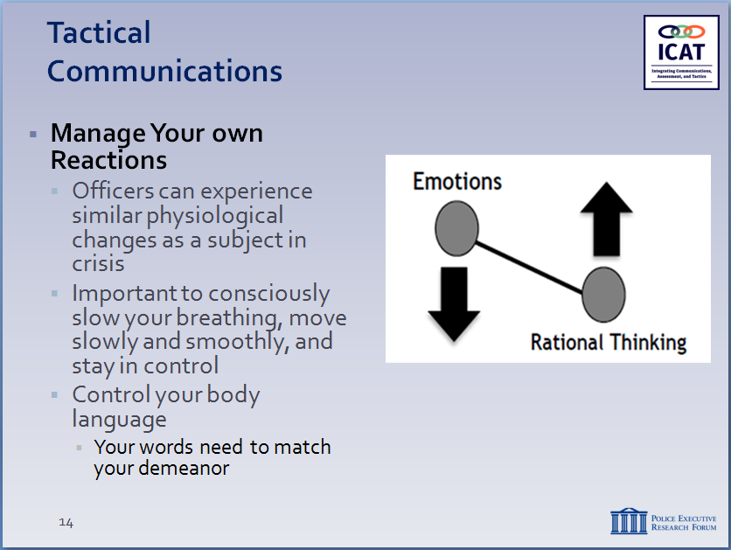

    - Can make the person suspicious or scared
    - Can feed into their anxiety/fear/paranoia – this can escalate their behavior
      - Subject may feel he or she is not being taken seriously
    - Don’t lie or deceive
      - Once you tell a lie, you set yourself up to having to keep going with that deception – that is difficult in a tense, negotiating situation
      - If you’re caught in a lie, you may never recover the person’s trust
      - Won’t be able to move up the Behavioral Change Staircase
    - Don’t automatically view non-compliance as a threat
      - There are many reasons the subject may not be following your directions (can’t hear, comprehend, process information)
      - Stay focused on the subject’s behavior and communication back to you
    - Remember … everything you do impacts all future contacts the individual in crisis (and maybe family and friends) have with the police
      - Don’t make it harder for the next officer by taking shortcuts or treating someone poorly
  - Finally … manage your own reactions
    - When faced with a subject in crisis, officers can experience some of the same physiological changes the subject is going through
      - Rapid heart rate – adrenaline rush
      - Increased breathing rate – shallower breaths
      - Increased muscle tension
Instructor Notes

SLIDE #18
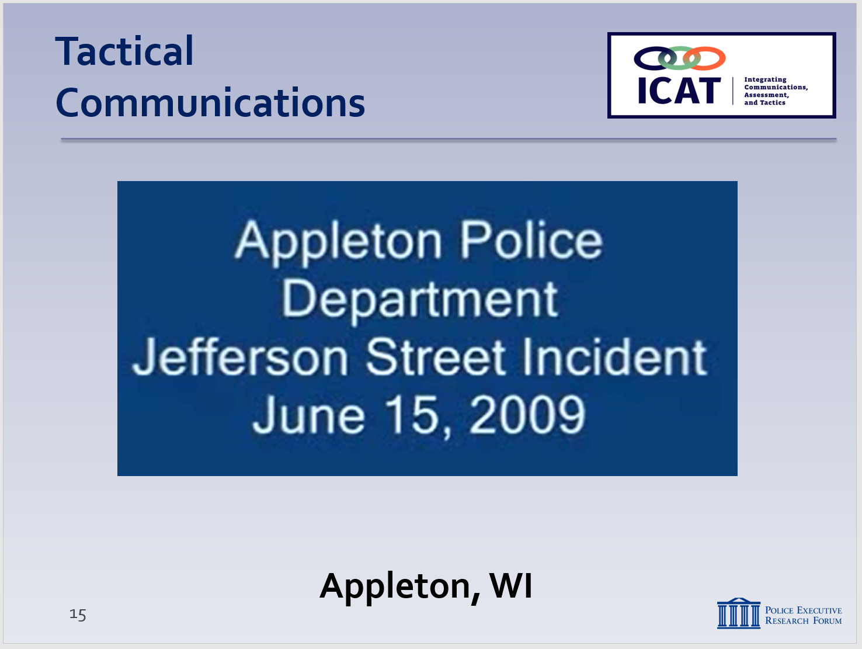

Video available at https://www.youtube.com/watch?v=jizOcTUlfV4

We will have other videos later in the training where this level of information was not collected, asked for, or relayed to responding officers.

This is an example of a “tactical pause”—a concept discussed later in the training. See Module 5.

      - Rapid eye movement and “tunnel vision”
      - Auditory exclusion
      - Amygdala Hijack (emotional redlining)
      - Again, you are also affected by the Emotional-Rational Thinking Scale
    - Important for officers to consciously:
      - Slow breathing (inhale-hold-exhale on 4 count)
      - Stay as calm as possible
      - Keep good posture
      - Use eye contact
      - Move slowly and smoothly
      - Stay in control
    - You can say all of the “right” things … but if you appear afraid, irritated, or angry, verbal communications will have little effect on defusing the situation
    - Your words need to match your body language and demeanor
- Learning Activity–3 (Video Case Study) - Optional

Note

This exercise is to illustrate how one officer used some of the tips and techniques that are covered in this module to respond to a person in crisis. The video also illustrates some of the important elements of the Critical Decision-Making Model.

A few reminders:
- Set up the video ahead of time; provide background and context.
- Remind students that the video is not “perfect;” the purpose is not to judge or second-guess the officer’s actions or render a grade. Rather the video illustrates the real-world challenges officers face. The purpose is to generate discussion on how these challenges can be handled as safely and effectively as possible. We are not suggesting this was the only possible course of action in this case.
- Although the video plays for 9:43, it can be stopped at about 5:02. The main learning points are covered by then.

  - Set up the video
    - Appleton, WI
    - June 2009
    - Mother calls 9-1-1 to report her son (inside their house) is acting erratically, not making sense, is naked
    - First part of the video covers the communications traffic
  - Start the video
    - Stop at 2:50
      - What information does he have? (CDM Step #1)
        - Dispatch gathered and relayed critical information
        - Field units asked for clarification
        - Frequent updates, notifications, asking for resources
        - Supervisory response?
        - Supervisor came on air and broadcast the “game plan”
        - Ensured specialized resources were in place
    - Restart the video – Stop at 5:02
      - Initial approach – first impression?
        - Started low – didn’t rush the action (appropriate based on the information he had)
        - Asked questions – gathered more information
        - Then, waited for other resources to get in place before going hands-on and securing Tim
- How was his communication?
Instructor Notes

        - Reassuring messages right away (“It’s OK,” “I understand,” “You’re OK”)
Instructor Notes

SLIDE #19
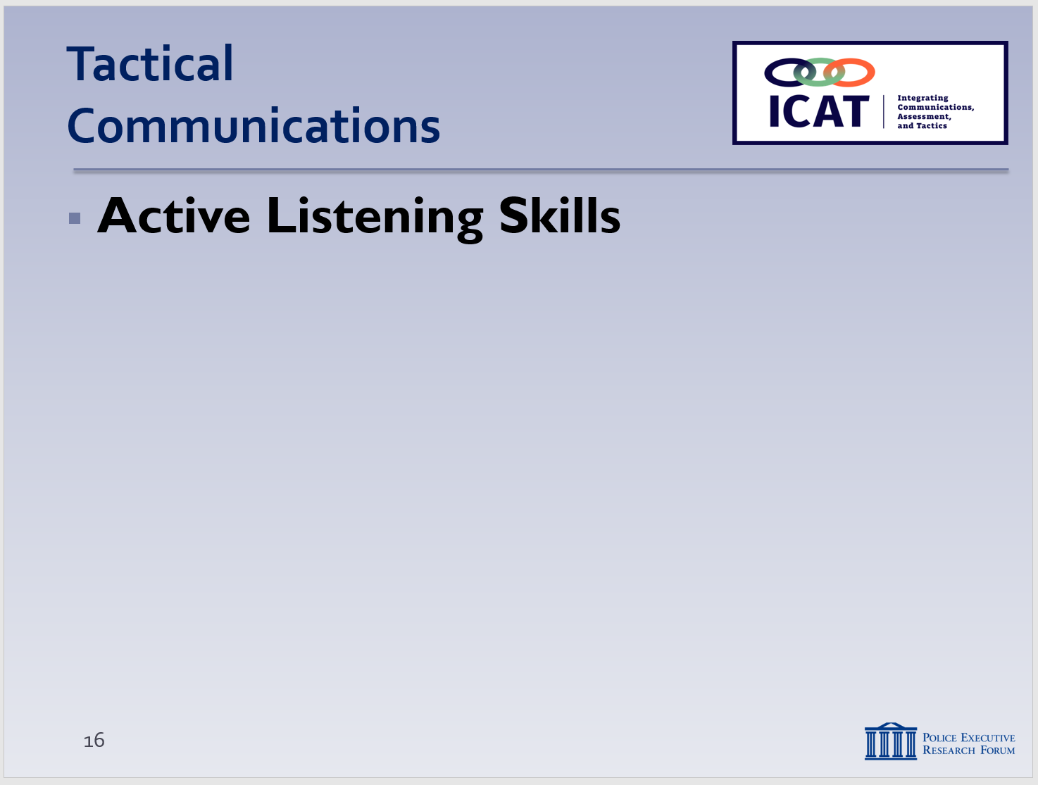

Emphasize that these are NOT “soft skills.” These skills, combined with sound physical tactics, are what keep officers safe day in, day out.

For more active listening tips, see https://www.mindtools.com/CommSkll/ActiveListening.htm

Another video: “Talk to Me: Active Listening Skills from NYPD Hostage Negotiators”: http://www.crisisnegotiatorblog.com/2016/10/active-listening-skills-from-nypd.html

        - Clear, simple directions (“Tim, we need to go to the hospital.”)
        - Calm, even tone of voice
        - Continued to offer reassurances throughout (“We’re not going to hurt you,” “We’re going to the hospital,” “It will be OK”)
      - Body language?
        - Open-handed gestures
        - Good presence – but still had the door available for cover initially
      - Rapport building?
        - Asked for and used the subject’s name
        - Acknowledged, was empathetic to the mother
        - Followed the subject’s lead – when Tim said he was going to lay down, the officer asked if he would lay down … Tim complied
      - Anything else?
- Active Listening Skills
Many people don’t actually listen; they are simply waiting to talk. That is why it is so critical not to interrupt and to pay close attention to what others are saying (and, sometimes, what they’re not saying). It takes effort to listen – and it takes skill to listen to understand, not simply to respond.

  - Common misconception:
    - Communication is about being a good talker
    - In reality, it’s about being a superb listener
    - Hearing is easy – listening is hard
    - What are some of things you can do to be a good and active listener?
  - Follow the “80-20 principle”
    - Ask the class if they know what the “80-20 principle” is
Instructor Notes

SLIDE #20
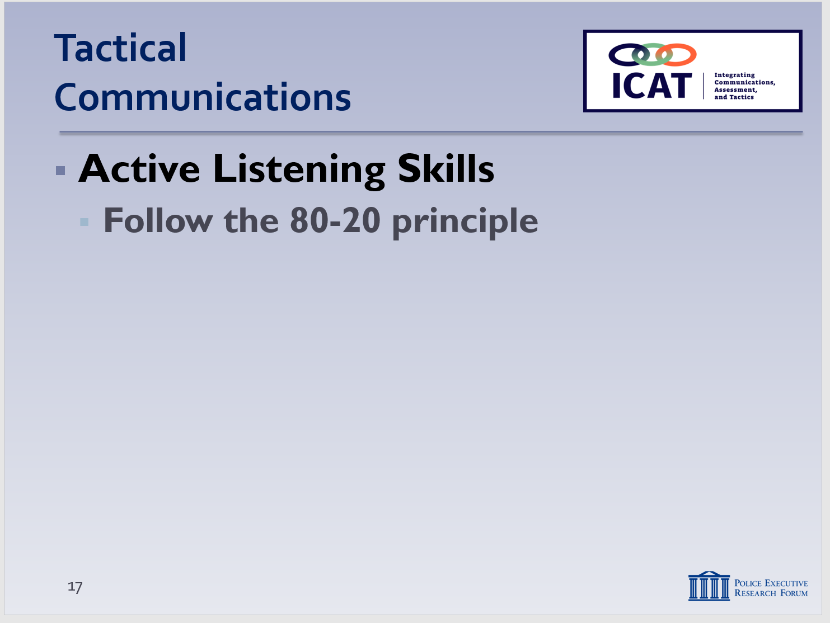
The Louisiana State Police helped to pioneer this concept, which is now used in many police training programs

A big component of active listening is asking “open-ended” questions that are designed to get the subject talking. That is covered on p. 12, below.

Active listening is a key element of CDM Step 2: Assess Situation, Threat and Risks,

SLIDE #21
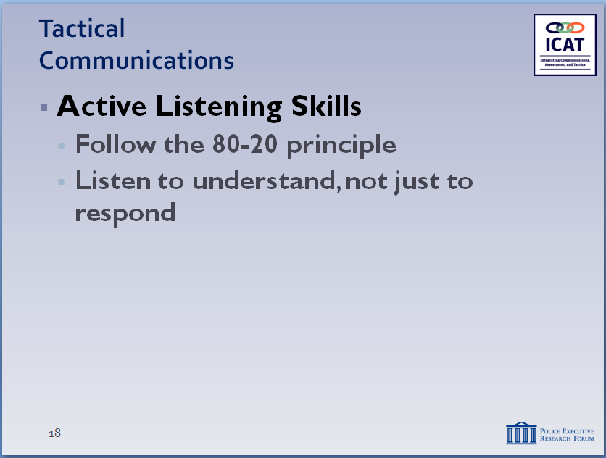
There are three levels of listening: (1) your agenda, (2) the subject’s story, (3) the subject’s values and beliefs. An effective “active listener” moves beyond (1) to fully understand (2) and (3). (Source: Police Scotland)

To change another person’s actions (i.e., gain voluntary compliance), you need to first understand their perspective. That’s why listening is so important.

Active listening is a critical part of the Behavioral Change Staircase

      - Invest 80% of communication time in listening
      - Devote just 20% to talking
    - Why this emphasis on listening? Because listening = intel gathering – about the subject’s …
      - Intentions and capabilities
      - Mental health history and medications
      - Criminal history / past violence
      - Emotional and behavioral triggers – “hot buttons” that might escalate the situation further
      - “Hooks” (things that might calm the subject) which you can leverage to de-escalate
    - Two practical benefits of active listening … of keeping the subject talking:
      - That’s time he/she is not doing something to threaten you or others
      - More time to gather more information and get additional resources to the scene

  - Listen to understand and learn – not just to respond
    - Often, people hear a few words from someone else and immediately begin thinking about their response
      - It’s impossible to be a good “active listener” if you do that
    - Take your time when you’re listening
      - Be patient, let the person finish their thought, and listen carefully
      - Try to understand their perspective
      - Demonstrate empathy
      - All this can lead to voluntary compliance
    - One officer (“contact”) may be doing the talking … but all officers on scene should be listening
Instructor Notes

SLIDE #22
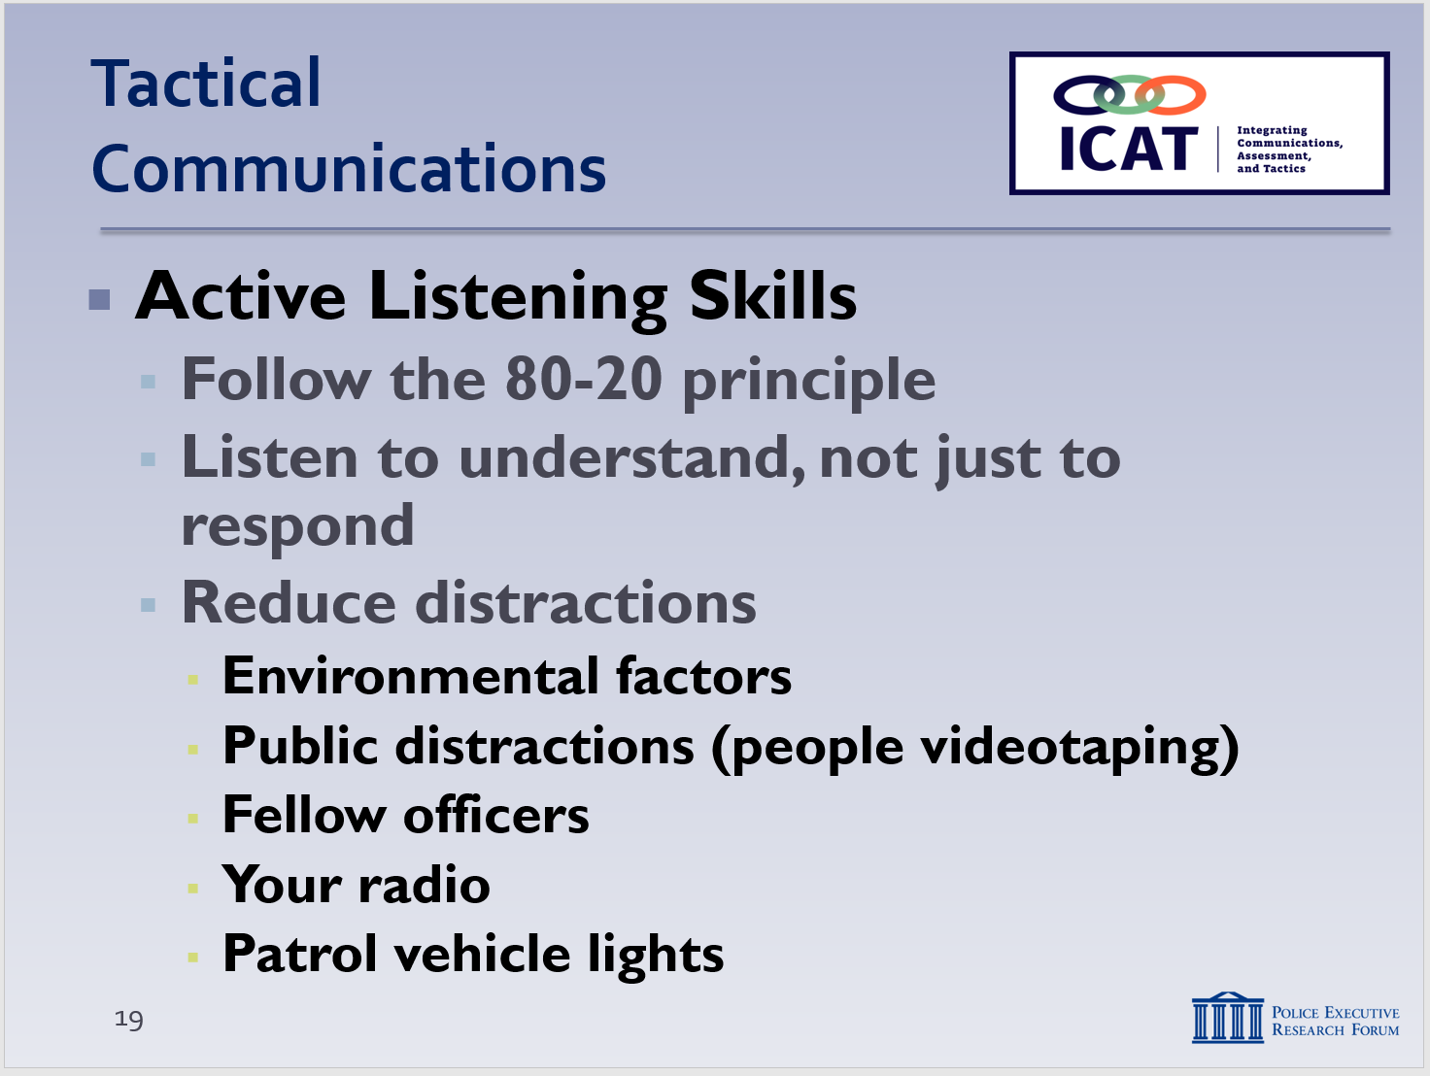

Emphasize that this requires coordination and teamwork on the part of responding officers—establishing roles and sticking with them.

.

SLIDE #23
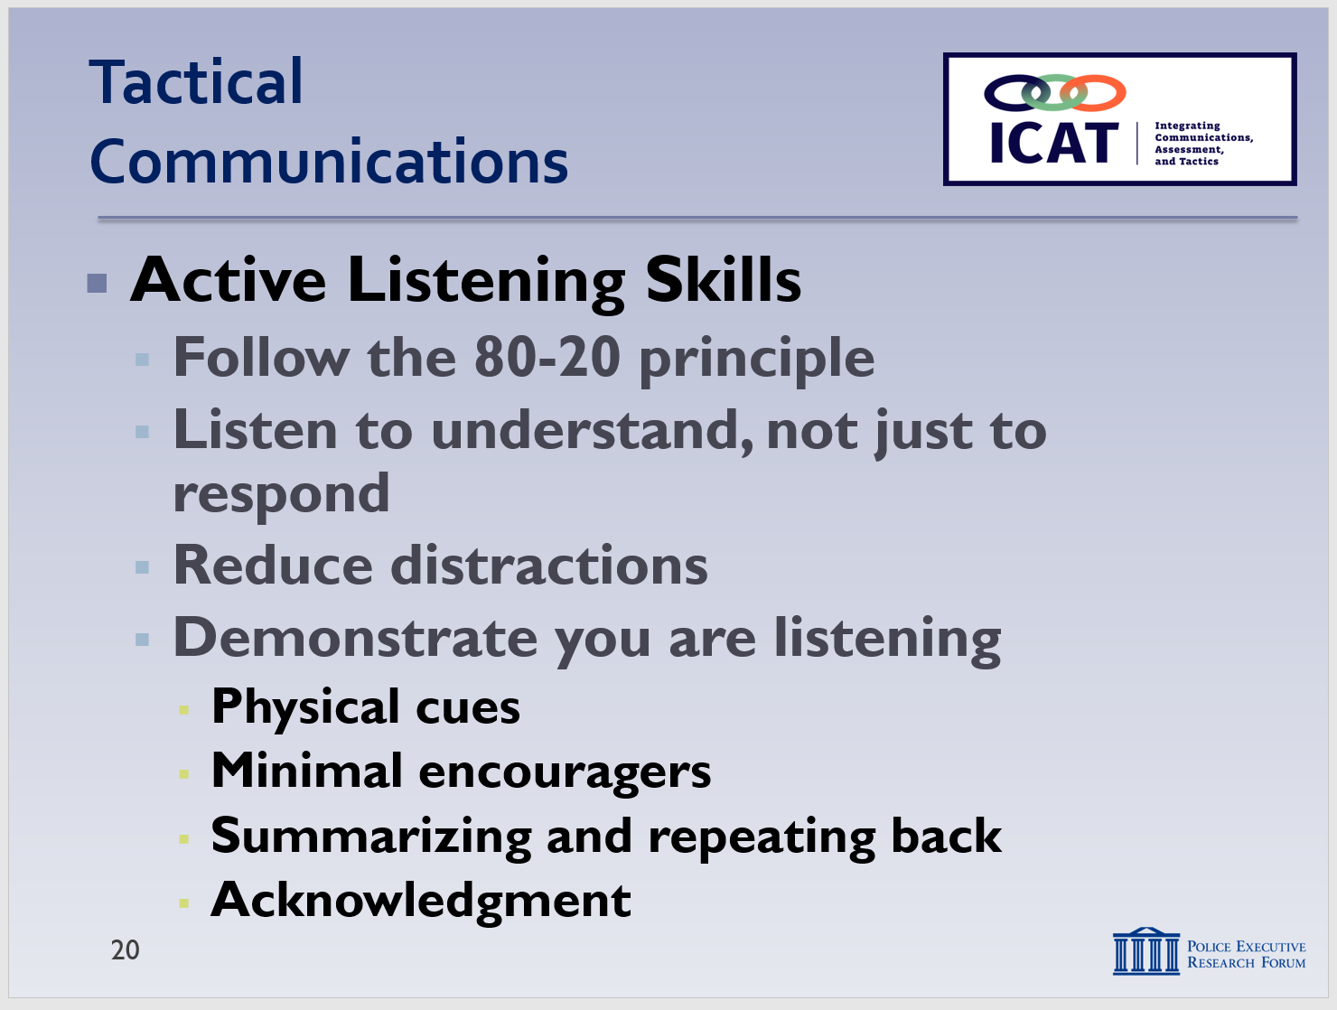

Non-verbal communication is covered in detail in the next unit.

In general, avoid saying “I understand.” That can be a trigger for some people in behavioral crisis.

      - Again, to pick up intel and understand the subject’s perspective
    - Also, pay attention to body language and non-verbal cues – not just the person’s words
      - Important for everyone’s safety
  - Reduce distractions
    - Stay focused on the subject, and ask the subject to focus on you
    - Environmental distractions (e.g., alarms, vehicles, etc.)
    - Public distractions (e.g., people who videotaping or questioning you and your actions)
      - While it’s generally permissible for members of the public to videotape police activities on the street, you can work to keep them at a reasonable distance and to not interfere with what you are doing.
    - Fellow officers (e.g., backup, mutual aid, etc.)
    - If feasible, consider turning down your radio – it can distract you and upset the subject
    - If possible, turn off your patrol vehicle’s emergency lights
    - If you’re the contact officer, rely on others to provide cover, crowd management, etc., so you can focus on listening and communicating

  - Demonstrate you are listening
    - Send the message that you care – are empathetic
    - Physical cues to show you are listening
      - Eye contact
      - Facial expressions
Instructor Notes

Some agencies and organizations use the acronym LEAPS:
Listen
Empathize
Ask questions
Paraphrase
Summarize
For background, see http://www.managetowin.com/blog/2014/5/14/leaps-forward.html

Don’t agree with or fight against hallucinations or delusions, but do react to their feelings. If the subject says, “I’m Jesus and I’m all powerful. You need to leave me alone!” you can say “I hear that you want to be left alone. I can’t leave because…, but I can take a step back to give you more space.”

SLIDE #24
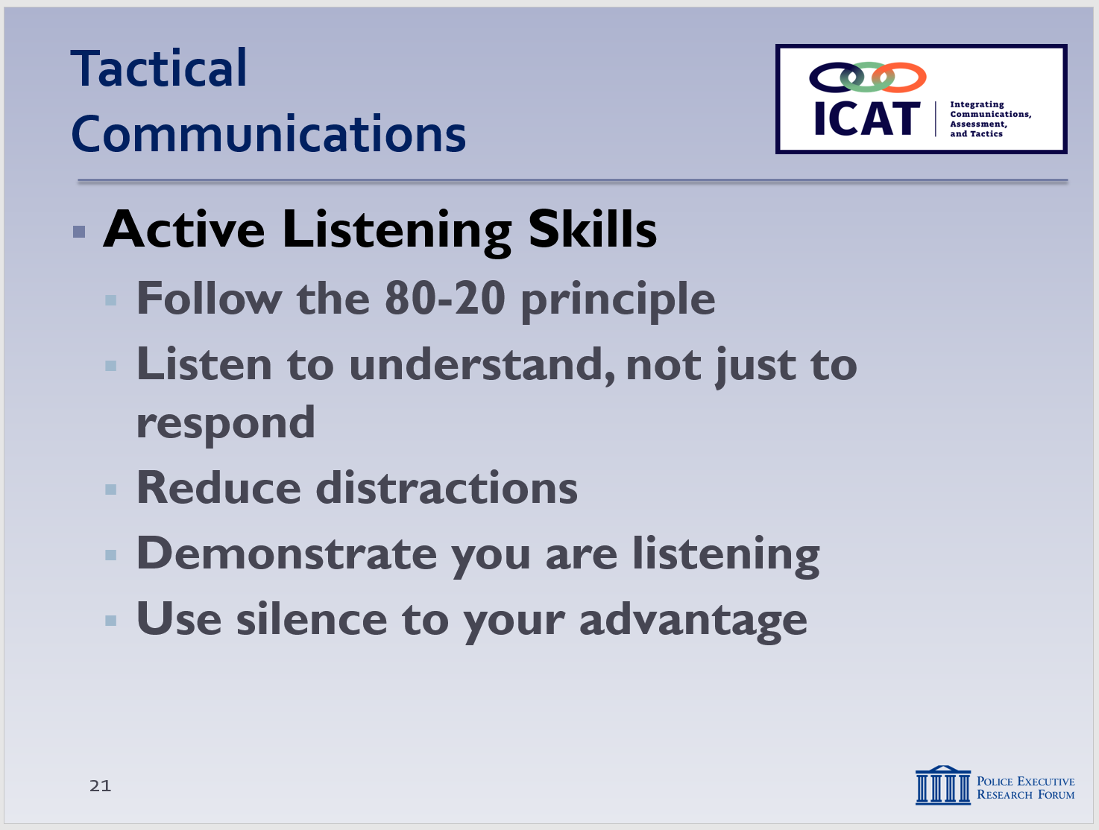

Remember: the dialogue is supposed to be all about the subject, not about you. Don’t let periods of silence be awkward for you and, therefore, prompt you to start talking. You want to encourage the subject to talk.

Option: if you know of a good, quick Active Listening exercise, insert it here. At a minimum, encourage students to think about and practice active listening skills during the scenarios, as well as on breaks, etc.

      - Posture
      - Calm, open-handed gestures
    - “Minimal encouragers”
      - Nod your head
      - Say, “uh-huh,” “I hear what you are saying,” etc.
    - Reflect, paraphrase and summarize
      - Repeat last few words the subject said
      - “So, what you are saying is that you are upset with your boss”
    - Acknowledgment
      - Acknowledge that the subjects’ problems are a big deal to them
      - Acknowledge the emotions associated with the crisis (e.g., fear, anger, anxiety, etc.)
      - Never belittle or dismiss their problems
      - Be respectful, fair, non-opinionated
  - Use silence to your advantage (“effective pauses”)
    - Don’t interrupt or feel the need to respond (verbally) right away to everything the subject says
    - Allow the subject time to finish – people in behavioral crisis may have trouble putting words/thoughts together – be patient
    - If there is no threat and the subject is comfortable with silence, don’t be in a hurry to talk
    - Silence may prompt the subject to talk more – to reveal more information and intelligence you can use
    - Silence can be an effective way to enforce boundaries, redirect someone who is yelling at you
      - You can’t argue with someone who won’t argue back
      - Puts pressure on subject to end the silence, start communicating (not yelling) again

- Non-Verbal Communication Skills
Instructor Notes

.

SLIDE #25
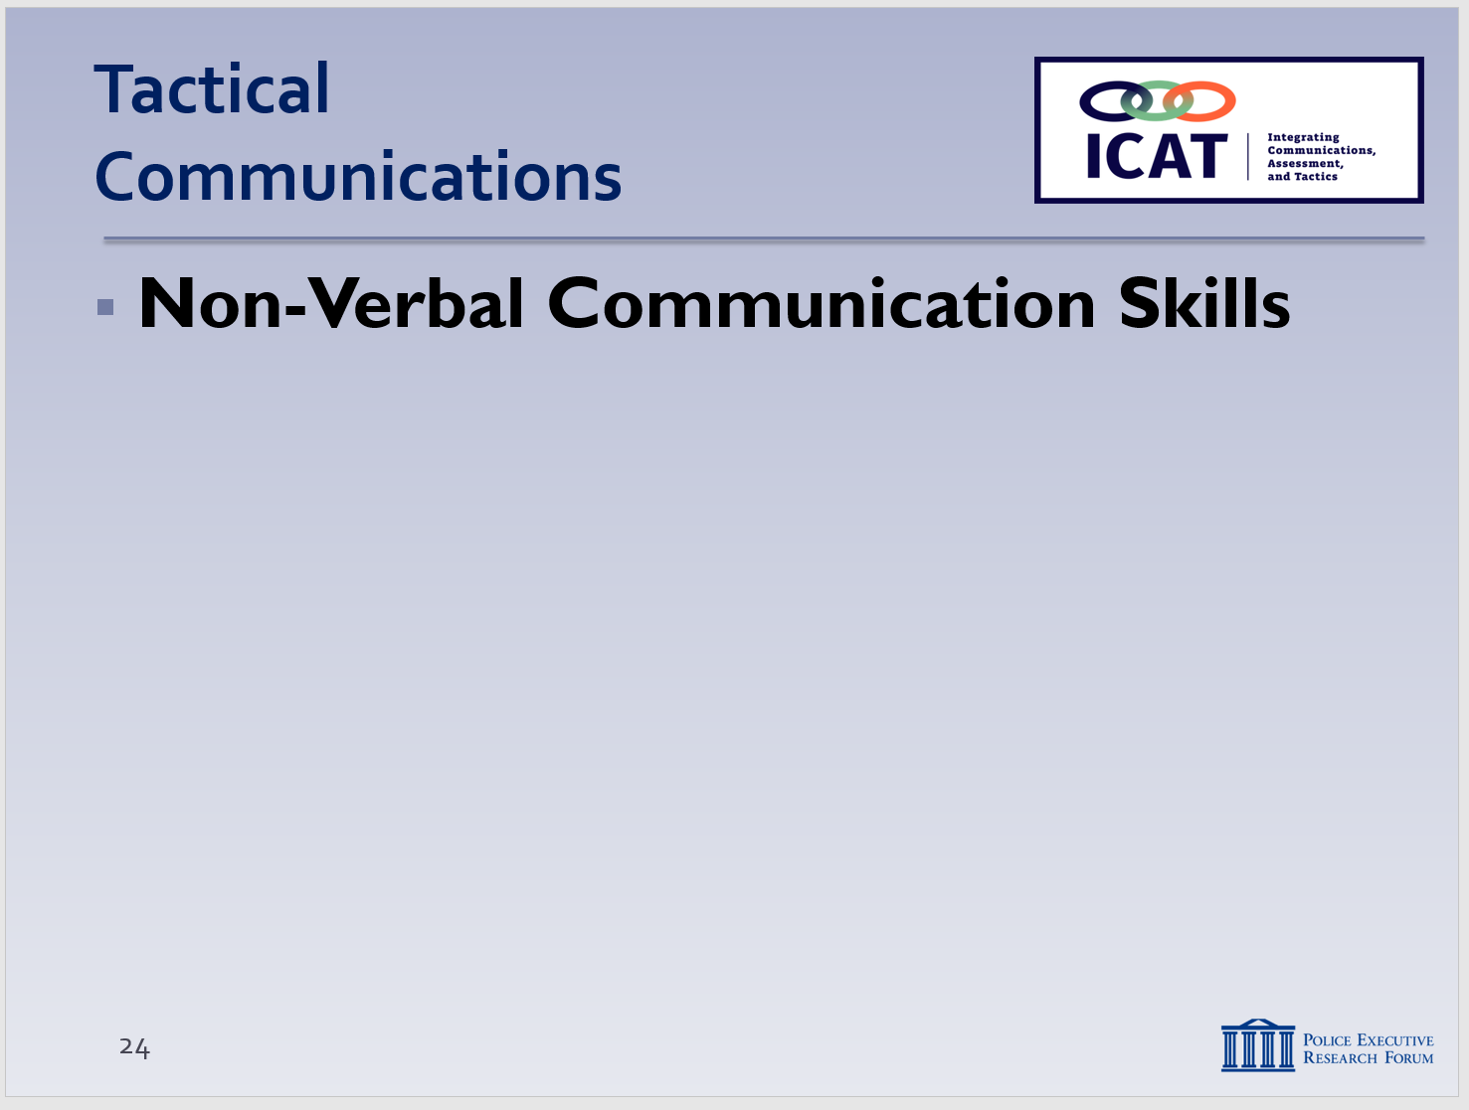

The end of this module discusses the concept of “emotional contagion” -- that your words and actions are contagious. If you’re calm and under control, there’s a greater chance the subject will be as well. You can introduce the “emotional contagion” concept here and ask students to keep it in mind throughout the module.

SLIDE #26
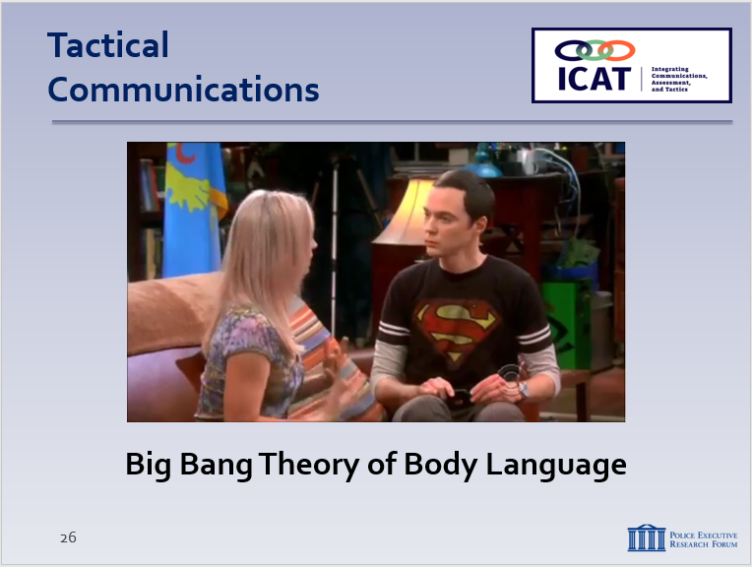
Available at https://www.youtube.com/watch?v=ApvEhdSjP2g

SLIDE #27
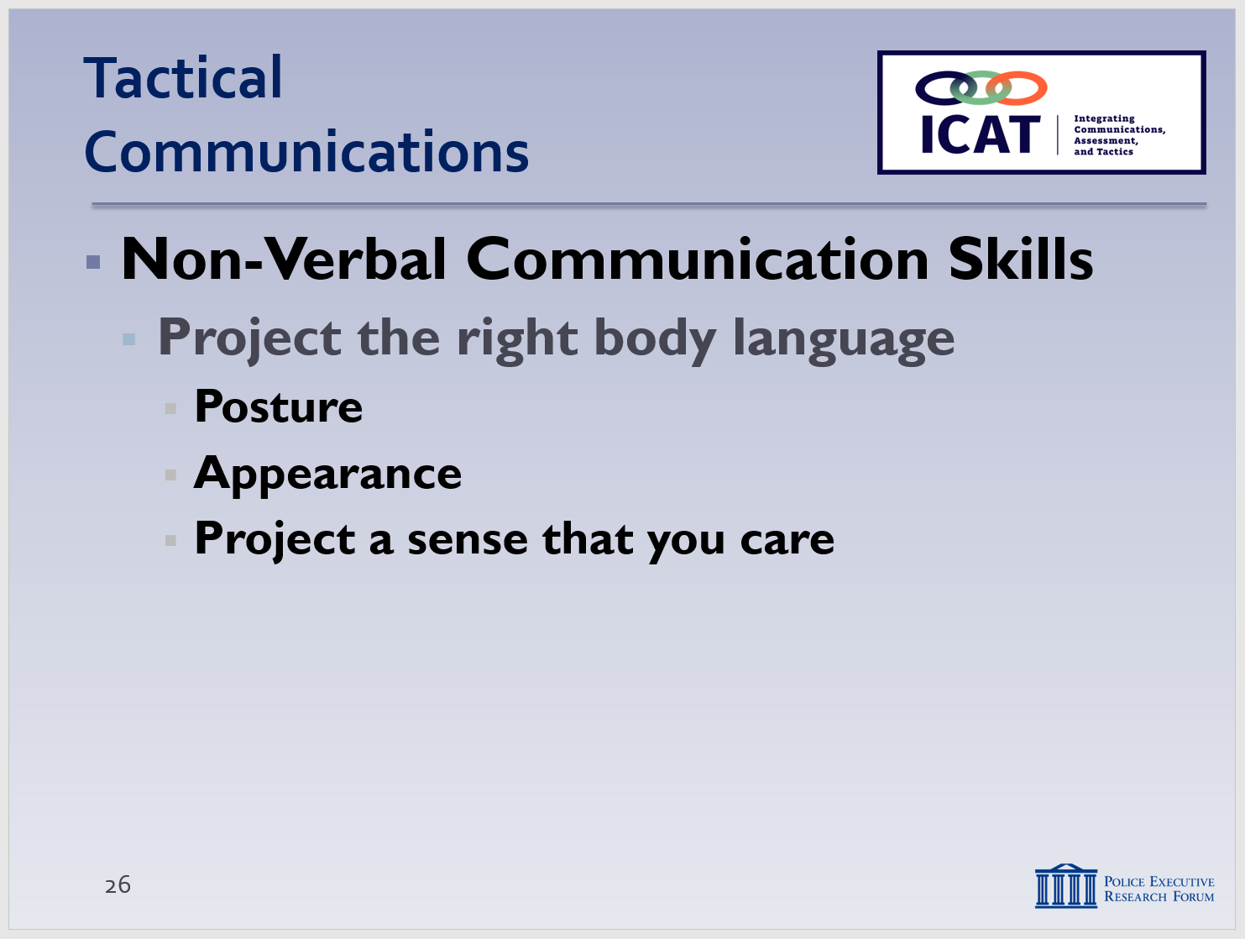

Remember: your appearance needs to match the words you’re using.

Good negotiators have a strong sense of self and don’t take things personally. Remember: the subject is usually yelling at your uniform, not at you.

Studies show that much of communication is non-verbal. Only part of any message is conveyed through words; the rest is projected through (1) physical cues such as facial expressions and gestures, and (2) vocal elements such as tone. Research also tells us that when words and non-verbal elements don’t align or contradict each other, people tend to believe the non-verbal. Perception always trumps intention. Understanding and paying attention to the non-verbal and tonal aspects of their communications can give officers a tactical advantage, which in turn can help to defuse volatile situations.
Optional: If you want to add some humor to the presentation, the video, “Big Bang Theory of Body Language,” may be appropriate. The video is brief: 2:37.
  - Project the right body language
    - Posture
      - Interview stance (for safety and communications)
      - No cross-armed stances
      - Don’t send signal you’re here to resolve the situation as quickly as possible
    - Appearance
      - Look sharp, act sharp, be sharp
    - All part of the first impression
      - A subject in behavioral crisis will likely react to how you look before reacting to what you say
Project a sense that you care

  - Make eye contact
    - Powerful non-verbal de-escalation technique
      - Presents you in strong, stable manner
      - Provides subject with a calming focal point – especially important for people in crisis
      - Allows you to observe the subject for signs of extreme or inappropriate responses (officer safety)
    - Officers should …
      - Look directly at the subject, focusing on the face (still scanning body and hands, for officer safety)
Instructor Notes

SLIDE #28
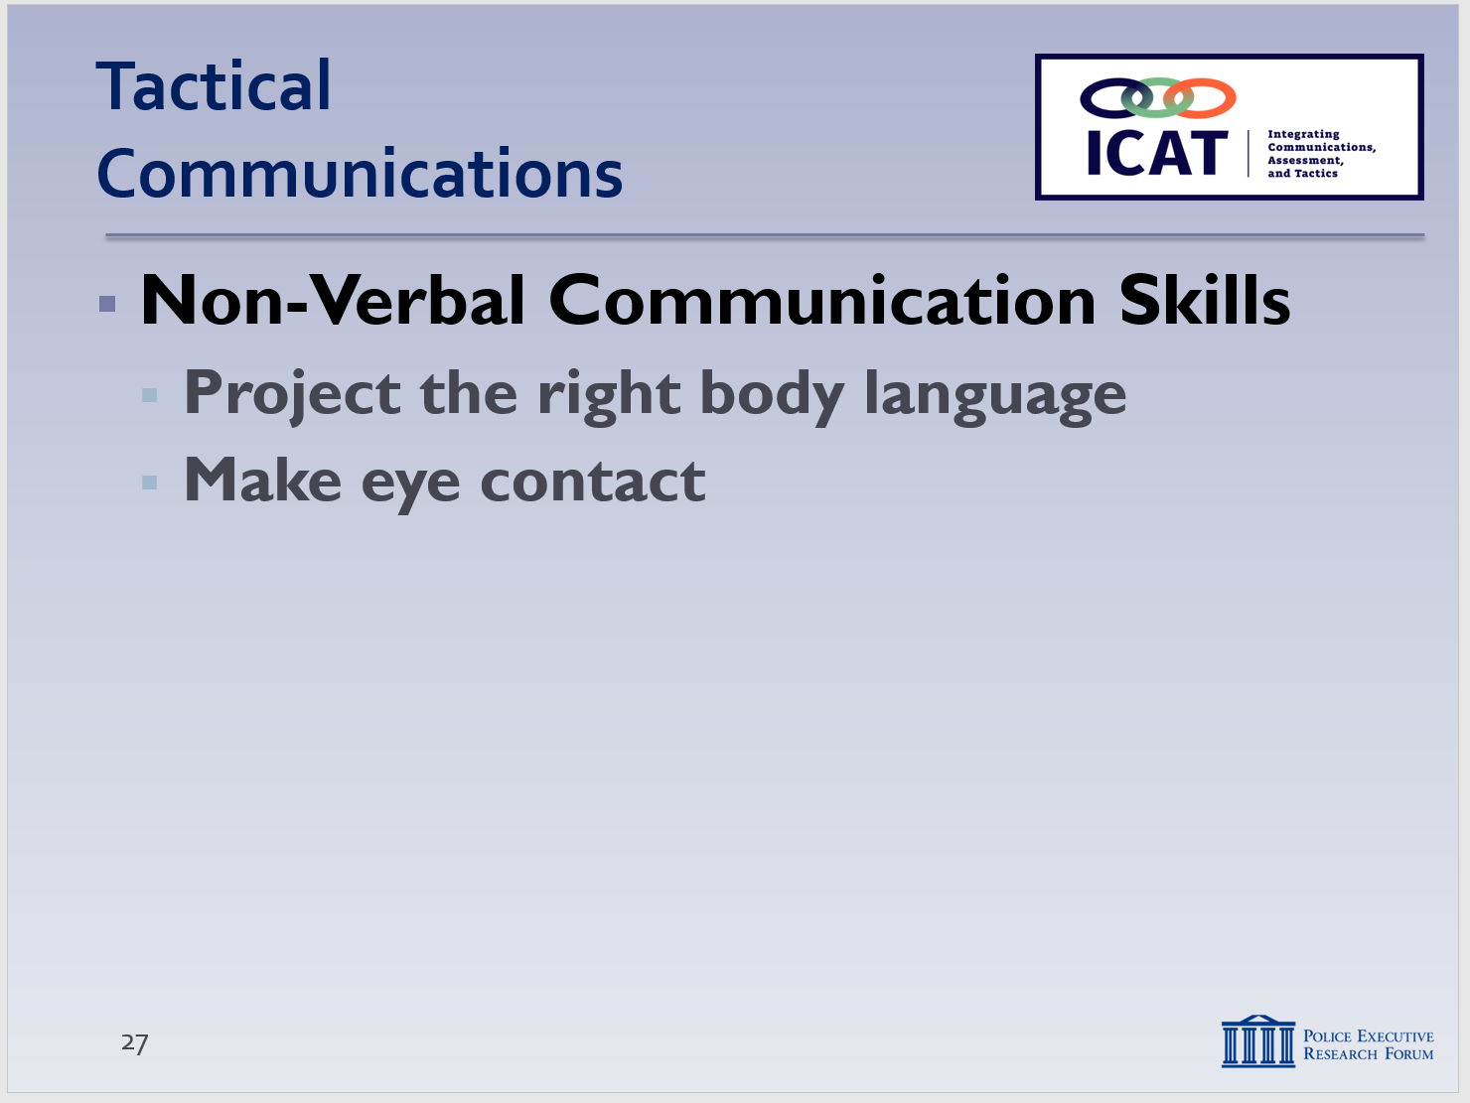
In Police Scotland, officers are trained to sometimes remove their hats so a subject can see the officers’ eyes more clearly.

For more cultural considerations, see http://www.brighthubeducation.com/social-studies-help/9626-learning-about-eye-contact-in-other-cultures/

SLIDE #29
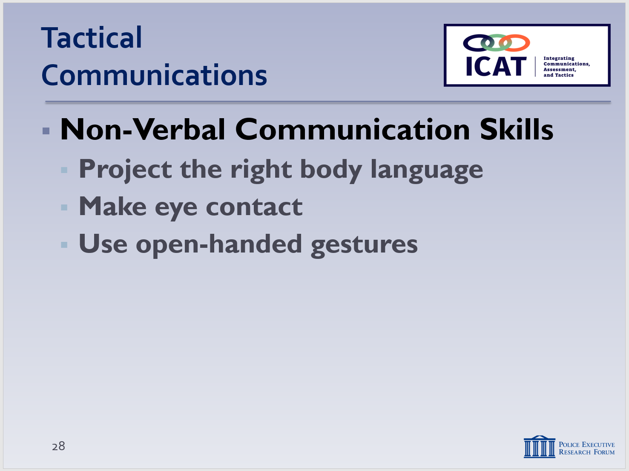

Demonstrate to the class what you mean by an open-handed gesture.

For more on hand gesture considerations, see
https://www.psychologytoday.com/blog/brain-wise/201209/your-hand-gestures-are-speaking-you

      - Maintain eye contact, even if the subject doesn’t
      - In some cultures, constant, direct eye contact is avoided – adjust accordingly
      - With some escalated persons, prolonged eye contact may be perceived as a challenge and won’t help in de-escalation attempts – again, adjust accordingly
  - Use open-handed gestures
    - Open hands communicate honesty and caring
    - Versus …
      - No hand gestures (indifferent)
      - Hands hidden (untrustworthy – plus subject may think you’re hiding something)
      - Hands clasped (nervous or tentative)
      - Arms folded (indifferent, aggressive)
    - Open hands in front of the body
      - A defensive (not offensive) posture
      - But provides for quick tactical response if needed
    - Complement hand gestures with head gestures too
      - Occasional nodding sends signal that you are listening and understand
  - Modulate your tone of voice
    - Using the exact same words but with different tones can create a sense of either comfort or aggravation
    - Match your tone to the needs of the situation – be calm and moderate, whenever possible
    - Recognize that some people can’t hear / clearly understand what you are saying (e.g., deaf/hard of hearing, some people suffering from mental illness)
Instructor Notes

SLIDE #30
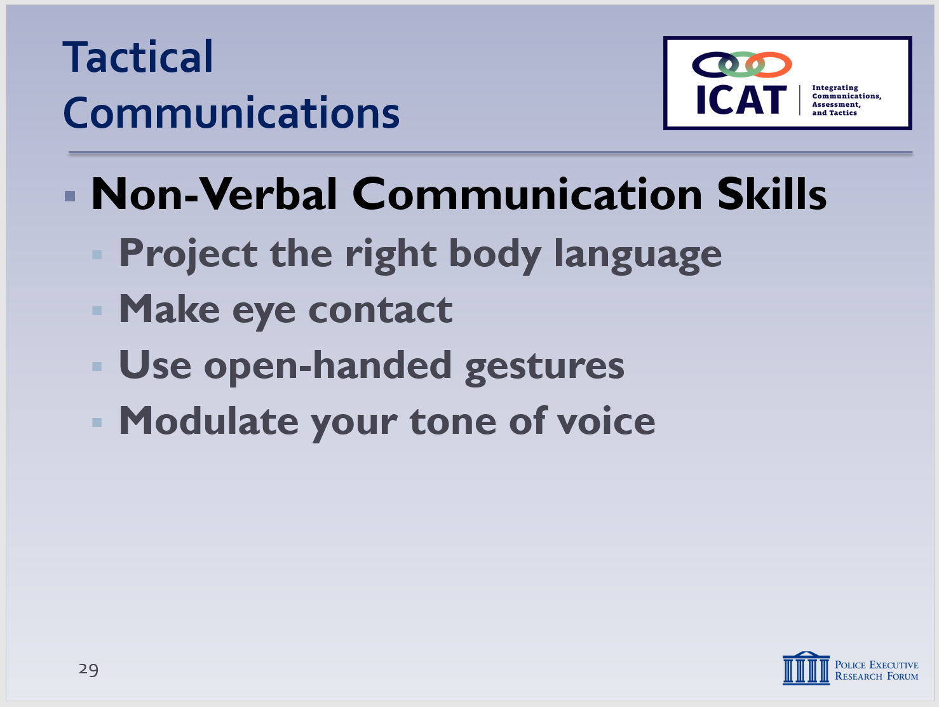

SLIDE #31
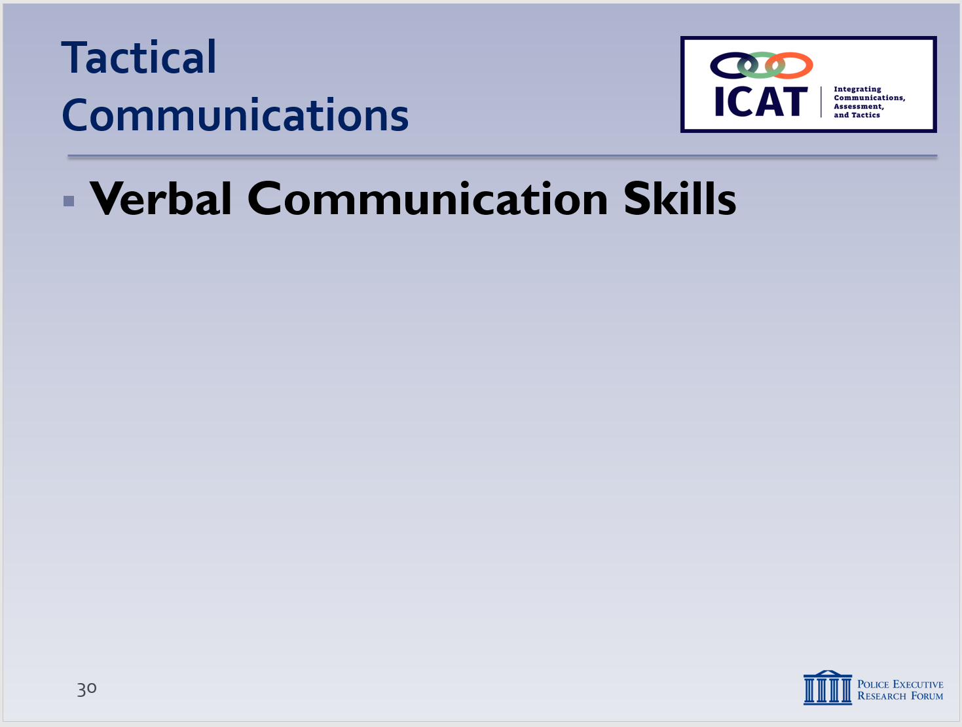

Many of these techniques are basic Negotiations 101. Hostage negotiators use them all the time. They can be easily and effectively applied to patrol officer encounters as well.

    - You can be both positive and assertive (“strong command voice”) without being aggressive
    - Don’t answer a raised voice by raising your own voice
      - Try to bring the subject down to your tone
      - Yelling/shouting sends signal that you’re out of control
    - Sometimes you may need to raise your voice to get a subject’s attention and gain compliance
      - If that doesn’t work, bring the tone down and try something else
      - Be flexible
      - No profanity

- Verbal Communication Skills
What you say is still important. This includes both the words you choose and the way in which you use them. Precise and professional verbal communication is especially important today. Many police interactions are video- and audio-taped by members of the public and posted online. Other interactions are captured on police body-worn cameras, with some eventually released to the public as well.
  - Use the team concept to communications
    - Develop a plan – decide roles ahead of time (whenever possible)
    - Only one officer speaks (“contact officer”)
      - Other officers provide cover, secure perimeter, other functions
      - If contact officer is having success, then stick with that
      - If communication is breaking down, then switch roles – be flexible
Instructor Notes

SLIDE #32
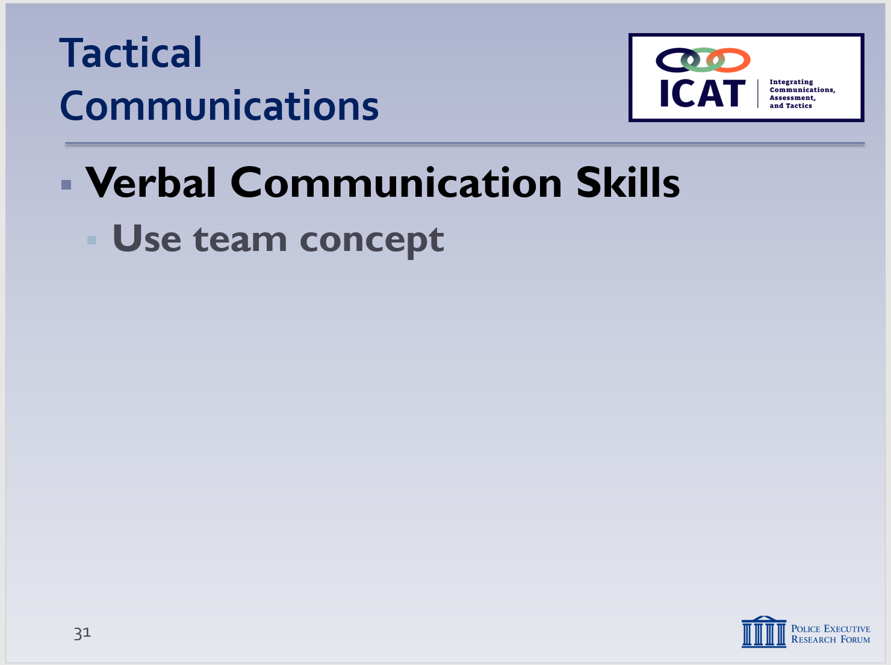

Teamwork – especially contact and cover roles -- is covered in greater detail in Module #5 – Operational Safety Tactics.

For example, you don’t want to have one officer saying, “Put your hands up,” with another officer saying “Get on the ground.” Confuses both the subject and officers.

SLIDE #33
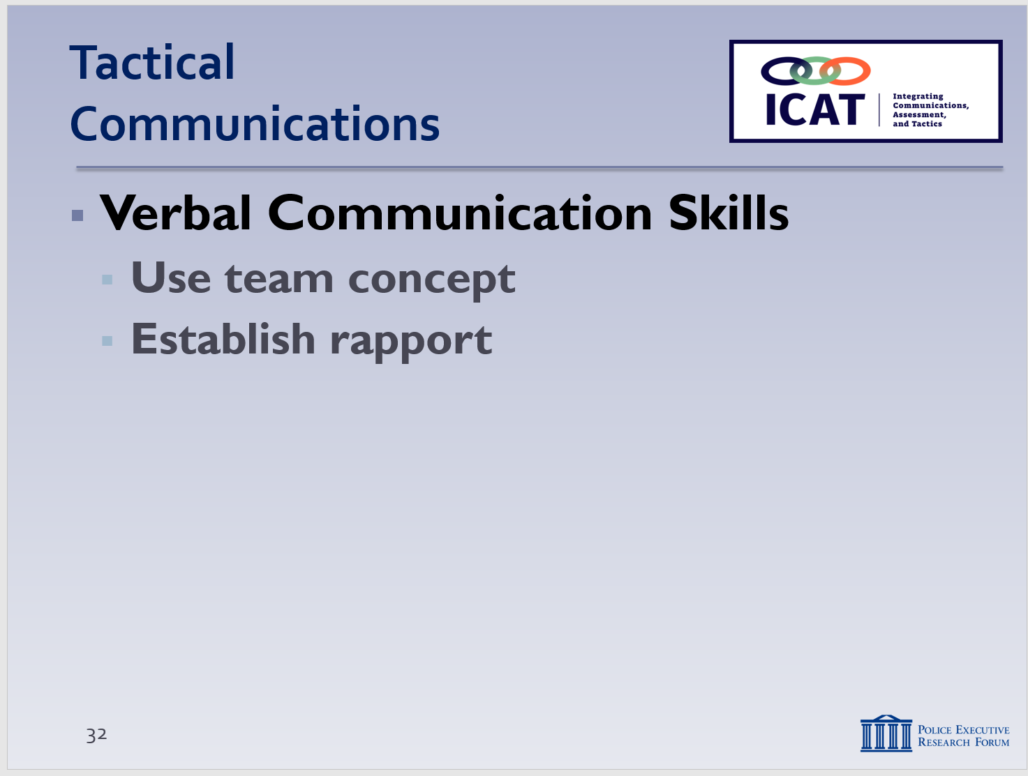

Think how you would introduce yourself at a social gathering.

Good negotiators have a strong sense of self and don’t take things personally. Remember: the subject is usually yelling at your uniform, not at you.

Sympathy is a feeling of care and concern for someone, accompanied by a wish to see him or her better off. Empathy is the ability to recognize and share the emotions of another person—to see someone else’s situation from his or her perspective and share those emotions. For a short video explaining the differences, see https://www.youtube.com/watch?v=1Evwgu369Jw.

Another way to look at this process is “Connect … then Direct.” As in, establish a connection, then direct the person toward stability and voluntary compliance.

      - If subject tries to talk with other officers, redirect him/her back to contact officer
      - Avoid having multiple officers talking, providing direction at the same time – this is confusing (especially for people with mental illness) and can be dangerous
    - Even with one contact officer, all officers need to be listening – gathering more information/intel
  - Use words to establish rapport, show empathy
    - You get only one chance at a first impression – it can set the tone/trajectory for the entire incident
    - Introduce yourself – get (and use) the subject’s name
    - Use vernacular of the subject – speak on his/her terms
    - Be patient and tolerant – let people work through their range of emotions
    - Always be truthful
      - Never get caught in a lie – you might not recover
      - It’s better to say “I’m not sure” and go to something positive – “What I do know is I am here to help you”
    - Don’t make promises you can’t keep
    - Show empathy (not the same as sympathy or agreement)
      - Imagine it were a loved one in the subject’s shoes
      - Try to find out more about the person – interests, “hooks”
  - Ask open-ended questions
    - A key element of active listening is asking the right questions
Instructor Notes

SLIDE #34
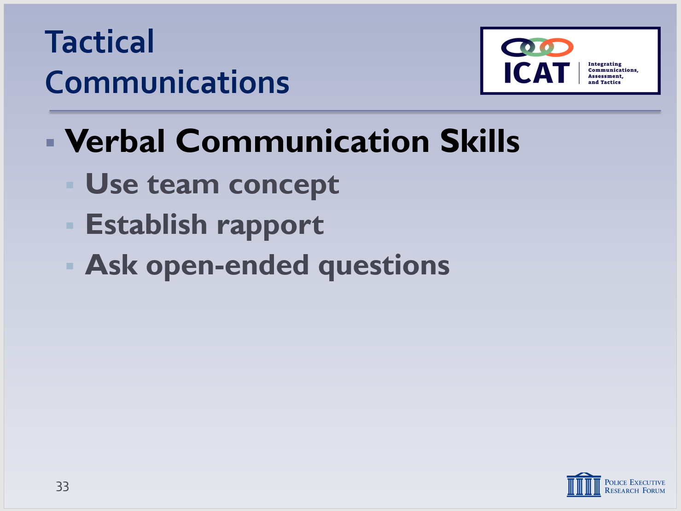

The New York City Police Department emphasizes active listening through an approach called PRIME SOS:

Paraphrase
Reflect/mirror
"I" message
Minimal encourager
Emotional labeling

Summarize
Open-ended questions
Silence

The Seattle Police Department uses a similar approach called MorePies:

Minimal encouragers
Open-ended questions Reflecting/mirroring
Emotional labeling
Paraphrasing
“I” Statements
Effective pauses
Summarizing

    - Especially “what” … “how” … and “why” questions
    - These questions generate discussion – provide you with more information
      - What happened? Can you tell me ….?
      - How are you feeling? (Not, “How are you doing?”)
      - How can I help you? (Not “Calm down, relax!”)
      - Why are you holding a knife?
    - Minimize the use of “closed” (yes-no) questions – they’re not as effective as open-ended questions in getting someone to talk
    - Exception: you’re trying to elicit a specific piece of information
      - What is your name?
      - Are you supposed to be taking medication?
      - Are you currently taking your medication?
    - Encourage conversation, without dominating/ steering it
      - Remember the 80-20 principle
      - Follow up questions with acknowledgments, encouragers, clarifications, empathetic responses
    - If you don’t understand the subject’s response, ask more questions to clarify
      - “I hear you saying _____. Is that correct?”
  - Provide clear, single questions or commands
    - Keep it simple – a person in crisis may not be able to handle multiple questions or complex requests
    - If you give multiple commands, subject may hear and respond to only the last one
Instructor Notes

SLIDE #35
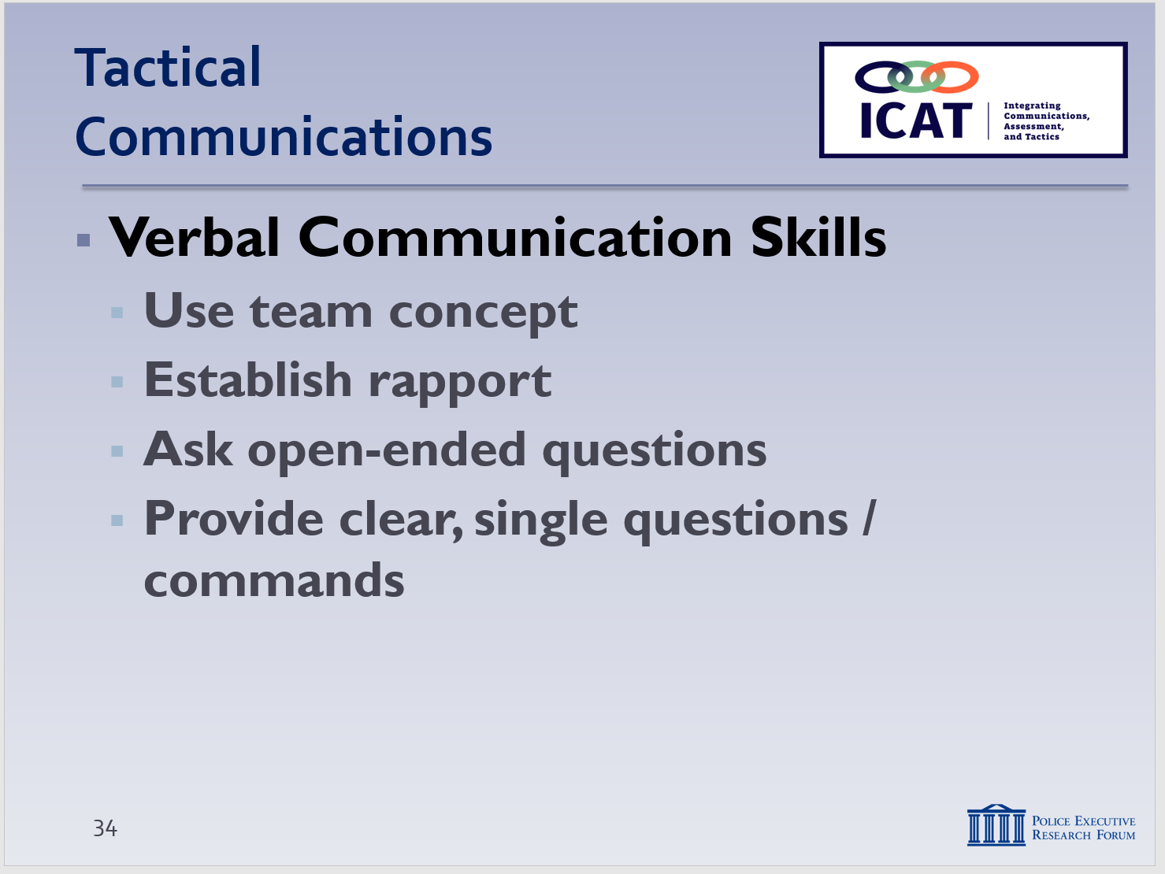

Whenever possible, explain both “what” you’re doing and “why” you’re doing it. (Dr. George Thomson: People have a desire to know why)

SLIDE #36
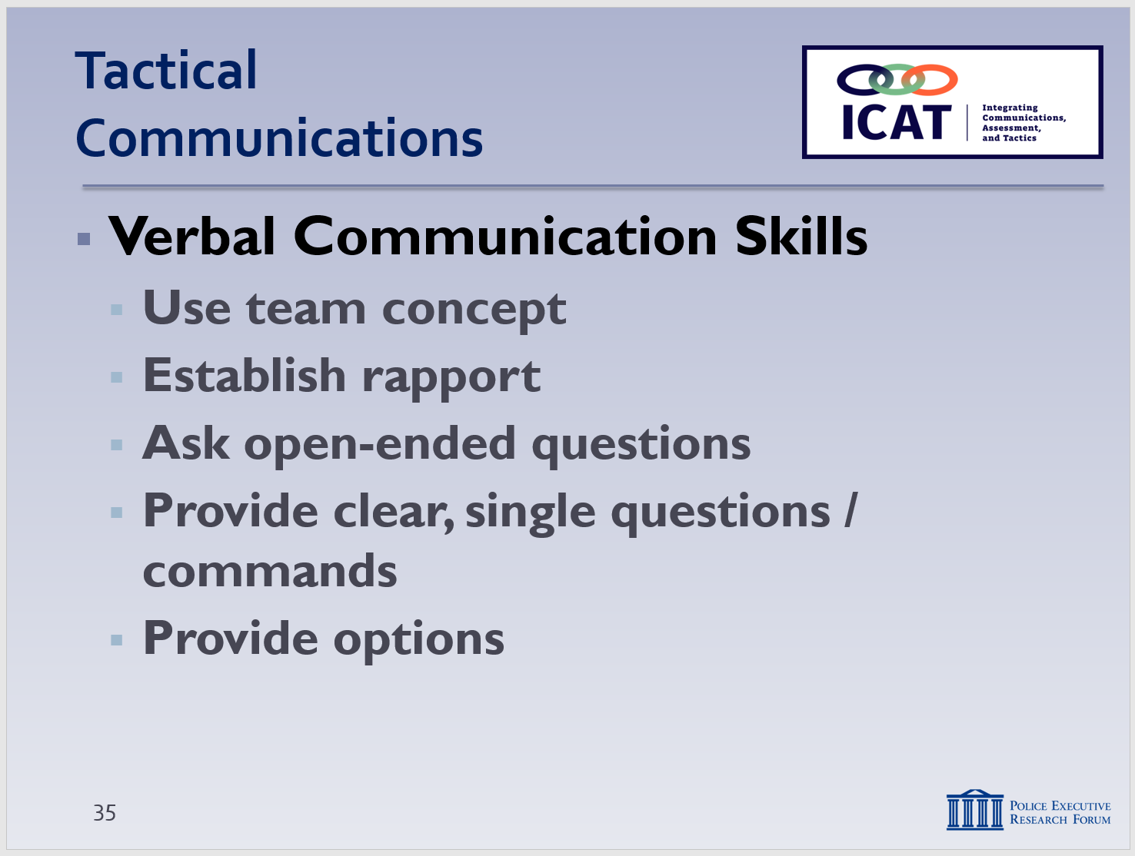

      - “Take your hands out of your pockets … and move away from the vehicle”
      - Subject may do only the latter, creating a safety risk
    - Expect to have to repeat questions or commands
    - Explain your actions whenever possible – the “why”
      - “I’m opening the door so I can make sure you’re safe”
      - “I’m handcuffing you because I want to make sure everyone is safe”
  - Provide options
    - Don’t talk yourself into a corner or give ultimatums
      - “Drop the knife or I’ll shoot”
      - Ultimatums can be particularly counterproductive in “suicide-by-cop” situations
    - Don’t turn a dialogue into a debate
      - Especially if someone is delusional, don’t argue with or debate their reality
    - Offer reassurance
      - “No one is going to hurt you”
    - Make it personal
      - “I’m going to make sure you’re safe”
    - Allow the subject to save face
      - Give them options to resolve a situation
      - If possible, make it seem as if the resolution was their idea
      - “If you leave the store now, we won’t arrest you”

- Learning Activity–4 (Video Case Study)
Instructor Notes

SLIDE #37
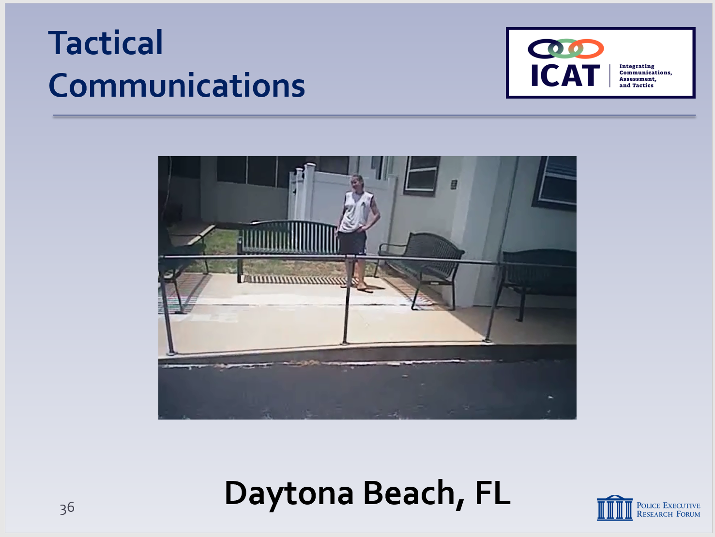

Video available at https://www.youtube.com/watch?v=MzbVm9UdSFg

Note

This exercise is to illustrate how a team of officers used some of the tips and techniques that are covered in this module to respond to a person in crisis.

  - A few reminders:
  - Set up the video ahead of time; provide background and context.
  - Remind students that the video is not “perfect;” the purpose is not to judge or second-guess the officers’ actions or render a grade. Rather the video illustrates the real-world challenges officers face. The purpose is to generate discussion on how these challenges can be handled as safely and effectively as possible. We are not suggesting this was the only possible course of action in this case.
  - Start and stop the video at the indicated times, then discuss with the students. Ask them open-ended questions about what they are seeing. If needed, the Training Guide provides some suggested discussion points. Try to tie the discussion back to the learning points in this Module.

  - Set up the video
    - Daytona Beach, FL
    - May 2016
    - Report of a suspicious woman pacing outside a mental health facility holding a knife
    - Multiple officers respond
  - Start the video
    - Stop at 2:35 and discuss
      - Initiated communications from a distance – that didn’t work so they moved closer
      - Coordinated/communicated with other civilians, officers
Instructor Notes

      - Assessed threat and approached slowly
      - When he got close, what is the first thing he did? … Called her by her name and introduced himself (as “Ricky,” not as “Officer ….”)
    - Restart … Stop at 8:10 and discuss
- Officers asked (mostly open-ended) questions …
To initiative conversation (“Want to talk to us?”)
To elicit information (“Thinking about hurting yourself?” “What’s your diagnosis?” “And medications?”)
- Provided options
“Put down the knife, and we can talk – get you help”
“I can make these other guys go away. We can have a conversation and make you feel better.”
- Offered reassurance and respect
“We’re here to help you”
“Please”
- Officer went on radio to try to get more information about the subject
Got correct spelling of her name
Directed other resources
- Two officers were talking
A problem here?
Better to have just one officer talking?
- Sergeant moved to railing
Trying to make a connection
Easier to hear her
    - Restart … Stop at 12:45 and discuss
      - More open-ended questions
“Where are you from?”
What’s your intention with the knife? Want to hurt anyone else?
Have you felt this way before? Any issues you’re dealing with?
      - Identified and tried to use “hooks”
New York Yankee tattoo – asked about the team
Cigarettes – attempted to make a trade
Instructor Notes

SLIDE #38
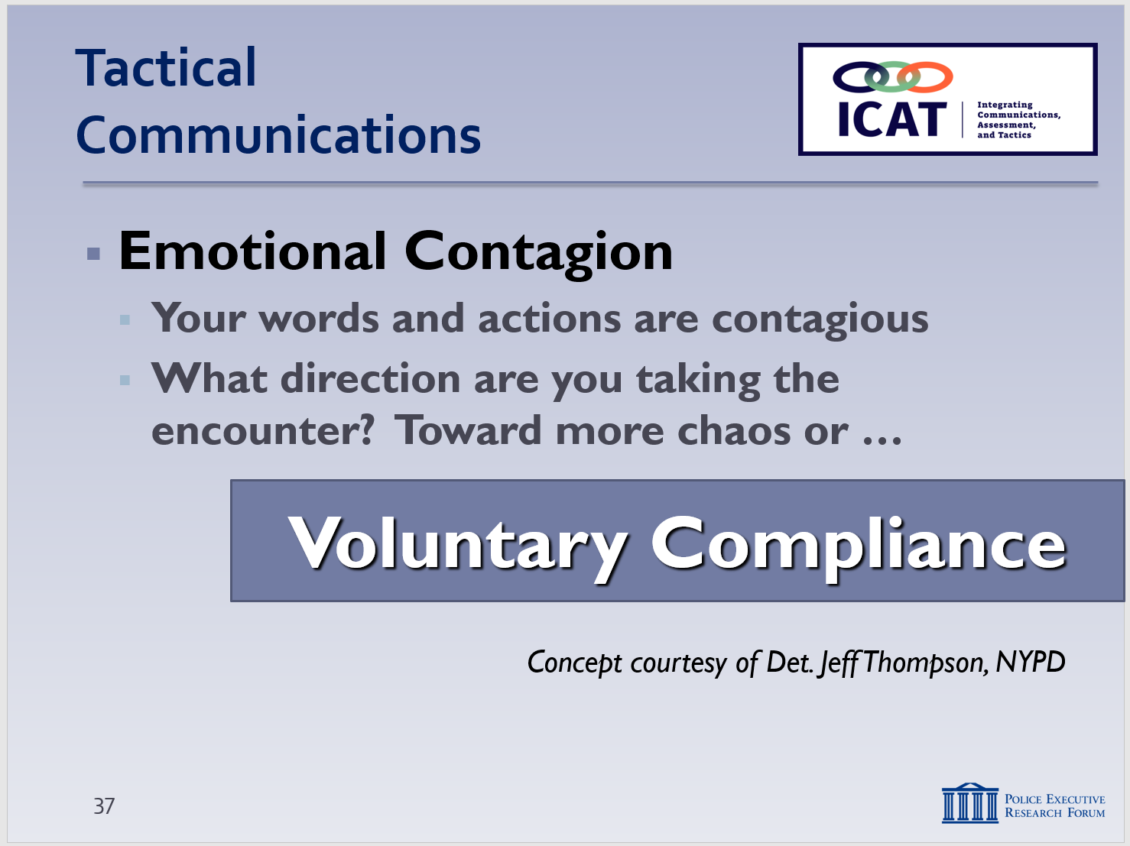
Courtesy of Detective Jeff Thompson, NYPD

Respect breeds respect. Anger and aggression breed anger and aggression

      - Not forcing the action
“Take your time to work up to it”
Comfortable with silence
Not sending any signals that you need to wrap this up quickly
    - Restart … Stop at 13:05 and discuss
      - Even when you do everything pretty well, you can’t always get voluntary compliance
She moved toward building – cover officer used less-lethal (Electronic Control Weapon)
Sustained serious injury – went into seizure
Officers rendered first aid and revived her
    - Any final thoughts or comments?
      - Anything you might have tried to get Karen to comply voluntarily?
      - How was officers’ “emotional contagion?”
They stayed cool – so did the subject
- Verbal Communication Skills (continued)
  - Emotional contagion
    - Your words and actions are contagious
    - What direction are you taking the encounter? – Toward more chaos? Or toward voluntary compliance and a peaceful resolution?
Instructor Notes

SLIDE #39
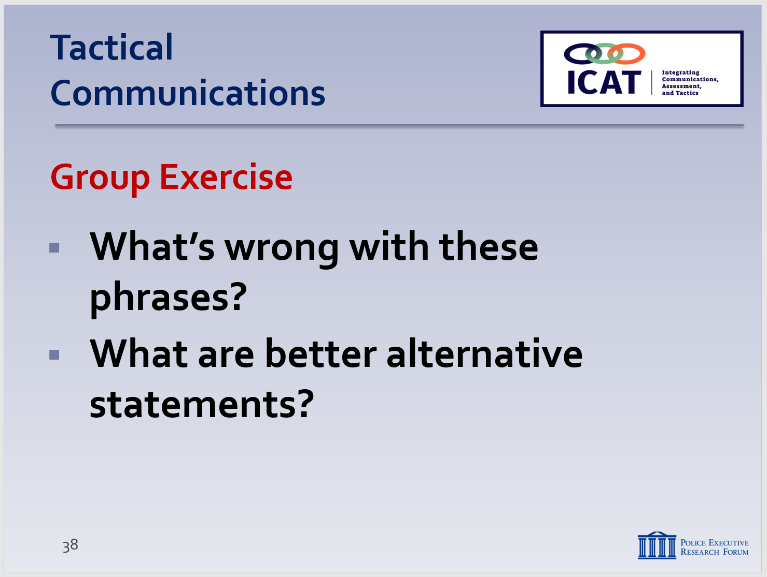

This exercise is based on “anti-peace phrases” developed by Dr. George Thompson and the Verbal Judo Institute.
    - If you’re displaying fear, anger, frustration, or aggression – through your words, voice tone and body language … those emotions will “leak out” and become contagious
    - If you’re displaying calm, control, empathy, and patience … those emotions will become contagious to everyone, including the subject
    - Remember: you are the person in control here – exercise that control with your actions and words
- Learning Activity–5 (Communications Exercise)
Activity: Class Exercise
Activity Time: 15 minutes
Activity Learning Objective: To identify and use alternative and more productive ways of saying some common phrases police may be inclined to use during a critical incident.
Required Equipment: Easel pads, markers
Facilitator Instruction: As a class, go through the following phrases (or other phrases you may have) and come up with alternatives that are more effective in trying to establish a dialogue, create stability, and gain voluntary compliance from a subject in crisis. Instructor should write each phrase at the top of a sheet of easel paper. Ask students to write down alternatives on a sheet of people at their places. Ask for volunteers to state what’s wrong with the original phrase and to offer an alternative. Write the students’ suggestions on the easel pad. Some alternatives are suggested here.
This exercise should be done at a fairly rapid pace: spend no more than a few minutes on each phrase. Get students engaged. Facilitators should be demonstrative in stating each initial phrase and calmer in repeating back the alternatives. In addition to the words themselves, voice modulation is an important part of this exercise.
Instructor Notes

Note: These are build slides. The Phrase will appear first. Click for the response alternatives once the class provides its ideas.

SLIDE #40
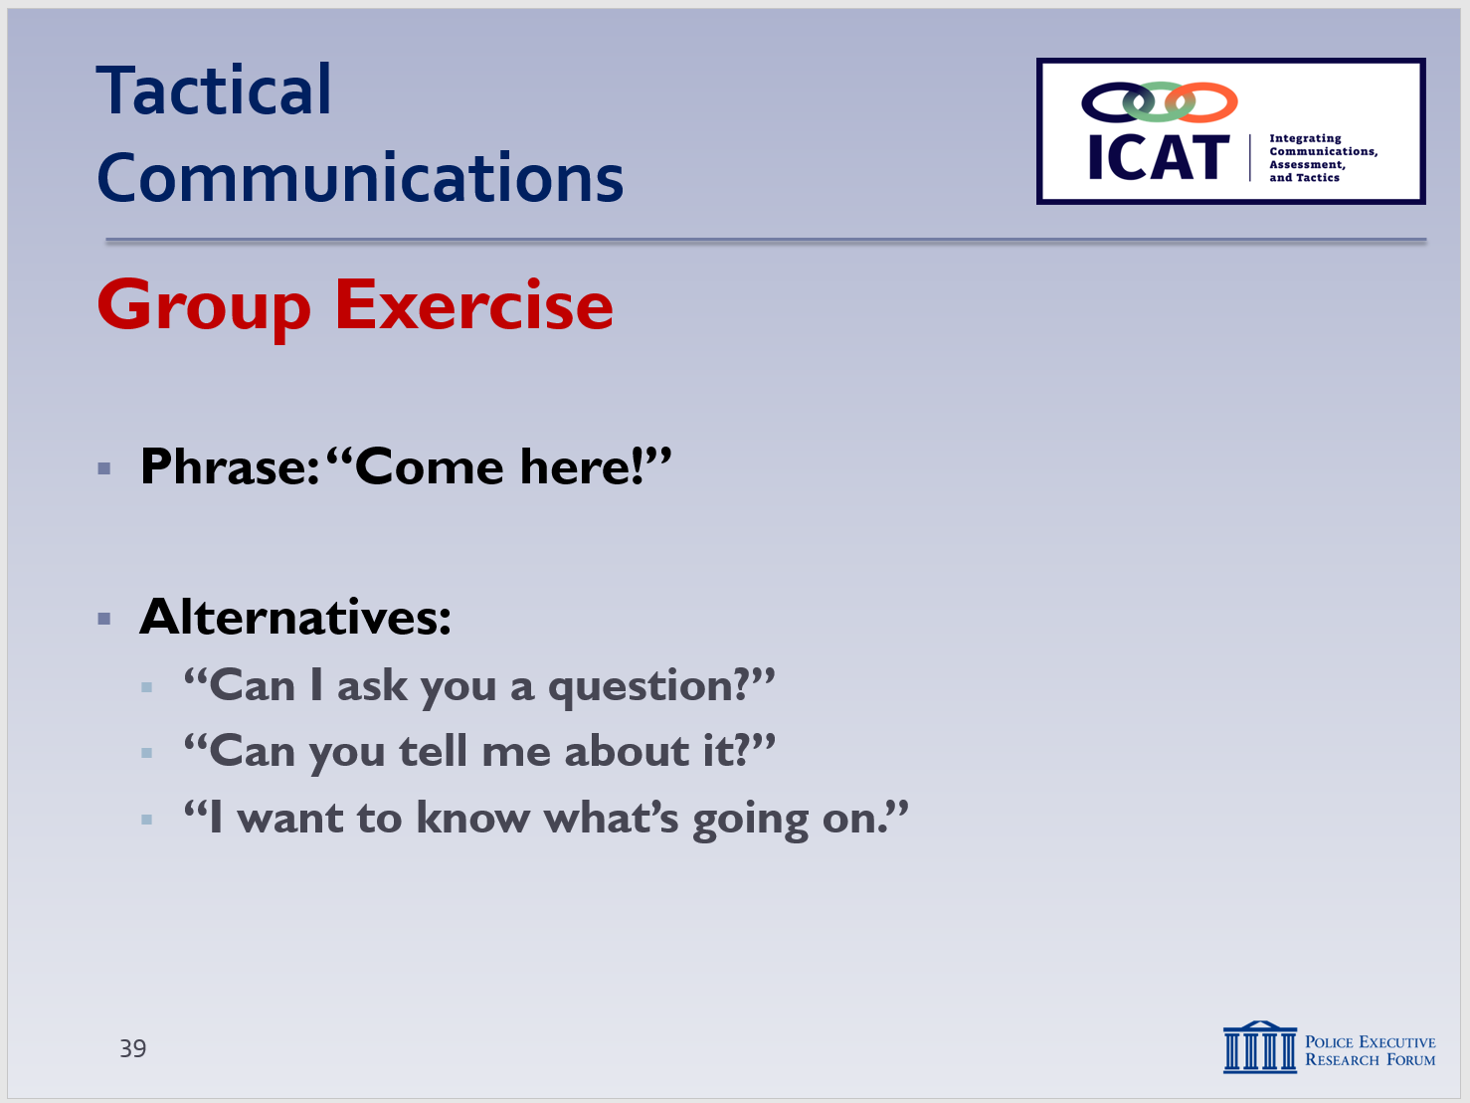

SLIDE #41
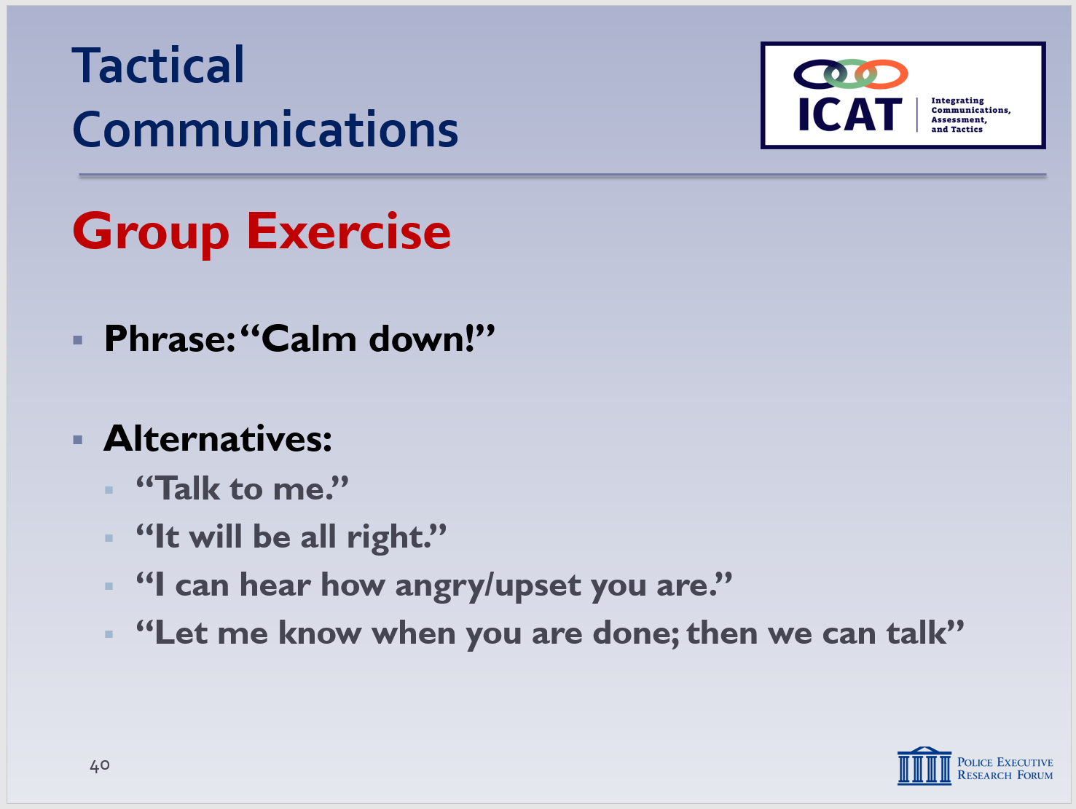

SLIDE #42
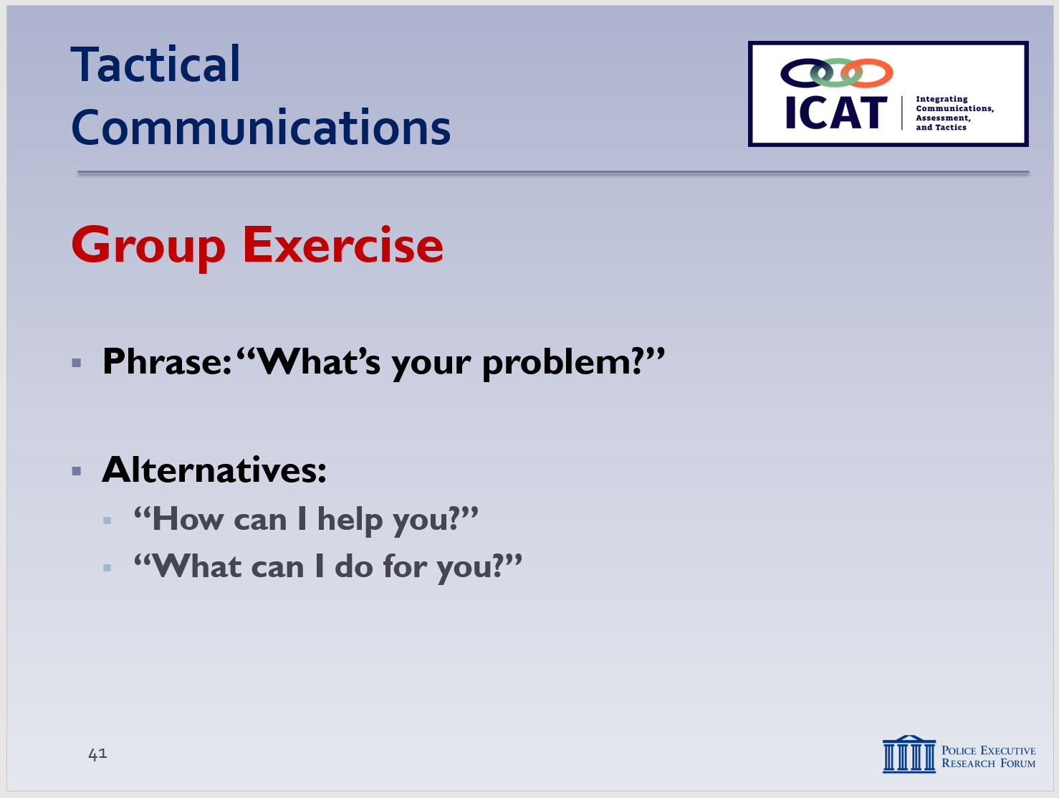

SLIDE #43
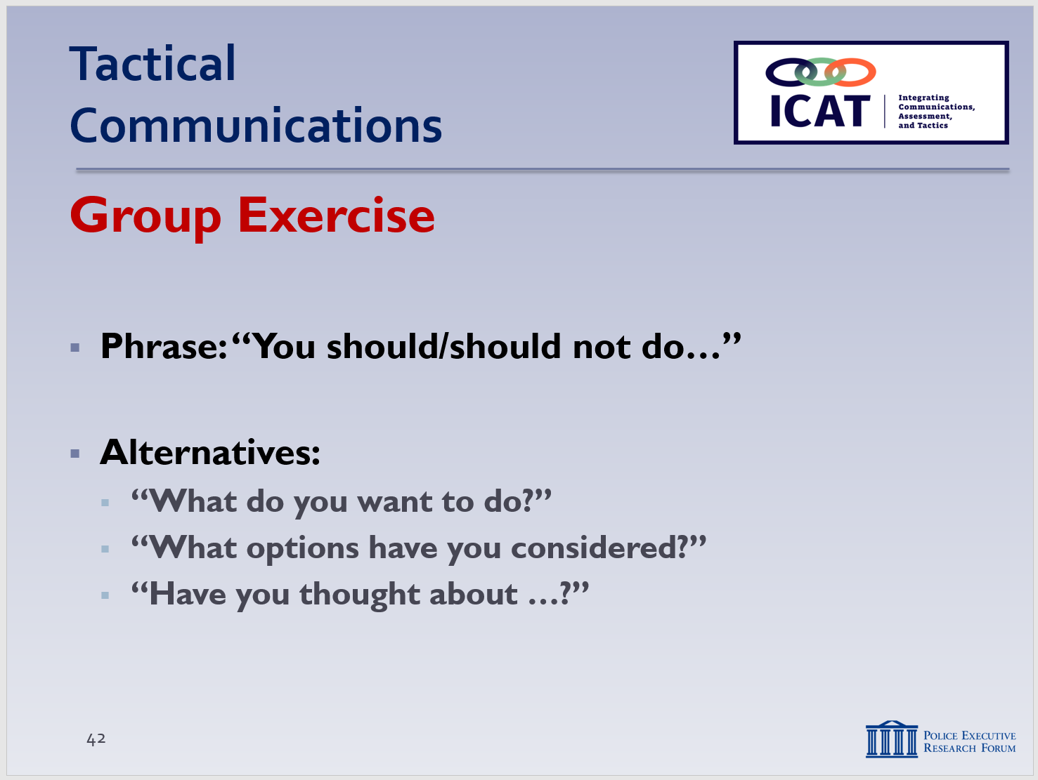

SLIDE #44
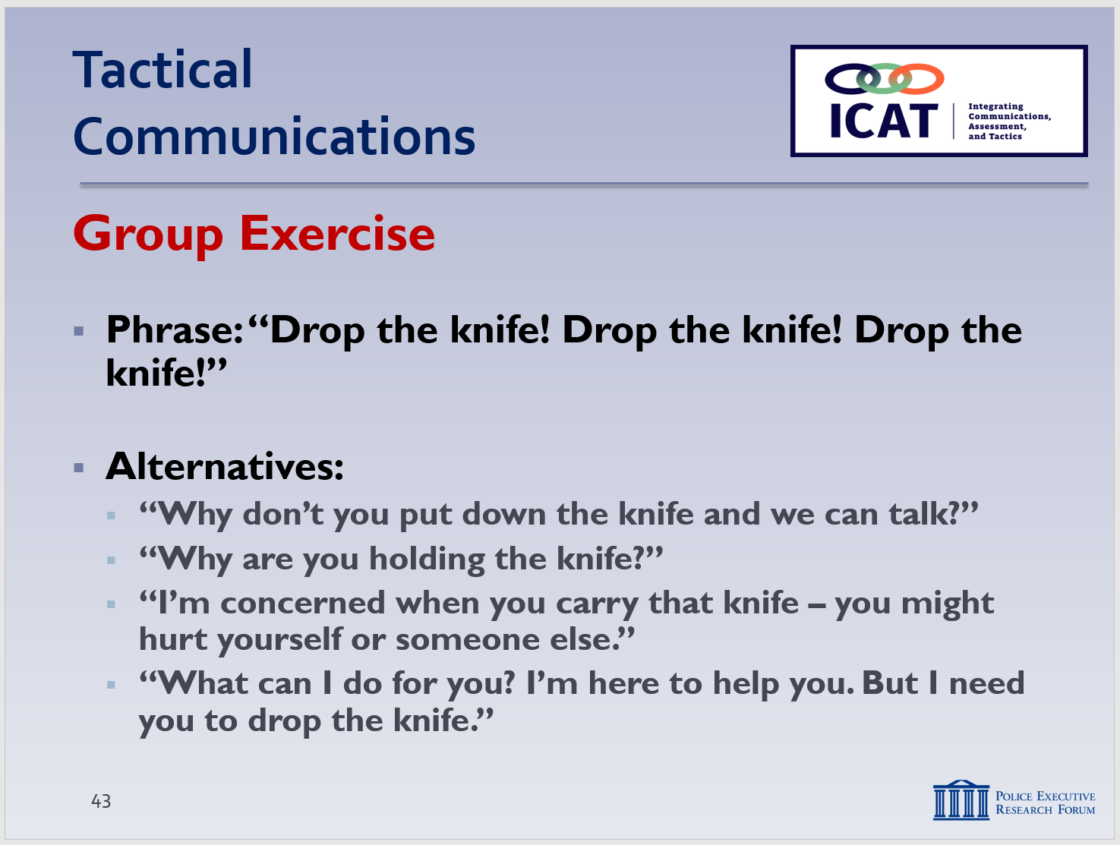

SLIDE #45
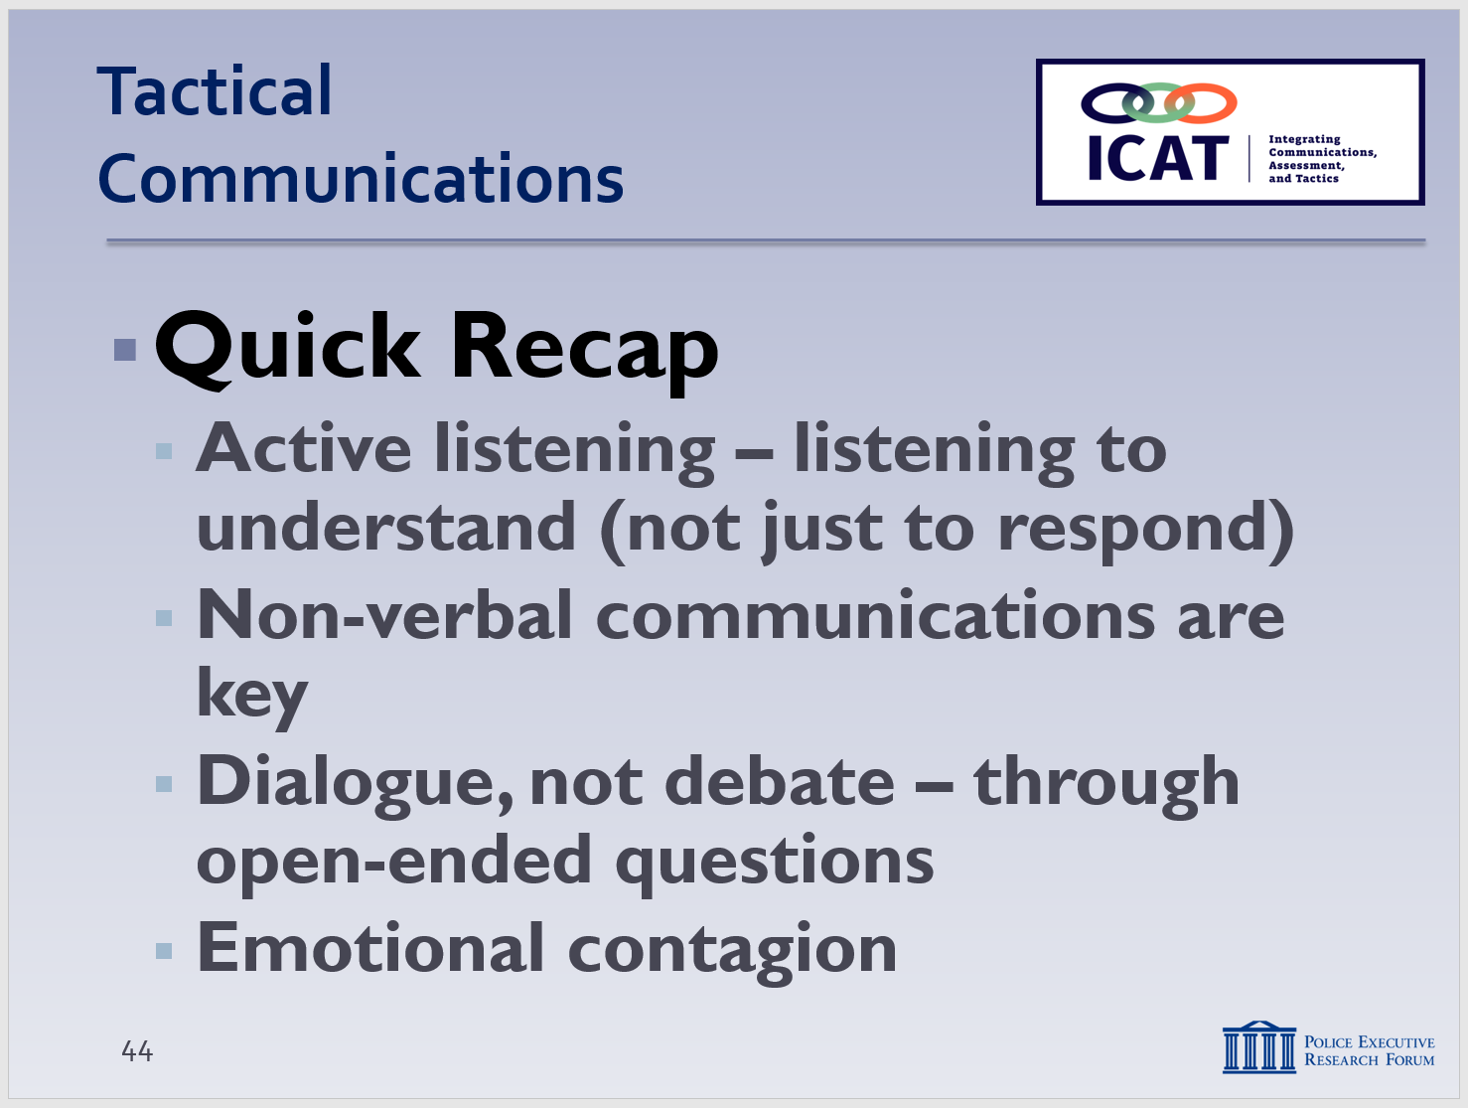
  - Phrase: “Come here!” (threatening)
    - Alternatives: “Let’s talk.” “Can we talk about it?” “I want to know what’s going on.”
  - Phrase: “Calm down!” (critical of others’ behavior)
    - Alternatives: “Talk to me.” “It will be all right.” “I can hear how angry / upset you are.”
  - Phrase: “What’s your problem?” (adversarial)
    - Alternatives: “How can I help?” “What can I do for you?”
  - Phrase: “You should / should not do ….” (judgmental)
    - Alternatives: “What do you want to do?” “What options have you considered?”
  - Phrase: “Drop the knife! Drop the knife! Drop the f***ing knife!”
(Verbalizing the presence of a knife is important to alert other officers/witnesses to the possible threat, but if this command doesn’t work after 3 or 4 times, you probably need to pivot)
    - Alternatives: “Why don’t you put down the knife and we can talk.”
“Why are you holding that knife?”
“Are you planning to hurt someone with that knife?”
“I’m concerned when you carry that knife – you might hurt yourself or someone else.”
(“I-when-because” phrases)
“What can I do for you? I’m here to help you.”

- Recap and Discussion
  - Quick Recap
    - Active listening – listening to understand, not just respond (80-20 principle)
    - Non-verbal communications may take precedence over your words – watch your posture, hands, tone of voice
    - Try to have a dialogue, not a debate
    - How? By asking open-ended questions, providing options, active listening
    - “Emotional contagion” – you should be the person in control – try to make your actions and words contagious
Instructor Notes

SLIDE #46
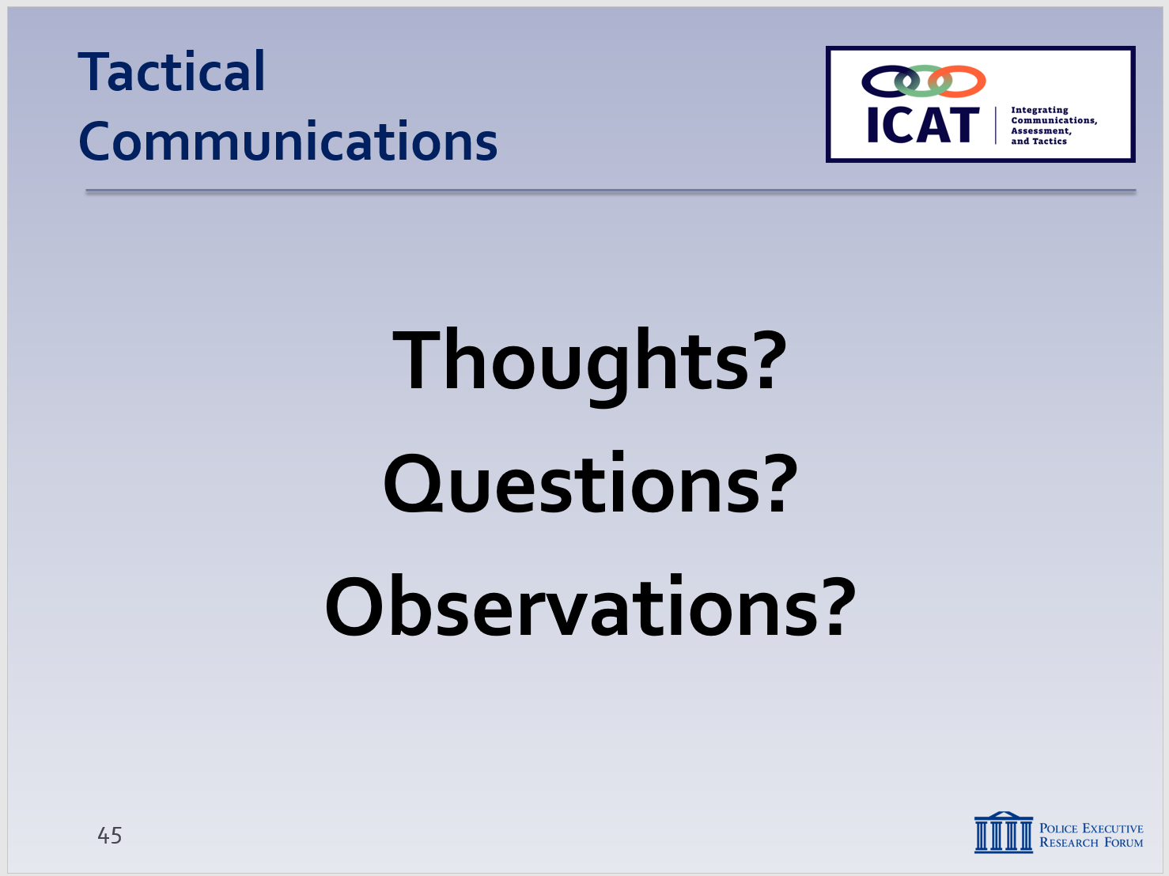

One option is to go back to the information collected in Learning Activity–1 and ask the class if they have any different thoughts on what a good police communicator looks like.

  - Any final lessons learned from the module? (can record on easel pad)
  - Ask each student to identify one new thing he or she learned
  - Or, one skill set he or she plans to focus on in the future
    - Review any specific agency policy considerations not previously discussed (as appropriate)
    - Distribute class evaluations of the module (if appropriate)

