Title: Training Guide Introduction
Recommended Time: 1 hour
Primary Audience: Patrol Officers
Module Goal: Through classroom instruction and discussion, introduce the training modules included in the ICAT Training Guide.
Required Materials: Digital presentation (Power Point, video); lesson plan
Learning Objectives: At the completion of this module, students will be able to:
  - Describe why this training is important and needed.
  - Describe the key elements and focus of the ICAT Training Guide.
  - Articulate how ICAT is designed to make the job of patrol officers safer and more effective when responding to many critical incidents, in particular those involving subjects in a behavioral crisis who are acting erratically and who are either unarmed or armed with a weapon other than a firearm.

Recommended Time Allocation
 | Unit | Recommended Time  (minutes)
1 | Introduction and welcome | 10
2 | Why this training? | 30
3 | What the training covers | 20
4 | Learning Activity (Optional Video)* | 20
Total |  | 60-80*

Table of Contents

- Introduction and welcome 3
- Why this training? 4
- What the training covers 10
- Learning Activity - (Optional Video) 13

- Introduction and Welcome
Slides & Notes

SLIDE #1
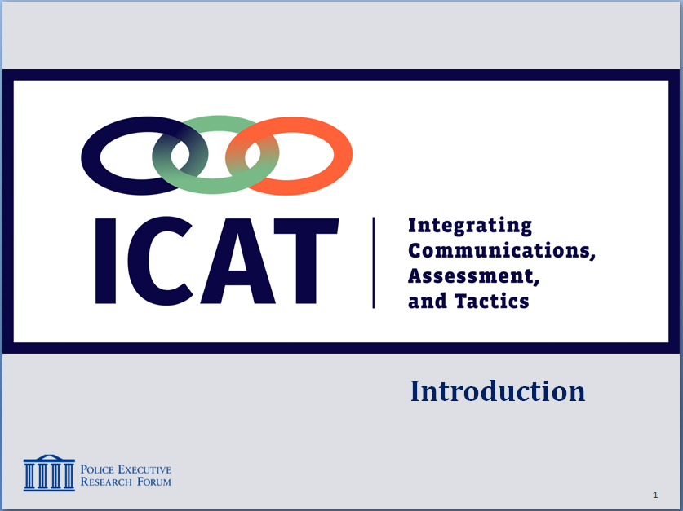

SLIDE #2
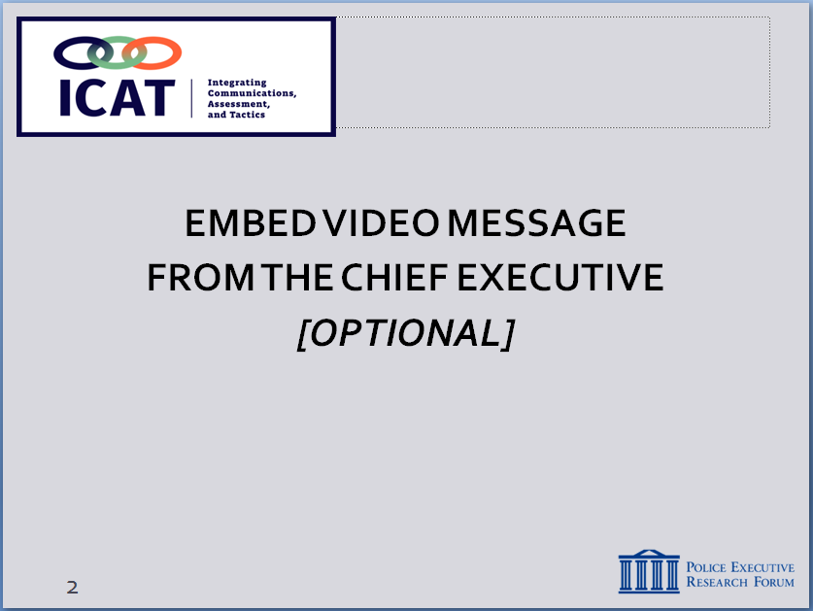

The chief’s message could touch on the ethical foundation of police work, why it’s important to confront difficult issues and how this training can help. For a sample video message, see https://www.youtube.com/watch?v=nEnp6y0iU6E&feature=youtu.be.

Recommendation

One way to open this Module is to engage the class in a brief, facilitated discussion on the big-picture issues confronting policing today. This can break the ice and get people talking about the difficult issues facing police today. Here is a possible example.
  - Welcome students – lead a facilitated discussion
    - What is the biggest issue facing law enforcement today? What are we getting the most criticism about?
      - Use of force
      - Breakdown of police-community trust
    - Is that criticism fair?
      - In some cases, yes. But in others, probably not.
      - There is a “new normal” – a controversial incident in one jurisdiction can affect all of law enforcement
    - As a profession, can we do some things differently? Should we strive to do better?
    - That’s the backdrop for this training
      - Confronting difficult issues facing law enforcement
      - Exploring options on how to make your job safer and more effective
  - Go over ground-rules
    - Discussion and participation … this is “hands-on” training – in the classroom and in scenarios
    - Be open-minded to new concepts
    - Be respectful of one another and others’ ideas

Recommendation

To demonstrate executive-level support for ICAT, it is recommended that the agency chief executive (or high-ranking official) deliver a welcome message, either in person or via video.
  - Welcome message from the chief [OPTIONAL]

- Why this training?
Instructor Notes

SLIDE #3
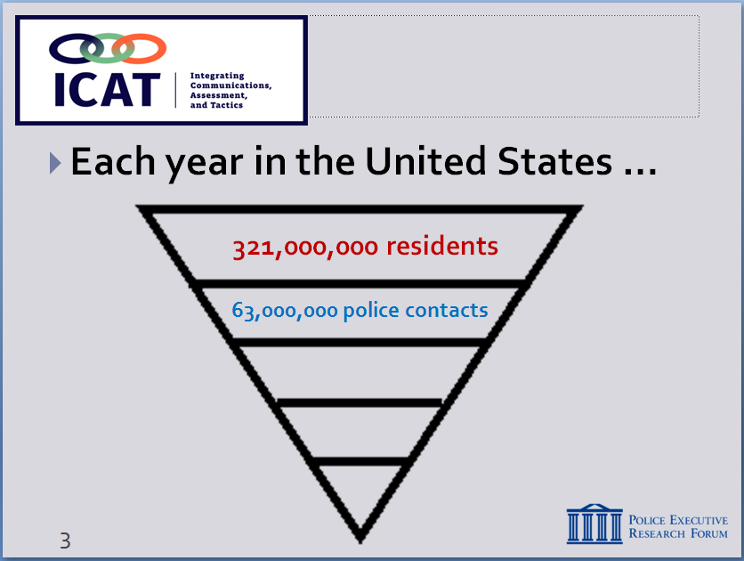

Population and police contact statistics come from the 2018 Bureau of Justice Statistics report: Contacts Between Police and the Public, 2015. https://www.bjs.gov/content/pub/pdf/cpp15.pdf

SLIDE #4
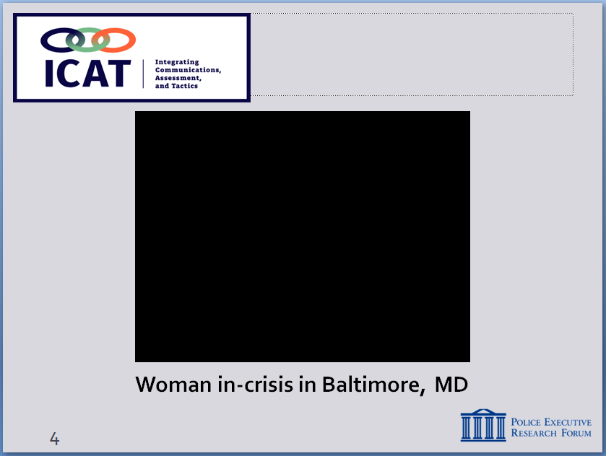
Video also available at:
Need to post link

  - First, it’s important to put these issues in some context
    - Approximately 253.5 million people in the U.S. age 16 or older.
    - Each year, about 53.5 million face-to-face contacts with the police – nearly half are traffic stops
    - Because most of these contacts with the public are “routine,” cops can become complacent. We tend revert back to the solutions that have worked for us in the past.
      - This training is important because not all contacts are “routine.” There are other, more complicated encounters, which require officers to identify critical incidents and use their communication and tactical skills to safely solve the problem.
      - Oftentimes, the best tools that we have are our ears and our mouth. They’re not on our belt.
      - ICAT is intended to highlight those strategies and solutions for when critical encounters require more than just reverting back to what has helped us get by in the past.
    - Let’s take a quick look at one such encounter

Recommendation
- Two reminders prior to showing this and other videos:
- Set up the video; provide some background information and context about the location, call for service, etc.
- Remind students that the videos are not meant to be “good” and “bad” examples; the purpose is not to judge or second-guess the officers’ actions or render a grade. Rather the videos illustrate the real-world challenges officers face. The purpose is to generate discussion on how these challenges might be handled as safely and effectively as possible.
- In every video, there will be elements or actions that students will have problems with. That’s fine; none of the videos is “perfect.” Ask students to focus on the “teaching moments” or “lessons learned” based on the Training Guide.

  - Baltimore, MD video
Instructor Notes

    - For context, the video that we’re about to show you happened in 2017. We all know what happened in Baltimore with the riots after the Freddie Gray incident. However, the Baltimore Police Department had not conducted scenario-based training in 5 years because of a live-fire accident. Baltimore started doing ICAT training over a year ago and began scenario-based training again. Members of the Baltimore Police Department say that the outcome of this encounter, shown in the body-worn camera video, never would have happened 3-4 years ago. It likely would have ended very differently.
    - March 28, 2017 - Daytime
    - Officers and EMS workers respond to a scene where children report their mentally ill mother threatened to stab them and is currently cutting herself with a knife in her kitchen
    - Show video
    - Lead a brief discussion: possible questions ….
      - Do we see enough videos like this on the news?
      - Is that representative of many of the 53.5 million contacts officers have with citizens each year?
      - Caring … compassionate … protecting life
      - Solid communications skills, tactics, teamwork (we’ll touch on those throughout this training)
      - That’s what much of policing in the U.S. is all about – important to remember that
Instructor Notes

SLIDE #5
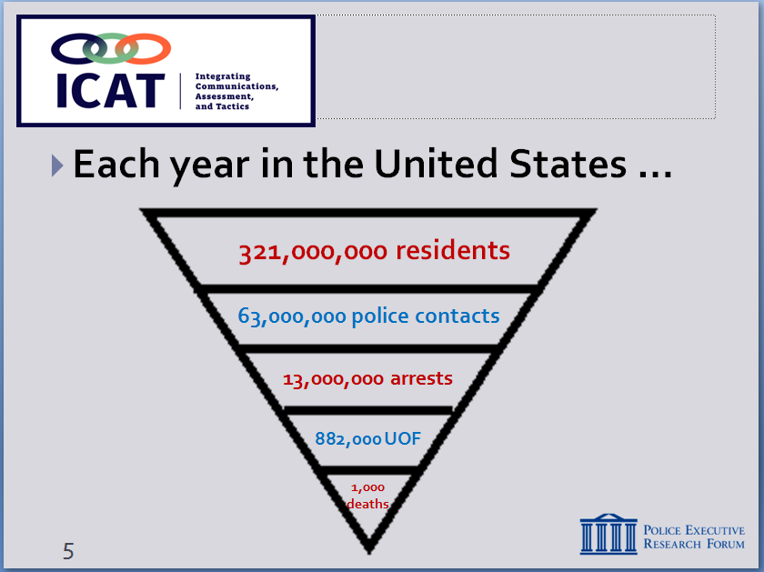

Arrest numbers come from the FBI 2016 UCR: https://ucr.fbi.gov/crime-in-the-u.s/2016/crime-in-the-u.s.-2016/topic-pages/persons-arrested

Use-of-force figures come from a 2018 BJS study:
https://www.bjs.gov/content/pub/pdf/cpp15.pdf

Fatal Use-of-force figures come from a database of fatal officer-involved shootings maintained by the Washington Post. For details see https://www.washingtonpost.com/graphics/national/police-shootings-2017/

Because the federal government has just begun collecting comprehensive use-of-force data (that begins in 2017), we have to rely on open-source information collected by the news media.

For additional info: “Police Use of Force is Rare, as are Significant Injuries to Suspects (2018) http://www.wakehealth.edu/News-Releases/2018/Study_Police_Use_of_Force_is_Rare,_as_are_Significant_Injuries_to_Suspects.htm

Additional background on the incident: http://www.stltoday.com/news/local/crime-and-courts/st-louis-police-release-video-audio-of-deadly-police-shooting/article_9326e02a-2a60-5baa-b63a-9c77b8b81bab.html

  - Some additional context
    - Of those 53.5 million contacts each year …
      - About 10.7 million arrests (FBI: 2015)
      - Estimated 985,000 instances in which police use some level of force (less than 2% of all encounters) – most involve low levels of force
      - Approximately 1,000 fatal uses of force a year
  - Bottom line: each day, police officers handle hundreds of thousands of calls for service – they do so professionally, often heroically and without force
    - Of those 1,000 deadly force cases a year, approximately 60% involve subjects with firearms – officers have very few options in these situations
    - This training focuses on the remaining 40% (people with knives, blunt objects, etc.) … these are challenging, often dangerous encounters, but ones where officers often have more options
  - Let’s take a look at one example ….
Recommendation
Again, remember to …
    - Set up the video; provide some background information and context.
    - Remind students that the videos are not meant to be “good” and “bad” examples; the purpose is not to judge or second-guess the officers’ actions or render a grade. Rather the videos illustrate the real-world challenges officers face. The purpose is to generate discussion on how these challenges might be handled as safely and effectively as possible.
    - These officers are responding to this call consistent with the way we’ve historically trained our officers to respond. Throughout this training, we will explore options on how to approach these situations safely and effectively.

  - Background on the call
          - Happened in St. Louis, August 2014, 10 days after Ferguson – tensions high, rioting and violence
          - Two calls to 9-1-1 reporting a male had taken drinks from a convenience store and was pacing in front of the store with a knife
Instructor Notes

SLIDE #6
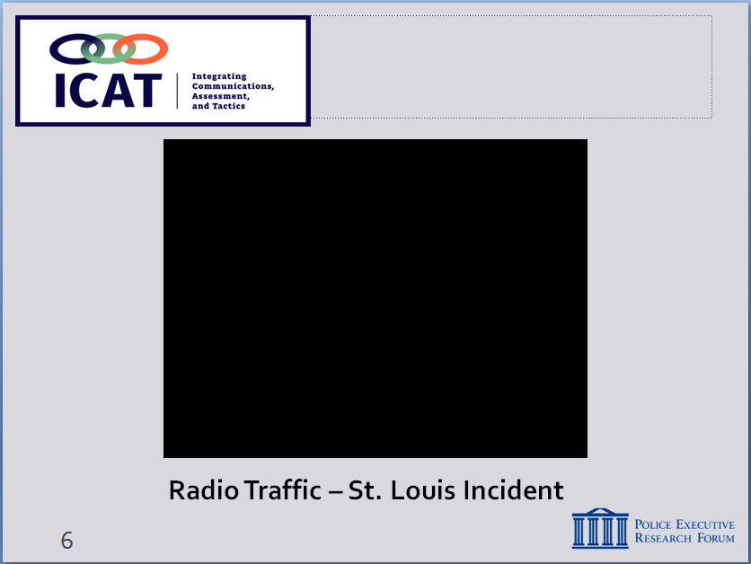
Also available at:
http://www.stltoday.com/online/audio-and-video-evidence-in-kajieme-powell-shooting/collection_b051817e-88bf-5b97-b09c-524e98538ad4.html

Instructor’s Note: Time permitting, consider having a brief class discussion on the 911 call and dispatch. What struck them about the calls?

SLIDE #7
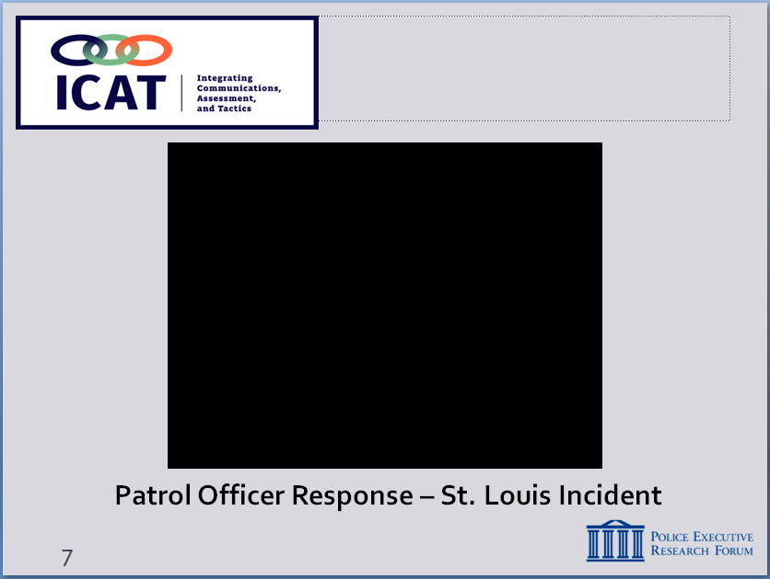
Video also available at https://www.youtube.com/watch?v=FsIlLKOya3c

SLIDE #8
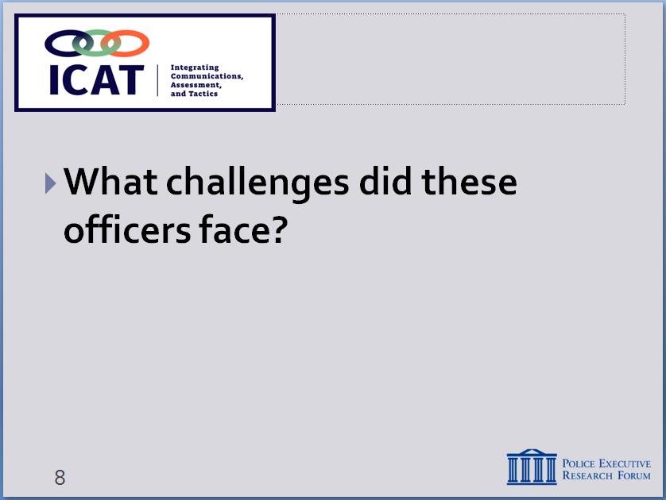

SLIDE #9
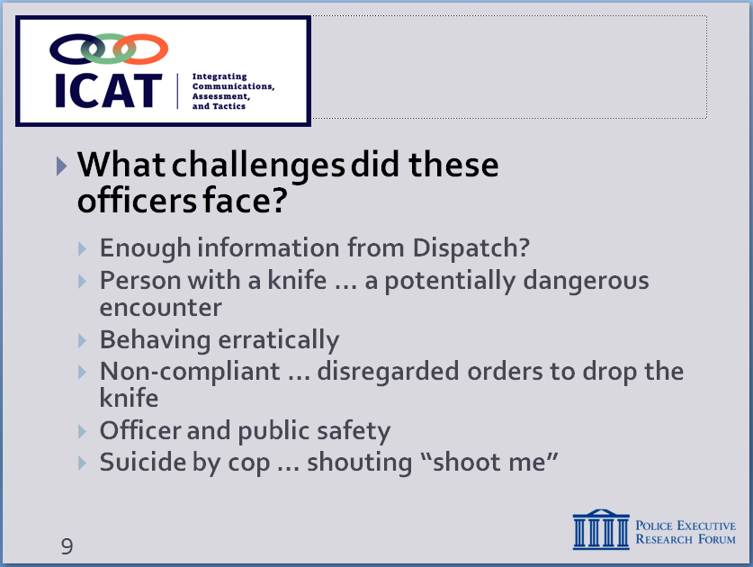

          - Play 9-1-1 calls and radio traffic (4 audio files)
  - The incident was captured on cell phone video
    - Play video
    - [NOTE: this video stops right before officers shoot]
- What were these responding officers faced with?
Lead a brief facilitated discussion (Slide #8)
Then, summarize – (Slide #9)
  - A complex, dynamic event
  - Did officers get enough information from Dispatch?
  - Person with a knife – potential danger to officers and public
  - Person behaving erratically
    - What does his behavior tell us?
    - Was this person in behavioral crisis?
    - (Turns out subject had history of mental illness)
  - Person was non-compliant
    - Disregarded orders to “drop the knife?”
    - When that fails, what else can we say?
  - Officer and public safety
    - Did officers create and maintain a safe distance?
    - Adequate cover?
    - What about the safety of bystanders?
  - “Suicide by cop”
    - Man shouted “shoot me”
    - What does that tell us? And what do we do?
  - What else might these officers have done?
  - What additional information/resources would you have wanted?
  - How might you have approached this differently?
  - What outcome would you have wanted?

- These types of encounters are not easy
Instructor Notes

SLIDE #10
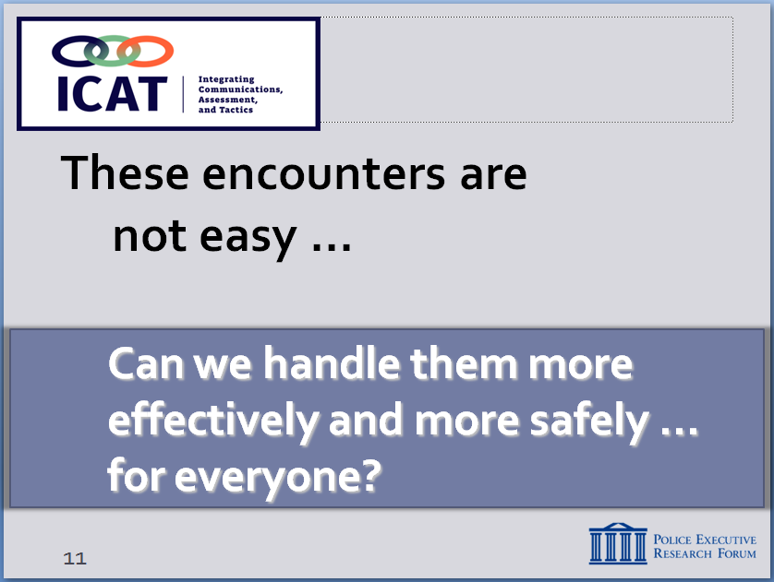

SLIDE #11
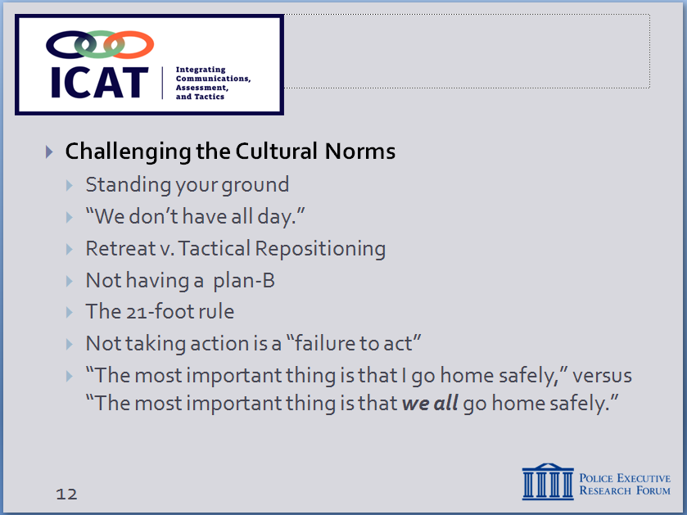

  - Traditional police training has taught officers to do essentially what those two officers did – respond immediately, give commands, take charge of the situation, hold your ground, and end the situation quickly to move on to the next call for service.
  - This is a “culture of speed.”
  - That approach often worked in the past
  - But today, we are dealing with …
    - A more defiant, non-compliant, even disrespectful public
    - Also, a sizeable number of people who are suffering from mental illness or behavioral crisis – people who don’t respond to police commands
    - Bystanders videotaping what we do – adds another “wild card”
  - This training challenges some of the traditional thinking and cultural norms about our response to these types of encounters – and it proposes some new ideas and different approaches.
  - By the end of this training, we want you to be able to view this incident in a different lens
  - It asks the questions …
    - Can we do things differently, more effectively and more safely for everyone – officers, the public and the subject?
    - It’s certainly a much better day when we don’t have to fill out paperwork.
    - Can we think differently about some of our conventional ways of thinking?
      - “We don’t have all day.”
        - In many of these instances, time is on our side.
        - Like a football coach in the last two minutes of a game, if we can extend the clock, we might be able to get additional resources to the scene.
      - Using the concept of “tactical repositioning” to your advantage (e.g., to gain cover, improve sight lines, etc.) – and recognizing that this is not retreating and running away.
        - The “tactical mambo” versus “standing your ground” in certain situations where moving is an option
        - The idea of moving and adjusting your positioning with the subject instead of planting your feet.
      - Having a Plan B
        - For example, what do you do if your Taser doesn’t work?
Instructor Notes

Note: For more context on duty to respond versus failure to act, please consult San Francisco v. Sheehan and Glenn v. Washington County. While there have been no definitive rulings on the issue, recent court cases have attempted to discuss officers’ uses of deadly force on subjects who are suicidal or contained and only a threat to themselves.

http://cdn.ca9.uscourts.gov/datastore/opinions/2011/11/04/10-35636.pdf

https://www.oyez.org/cases/2014/13-1412

      - Discarding the notion of the “21-foot rule” and replacing it with the idea of a “reaction gap”
        - Not an automatic “kill zone” – but rather a flexible reactionary gap to help officers maintain a safe distance and keep their options open.
      - The notion that you will be penalized for “failure to act” if you don’t take direct and immediate action.
        - Do you need to enter a room if the subject inside hasn’t committed a crime and isn’t a danger to others?
        - How do you handle situations in which a person is a harm only to themselves?
      - The idea that the most important thing is that you “go home safely.”
        - Yes that’s very important.
        - But isn’t it just as important for everyone to go home safely, both the public and your fellow officers?
  - In short, this training is about creating more options
    - Slowing down situations like this one in St. Louis, whenever possible
    - Giving you more tools and skills to resolve them without having to resort to lethal force, if possible

- What the training covers
Instructor Notes

SLIDE #12
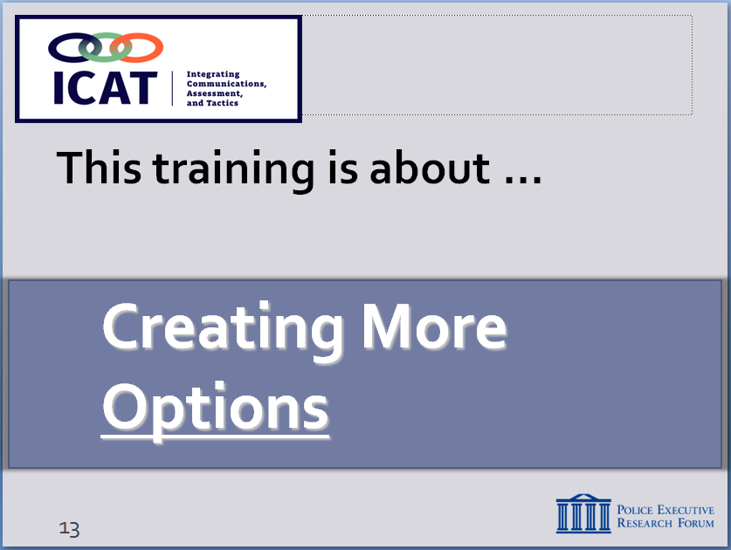

SLIDE #13
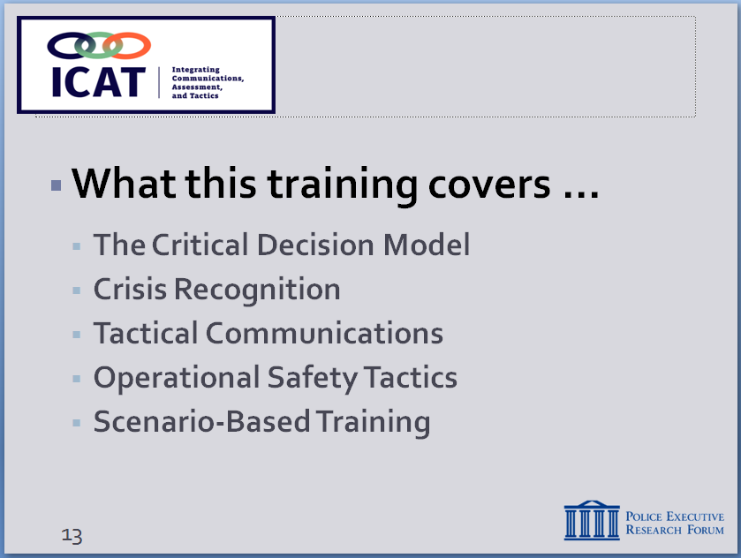

  - Module 2 will discuss decision making and the Critical Decision-Making Model, a tool to help you critically think your way through an incident, from the time you first receive a call-for-service to when you finally clear the scene
  - Module 3 will talk about crisis recognition to help you identify some of the common traits of a person in-crisis
  - Module 4 will provide strategies for communicating tactically, to help you successfully respond and communicate to a person in-crisis
  - Module 5 will cover the tactics to keep you safe, and hopefully prevent a critical incident from escalating to a deadly use-of-force incident
  - Module 6 stresses the integration of these skills by providing scenario-based training examples
  - These are skills you already use, own, and depend on, on a daily basis:
    - ICAT integrates those skills … emphasizes the importance of using them in tandem
    - Also, the importance of teamwork, responding and working as a team (e.g., contact and cover roles, positioning, etc.).
Instructor Notes

SLIDE #14
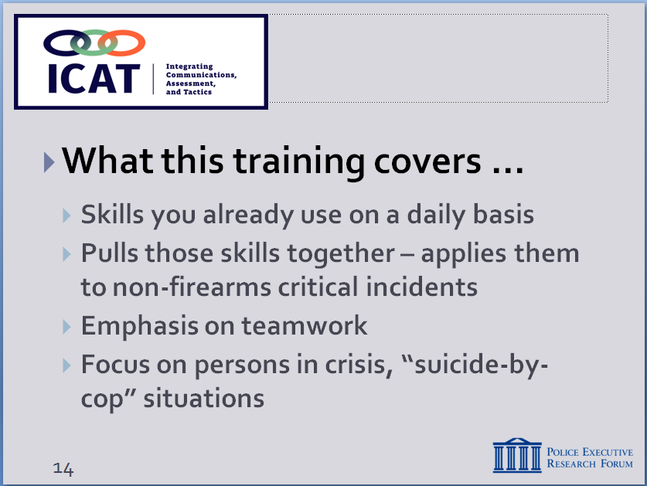

The best athletes continue to practice even though they have played for years. Always looking to perfect their skills, apply them in new ways to new challenges.

Too often, these skills are taught in separate “training silos.” ICAT works to integrate training on these skills.

25% of fatal OISs involve persons with mental illness, per Washington Post database.

SLIDE #15
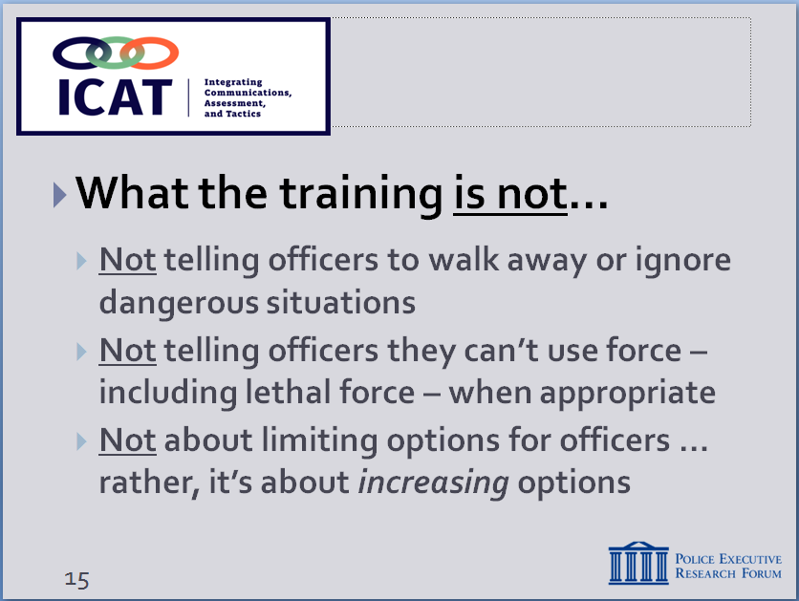

Some view “de-escalation” as taking away options from officers. Need to emphasize this training is designed to increase options.

SLIDE #16
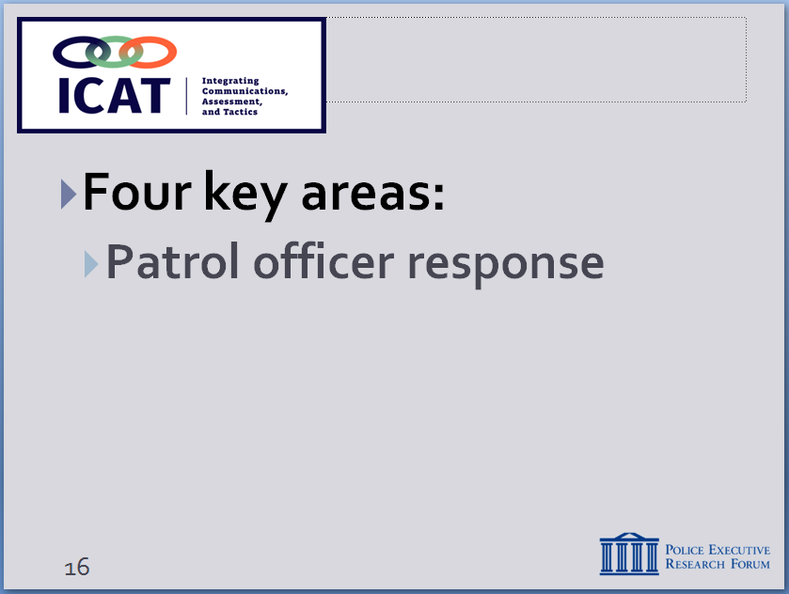

    - Focuses on situations involving persons with mental illness or in behavioral crisis … plus, “suicide-by-cop” situations
  - What the training is not
    - Not telling officers to walk away from danger
    - We are not trying to put you in an unwinnable situation
    - Not telling officers you can’t use force, including lethal force, when appropriate
    - Not taking away or limiting options for officers … rather, trying to increase options, which enhances safety
  - Training focuses on four key areas:
    - Patrol officer response – not SWAT or other specialized units (although ICAT builds on SWAT best practices)
      - Patrol is typically the first ones on the scene
      - First few minutes of the encounter are often crucial to a safe resolution
      - Goal may be to stabilize the situation – not necessarily resolve it right away
      - Often means “buying time” … so supervisors, additional resources, specialized units can respond
      - Supervisors: you need to give officers time to work these situations – not every incident can be handled quickly
Instructor Notes

SLIDE #17
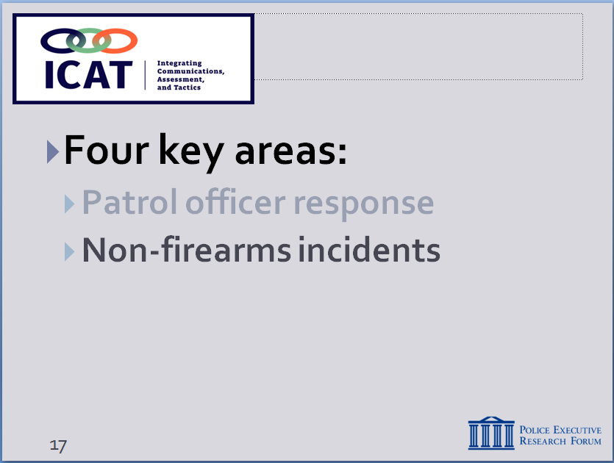
Again, data is from a Washington Post analysis of 2017 fatal officer-involved shootings (see https://www.washingtonpost.com/graphics/national/police-shootings-2017/) Until the FBI begins collecting and reporting this information (scheduled for 2018), the data collected by the news media represent the best we have.

SLIDE #18
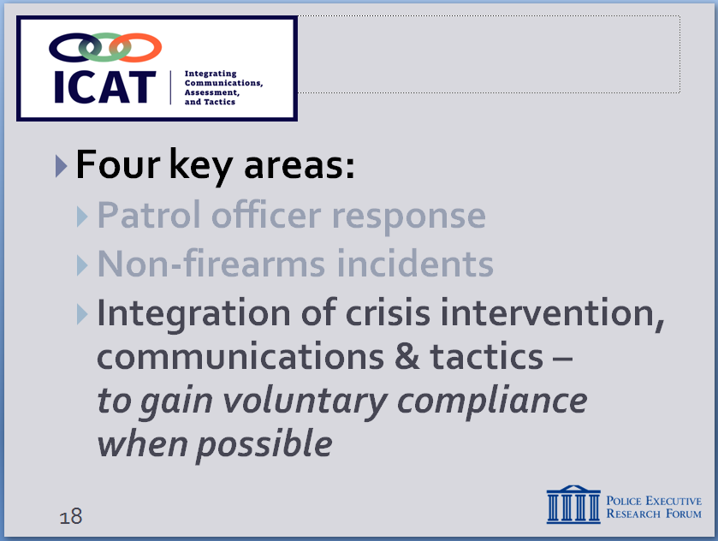

SLIDE #19
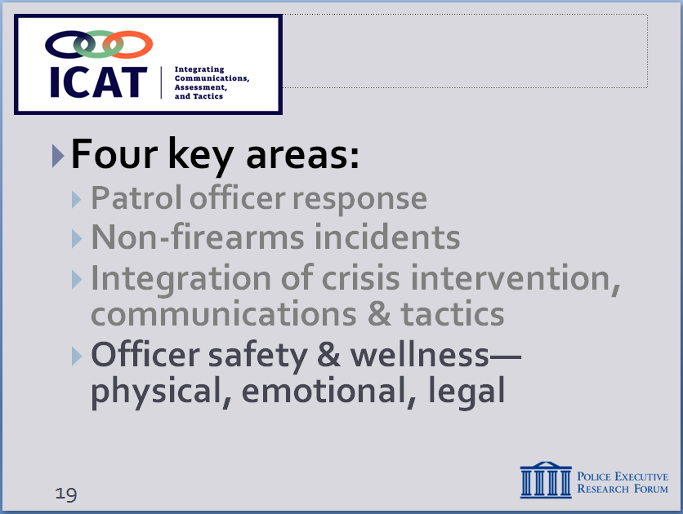

    - Incidents that do not involve firearms
      - About 60% of fatal OISs involve subjects armed with guns. Officers have few options other than lethal force in these instances.
      - Focus of this training is on the remaining cases (almost 400 in 2017) where the subject is unarmed or armed with a weapon other than a firearm (knife, bat, rocks, etc.)
      - Many of these encounters are dangerous – not minimizing that, but the threat is different
      - Some can be safely resolved without the use of deadly force – that’s the focus of this training
    - Integration of skills – crisis recognition, communications/negotiations, and tactics
      - Taking key skills from each discipline – then putting them together as part of an overall response strategy
      - Goal: Influence behavioral change to gain voluntary compliance (when possible)– officers need a wide range of skills to confront and stabilize often chaotic scenes
      - Training presents practical alternatives to drawing service weapon and repeatedly shouting “drop the knife”
    - Officer safety and wellness
      - Keeping officers out of harm’s way (physically) by providing more options to rushing in on every call
      - Also, protecting officers from the emotional trauma, media scrutiny (both news media and social media), and legal troubles that often accompany an officer-involved shooting
Instructor Notes

SLIDE #20
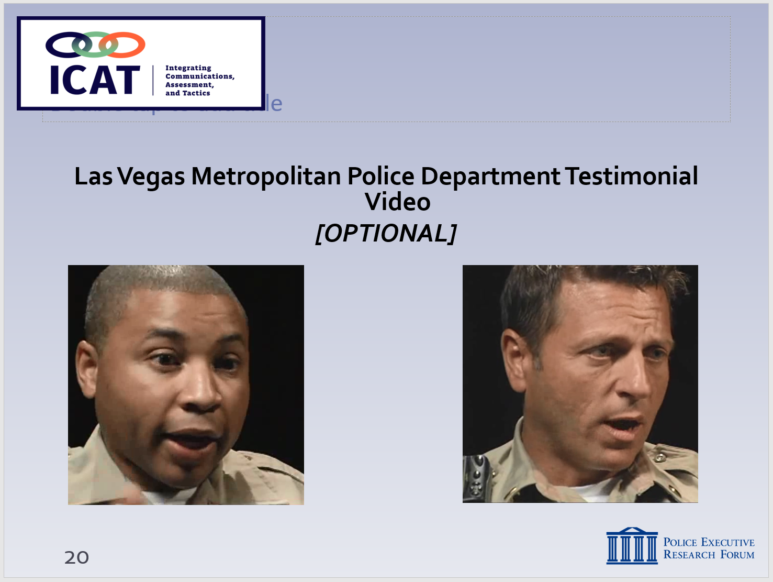

Videos can be found at:

SLIDE #21
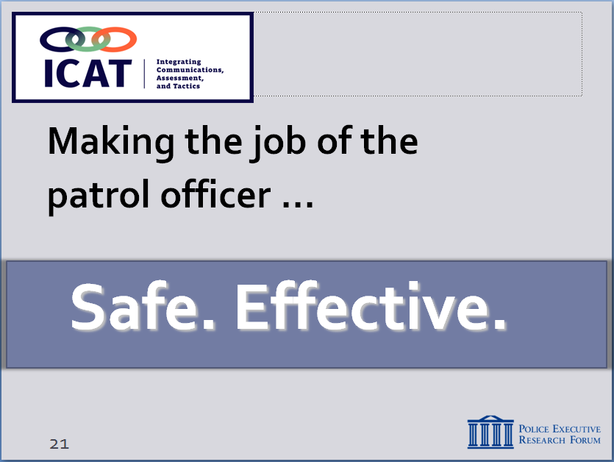

      - ICAT was put together using the input of hundreds of officers, supervisors and police executives from agencies across the country. They would not put their names to anything that would endanger officers – neither would PERF.

Optional Video: Las Vegas Metropolitan Police Department
- This video is from the Las Vegas Metropolitan Police Department. It shows two officers who have been involved in officer-involved shootings. In the video the officers provide testimonials of their experience and the effect that those experiences have left with them.
  - Bottom line: the purpose of this training is to …
    - Make the job of the patrol officer …
      - Safer – by avoiding situations that put officers in danger and where deadly force may be the only option
      - More effective – by providing officers with more options and more opportunities to achieve safe and peaceful outcomes for everyone
      - Make sure you go home safely … the public goes home safely … and the subjects we deal with can go “home” as well (or to jail or treatment, as the case may be).
    - When we do that, we also build public trust and confidence in the police
      - Demonstrate that we are a profession that strives for the safest outcomes in every encounter
Instructor Notes

SLIDE #22

      - That we are committed to the sanctity of all human life
      - All of which gets to the heart of our mission, ethics and values – what we stand for as officers and as a profession

- Thoughts? Questions? Observations?
  - What doesn’t make sense?
  - What concerns do you have?
  - Anything you disagree with?

