Title: Integration and Practice
Recommended Time: Up to 8 hours (depending on number of students and scenarios)
Primary Audience: Patrol Officers
Module Goal: Through scenario-based training and a video case study, the student will review and practice the range of skills needed to safely and effectively stabilize, manage and resolve critical incidents involving subjects not armed with a firearm. Skills related to critical decision-making, crisis recognition and response, tactical communications, and operational safety tactics will be reviewed and practiced in an integrated, hands-on manner.
Required Materials: Digital presentation (Power Point); lesson plan; easel pad and markers; safety equipment/weapons, role players for scenario-based training
Optional Materials: Video recorder for scenarios
Learning Objectives: At the completion of this course, students will be able to:
  - Demonstrate their understanding of the key concepts covered in the ICAT training.
  - Demonstrate their ability to put those concepts into practice through successful completion of scenario-based training exercises.
  - Better recognize “suicide-by-cop” encounters and demonstrate the skills to successfully defuse and resolve these situations.
  - Explain the use of the Critical Decision-Making Model (CDM) in managing and resolving a critical incident.
Structure and Sequencing: This module starts with a recap of Modules 2-5 and a video case study to review key concepts. The bulk of the module involves scenario-based training. The module offers a menu of four different scenario-based exercises that agencies can pick and choose from. Agencies may also decide to customize the scenarios to match particular challenges they face. Agencies should sequence these elements in the way that best fits their training needs and schedules. For example, some agencies may choose to run Scenario #1 as part of Module 4 and Scenario #2 as part of Module 5 (some trainers feel that it is best to practice skills immediately after being taught them). However, conducting scenarios can be disruptive to the flow of classroom instruction, and the scenarios can require considerable training resources. For those reasons, agencies may decide to run all of their scenarios at one time as part of this final module.

Recommended Time Allocation
 | Unit | Recommended Time  (minutes)*
1 | Review of Modules 2-5 | 15
2 | Learning Activity–1 (Video Case Study—Shenandoah County, VA) | 45
3 | Learning Activity–2 (Scenario #1—Suicidal Person with a Knife) | ***
4 | Learning Activity–3 (Scenario #2—Person in Behavioral Crisis with Baseball Bat) | ***
5 | Learning Activity–4 (Scenario #3—Intoxicated Person Refusing to Leave) | ***
6 | Learning Activity–5 (Scenario #4—Agitated Person with a Knife, Suicide-by-Cop) | ***
7 | Recap and Discussion | 15
Total |  | ***

*** Time estimates will depend on the number of students in the class and the amount of time needed to get all students through the selected learning activities. If training resources are available, agencies can split their classes and run exercises concurrently.

Table of Contents

- Review of Modules 2-5 4
- Learning Activity–1 (Video Case Study—Shenandoah County, VA) 7
- Learning Activity–2 (Scenario #1—Suicidal Person with a Knife) 9
- Learning Activity–3 (Scenario #2—Person in Behavioral Crisis with Baseball Bat) 14
- Learning Activity–4 (Scenario #3—Intoxicated Person Refusing to Leave) 18
- Learning Activity–5 (Scenario #4—Agitated Person with a Knife, Suicide-by-Cop) 22
- Recap and Discussion 26

Overview: In many respects, critical incidents involving subjects armed with knives, baseball bats or other weapons besides a firearm are among the most challenging encounters that patrol officers face. These situations can pose serious threats and danger to officers and the public; just because a subject doesn’t have a firearm doesn’t mean the encounter is, by default, “safe.” In addition, these situations present a range of possible response options that require a diverse and complementary set of skills. These encounters become even more challenging when they involve individuals who are experiencing a mental health, substance abuse or other crisis.

The previous modules in the ICAT Training Guide have presented key information in the areas of critical decision-making, crisis recognition, tactical communications, and tactics to promote operational safety. This final module completes the cycle. It gives students the opportunity to practice these skills through rigorous and challenging scenario-based training exercises. The module also provides opportunities for students to explain what they have learned through a facilitated review of the scenarios and a video case study. Significantly, one of the scenarios covers an all-too-common occurrence for police officers: an intentional suicide-by-cop situation.
Instructor Notes

SLIDE #1
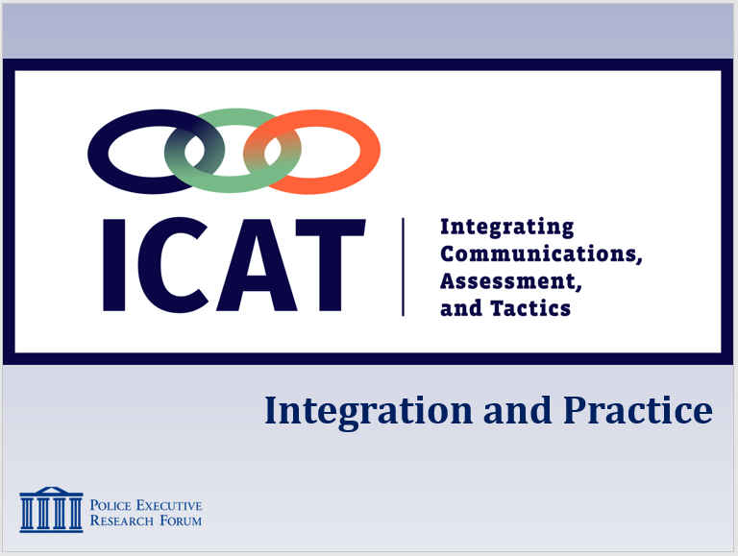

SLIDE #2
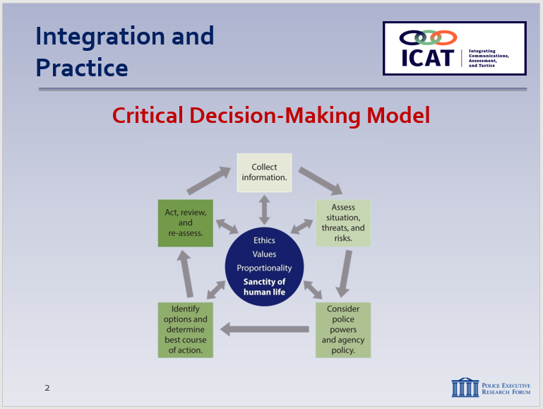

- Review of Modules 2-5
  - Critical Decision-Making Model (CDM)
    - Five-step model … but a familiar, intuitive process
      - Provides structure for the type of decision-making you do every day
      - Allows for immediate action when that’s needed
      - Helps you think through situations when immediate action is not needed
      - Promotes the safety of everyone – the public, you, and the subject
    - The CDM core is based on ethics and values
    - CDM emphasizes ongoing information collection and threat assessment
      - Circular, not linear process
      - As new information comes in or threats change … then “spin the model”

    - Key benefits of the CDM
Instructor Notes

SLIDE #3
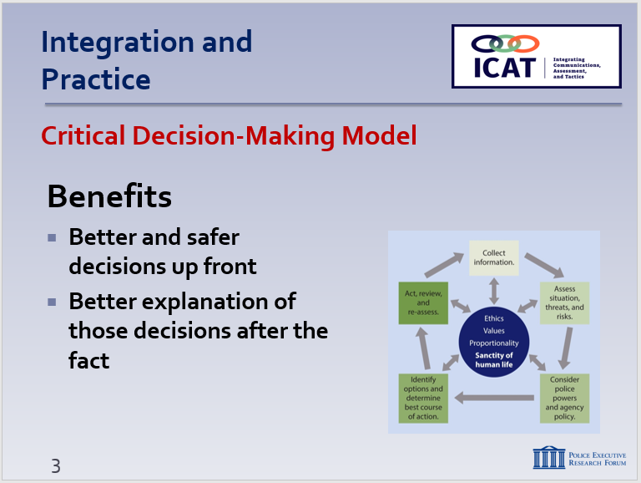

SLIDE #4
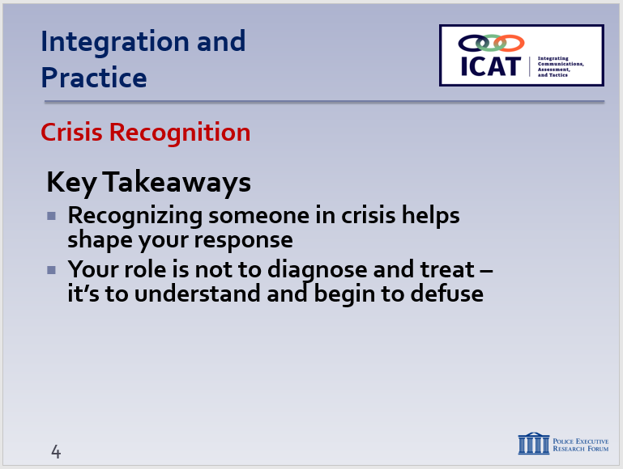

SLIDE #5
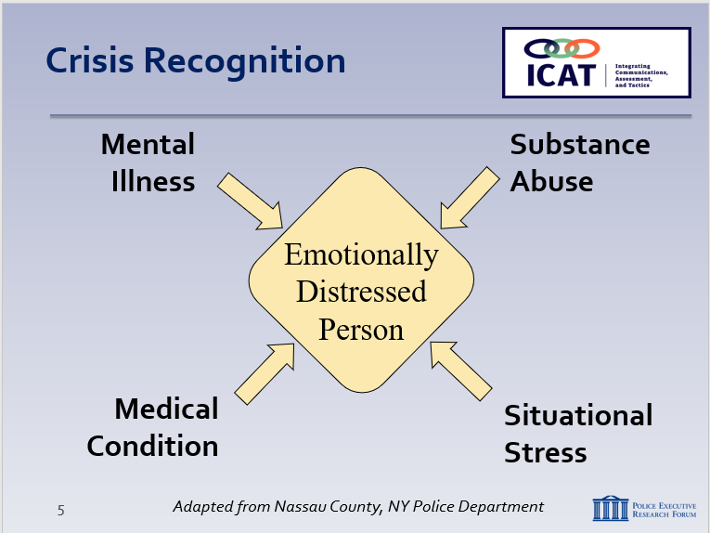

SLIDE #6
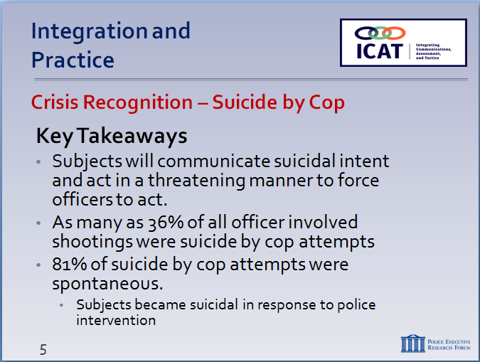

SLIDE #7
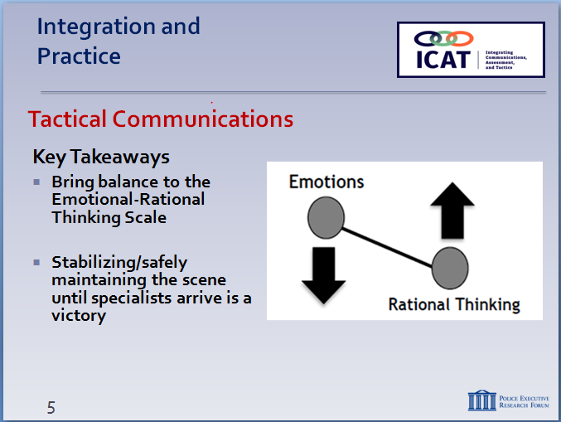

SLIDE #8
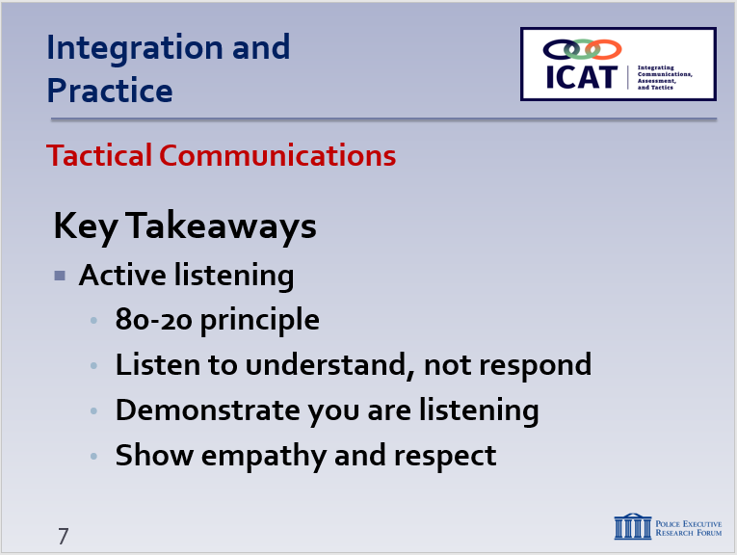

Remember: SWAT teams and hostage negotiators train on and use these skills every day. They are extremely valuable for patrol officers as well.

SLIDE #9
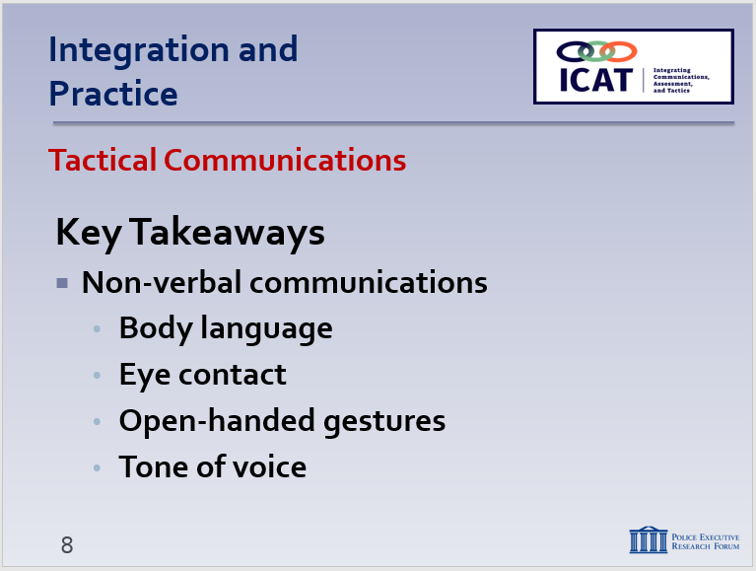

      - Helps you make better and safer decisions up front
      - Helps you explain those decisions – to supervisors (After-Action Reviews), investigators, in court
  - Crisis Recognition
    - Recognizing when someone is in crisis helps you approach the situation more safely and effectively
    - Your role is not to diagnose and treat – it’s to try to understand the situation and begin to defuse
    - In a suicide by cop situation, the subject will communicate suicidal intent and act in a threatening manner to force officers to act
    - One study found that 36% of all officer involved shootings was a suicide by cop attempt
    - 81% of suicide by cop attempts were spontaneous. Subjects became suicidal in response to police intervention.
  - Tactical Communications
    - Bring balance to the Emotional-Rational Thinking Scale
    - Safely maintaining the scene until more resources (specialists) arrive is a victory
    - Active listening
      - 80-20 principle
      - Listen to understand, not to respond
      - Demonstrate you are listening (minimal encouragers, summarizing, acknowledgments)
      - Show empathy and respect
    - Non-verbal communications
      - Body language – posture and appearance
      - Eye contact – powerful de-escalation technique
      - Open-handed gestures – convey honesty and caring
      - Tone of voice – bring the subject down to your level
    - Verbal communications
      - Team concept – contact and cover
      - Clear, simple questions/directions – one at a time
      - Ask open-ended questions – get the subject talking
      - Provide options
      - Emotional contagion – use your words/actions to move situations from chaos to compliance
  - Operational Tactics
Instructor Notes

SLIDE #10
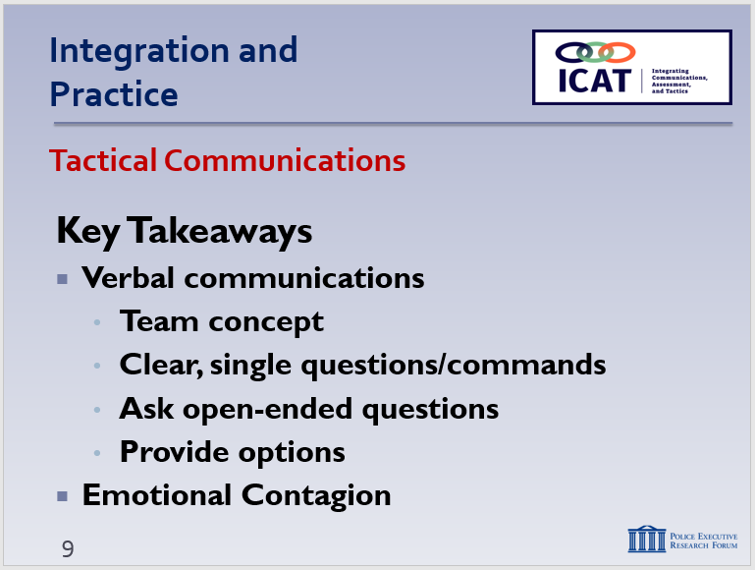

Your actions and words are contagious—the influence they subject and others on scene.

SLIDE #11
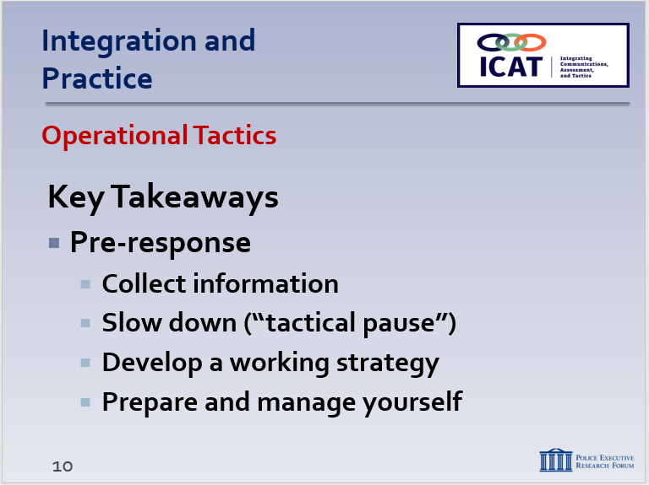

SLIDE #12
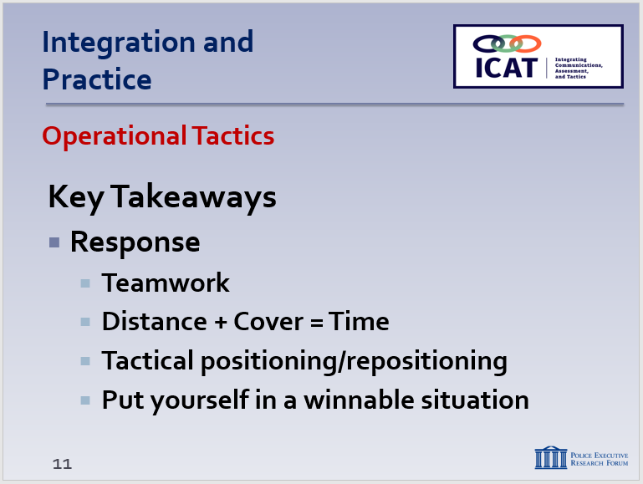

Get in the balcony so you can see the dance floor.

    - Pre-response
      - Collect information and intelligence – this is an ongoing process
      - Slow down (when possible) – “tactical pause”
      - Develop a working strategy
      - Prepare and manage yourself – and your partners
    - Response
      - First impressions are critical – start “low” whenever possible
      - Respond as a team
      - Use Distance + Cover = Time to your tactical advantage
      - Tactical positioning/repositioning
      - Keep yourself in a winnable situation
      - Tactically, during a suicide by cop situation, remember that officers must be extra-vigilant about not escalating the situation further.
        - Again, consider D+C=T
        - Call for your backup
        - Continuously spin the CDM and assess the evolving threat in front of you
        - Try not to let the subject force you to act and try not to initiate confrontation
        - Try to maintain communication to make a connection and begin crisis intervention
    - Post-response
      - After-Action Reviews
      - Not “Monday morning quarterbacking” – not grading past success or failure
      - Rather, a continuous learning process – improving future performance
      - AARs complement the Critical Decision-Making Model – the CDM provides a structure for reviewing and evaluating incident responses

- Learning Activity–1 (Video Case Study)
Instructor Notes

SLIDE #13
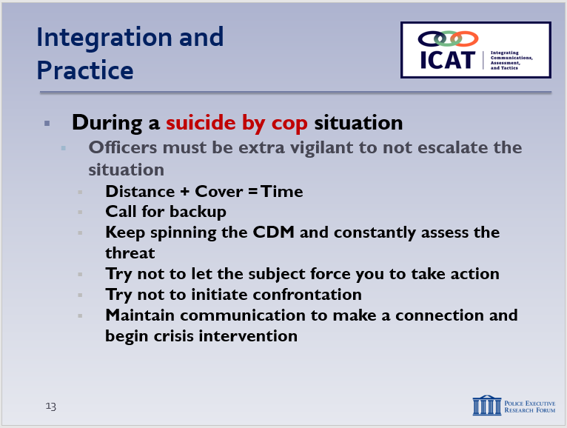

SLIDE #14
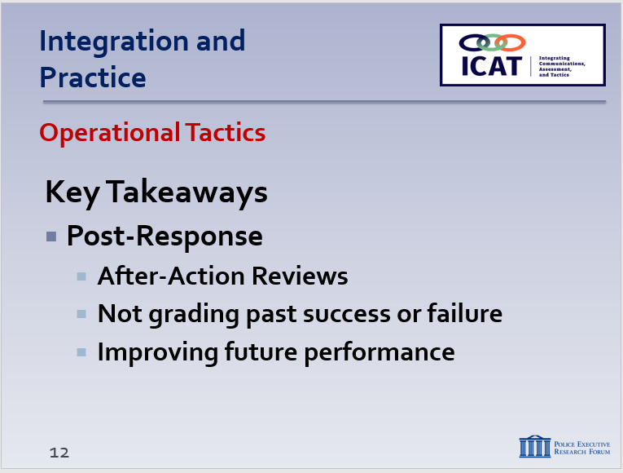

SLIDE #15
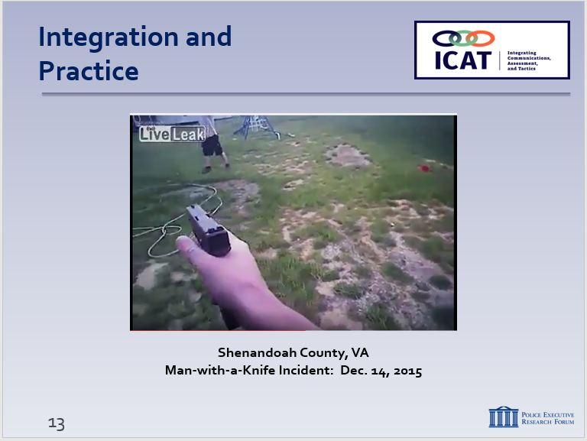

Video available at https://www.youtube.com/watch?v=TKOSDh4lvM4

Activity: Video Case Study—Shenandoah County, VA
Activity Time: 45 minutes
Activity Learning Objective: Review and discuss the decision-making, crisis recognition and response, tactical communications, and tactical response of the officers involved in a man-with-a-knife incident.
Required Equipment:
  - Digital presentation (Power Point and/or video); easels and markers

Facilitator Instruction:
Instructor Notes

Set up the video; provide background and context:
    - Shenandoah County, Virginia (100 miles west of Washington, DC)
    - December 2015
    - Two deputies respond to a domestic disturbance call
    - They encounter 38-year-old Corbyn Lee Rush outside

Remind students that the video is not “perfect;” the purpose is not to judge or second-guess the officer’s actions or render a grade. Rather the video illustrates the real-world challenges officers face. The purpose is to generate discussion on how these challenges can be handled as safely and effectively as possible. We are not suggesting this was the only possible course of action in this case.
Play the video all the way through (5:25). At the conclusion, break the class into small groups. Provide each group with easel pads and markers. Ask each group to record their impressions – positive and negative – of the officer’s decision-making, crisis recognition and response, tactical communications, and tactical response to the incident.
For this video, students should pay particular attention to the officers’ communications and tactical skills. Note also how the officer handled this potential suicide-by-cop situation. Allow the groups approximately 20 minutes to discuss and record. (If possible, allow students to re-view video in their small groups.) Each group will delegate a spokesperson who will present the findings to the class.
- Depending on the class size and engagement level, this case study could be conducted as a large group (whole class) exercise.
During the report-outs, consider replaying and stopping the video at key points to illustrate/amplify points made by students. Possible discussion points:
Instructor Notes

  - First impression:
    - Assertive, but not aggressive. (“Put it down, man. Do it now. Come on, dude.”)
    - Didn’t charge in yelling “drop the knife!”
    - Attempted to establish and maintain a dialogue throughout.
  - Teamwork: Officers communicated with each other right away and throughout (e.g., worried about cross-fire at one point).
  - Clear, simple commands:
    - “Don’t take a step forward. Stop.” (0:45)
    - “Corbyn, drop it buddy, please.” (3:18)
  - Rapport:
    - Established and used the subject’s name.
    - Also used terms such as “man,” “buddy,” and “dude” (subject’s vernacular).
  - Empathy and reassurance (in response to suicide-by-cop requests):
    - “No, I don’t want to shoot you, buddy” (0:49).
    - “We’ll get you the help you need” (1:19).
    - “We don’t want to shoot you, man” (2:20).
  - Active listening/open-ended questions:
    - “Relax. What’s the problem, buddy? What’s wrong today? Talk to us a little bit. Just tell us what’s going on, dude.” (1:46)
    - Transitioned to this when another “put it down” command did not work.
  - Maintained contact role:
    - After unsuccessful TASER deployment, subject became agitated at other officers.
Officer redirected his attention: “Corbyn, talk to me, man, talk to me.” (4:00)

  - Tactical repositioning:
    - No “line in the sand.”
    - Maintained a reaction gap throughout.
Instructor Notes

    - Ebb and flow, based on subject’s movements (which weren’t threatening).
  - Threat assessment:
    - Subject had knife, but what was he doing with it? (Holding it at his side.)
    - Walking unsteadily. Urged officers to “just kill me.”
    - When threat changed (he dropped the knife to pull out TASER prong), officers rushed and went hands on. (Example of quickly “spinning the CDM model” based on new information.)
  - Didn’t rush the action:
    - As long as the threat didn’t change and communication was an option, officer kept the dialogue going.
    - How long would you let this incident go on?
  - Tactics:
    - TASER deployment. What do you think? Appropriate? Too soon? (It’s when the subject pulled out TASER prong that he dropped the knife and was subdued.)
    - How do you think it might have ended if officers had not used the TASER?
    - What else might the officers have done to get voluntary compliance?
  - Suicide-by-cop:
    - How to respond – verbally and tactically – to statements such as “just kill me?”
  - Decision-making:
    - How did the officers use the CDM?
    - Did they “spin the model?” When? And how did it work out? (when the TASER deployment was unsuccessful)
  - Other thoughts?
- Learning Activity–2 (Scenario #1)
Activity: Scenario-Based Exercise
Activity Time: Dependent upon the number of students, instructor resources
Activity Learning Objective: Utilize and apply the decision-making, crisis recognition and response, tactical communications, and tactical response skills covered in ICAT.
Required Equipment/Personnel:
  - One rubber knife
  - Safety gear for officers
  - One primary officer
  - One cover officer
  - One subject (role player)
  - Additional role players for possible injects
  - One scenario facilitator (instructor)
  - One debriefing/After-Action Review facilitator (instructor) – optional
Optional Equipment: Video recorder (although optional, it may be helpful to film the scenario and have it available for use during individual debriefings)
Safety Brief: If available, all scenarios should include a designated safety officer and non-functioning training weapons. Prior to conducting any exercise, ALWAYS conduct a weapon’s safety check, especially after any break in training or whenever the students leave the training location. All instructors will have the ability for cellular communications, transportation protocol and location of the nearest trauma center. No live ammunition will be allowed in the training area. Officers will unload all live ammunition in an adjacent room using the designated firearm safety chamber. After passing the safety check, all personnel should be visually able to determine if someone has not been checked. Consider a way of delineating the two groups (e.g., use a reflective leg band for those who have been checked). If someone doesn’t have a leg band, a student can alert the instructor so that person can be checked.
Facilitator Instruction: As noted in the ICAT chapter “How To Use the ICAT Training Guide,” there are two basic approaches to running scenario-based training exercises: (1) stop and discuss, or (2) run through, then discuss. Your role during this exercise will depend on which approach you select. The exercise requires two students for each iteration. Budget your time to allow for each pair of students to complete the exercise, but give each scenario a chance to play out. Do not feel compelled to speed up the action. At the conclusion of the scenario, conduct a debriefing with the officers. (Again, consult “How To Use the ICAT Training Guide” for guidance on conducting effective debriefings following a scenario-based exercise.) If resources are available, consider using a second instructor for the debriefing/After-Action Review process. This provides additional perspectives, and may allow the scenario facilitator to prepare the next group of officers to run the scenario.
Injects: Note that the script includes some possible injects – unexpected situations that you may want to insert into the scenario at different points. (Injects will require additional personnel to serve as role players.) These injects should not be viewed as “gotcha” moments intended to trip up students. Rather, they are meant to add challenge and stress to the scenarios—to make them even more realistic. Especially with the addition of injects, facilitators should continue to make sure that students learn and feel like they have succeeded by the end of the scenario. If you choose to use injects in which the subject becomes a serious threat, you need to ensure that proper safety equipment, protocols, and precautions are in place to protect all members participating in the scenario.
Video examples: The following videos offer examples of how you might set up and run this scenario: https://www.youtube.com/watch?v=oXj6i1sPND8 (shows the scenario run all the way through) and https://www.youtube.com/watch?v=tauIaGgsyBk (shows the scenario stopped and issues discussed at key points). These videos are not intended to suggest the only way the scenarios can be run, but rather to give you ideas and suggestions on how you might run the scenario successfully. In addition, the videos do not have any injects.
Script:
Location and Setting: Sidewalk/steps outside an apartment building; ex-boyfriend of the subject lives in the building.
Situation: A tenant in the apartment building has called 9-1-1 to report a woman pacing up and down in front of the building, holding a knife and occasionally sitting on the building’s steps. She appears to be crying and talking to herself, but is not screaming, yelling or engaging others.
Two officers respond. Subject is sitting on the steps leading up to the building; she is calm, melancholy (crying occasionally) and threatening suicide, occasionally holding the knife to her throat. In general, she is not threatening anyone else and is not displaying the knife aggressively.
Officers establish tactical positions and begin communications. Because she is crying at times and speaking in a low voice, it may be difficult for the officers to sometimes hear what the subject is saying. The officers should use effective communications and active listening skills, with the objective of getting the subject to voluntarily drop the knife and agree to be transported to a medical/mental health facility for an evaluation.
Subject (Role Player):
Kim Anderson, Female, DOB: Today’s date 1974
(a male role player may be substituted if needed)
Demeanor/actions:
- You have just broken up with your boyfriend, who lives in the apartment building
- When officers arrive, you sit and place the knife to your throat
- Overall, you make conversation difficult for the officers due to your depressed state and low tone of voice
- Slow, detached, low-volume speech at first – become more agitated at any “hot button” issues
- Stopped taking anti-depressant medication a week ago; you are seeing a therapist
- React based on the effective/ineffective communication from the officer(s); you can become agitated and use the knife defensively (to keep others away), but in general do not make overtly aggressive moves using the knife
- HOT BUTTONS (things that set you off):
  - Any questions about/mention of your former partner
  - Today is your birthday – upset about getting older alone
- HOOKS (things you like):
  - Long walks in the park
  - Summers at the beach
- Emotions you are experiencing
  - Depression
  - Confusion
  - Anger
- DEMANDS:
- For the police to go away
- For the police to allow you to kill yourself
- For the police to bring your former partner so he can see you kill yourself
Possible Injects:
- Ex-boyfriend shows up on the scene and tries to engage with the subject
- Additional officer(s) arrive on the scene, service weapons drawn; advance toward the subject screaming “drop the knife”
- Subject suddenly and unexpectedly advances toward the officers with the knife in a threatening manner
- After dropping the knife and seeming to comply, subject suddenly rushes the officers (no weapon)
Learning Objectives:
- Demonstrate a safe, tactically sound response
- Demonstrate teamwork
- Demonstrate active listening skills – ability to gain information about the subject and the situation
- Demonstrate the ability to show empathy and respect
- Demonstrate strong verbal and non-verbal communications skills (recognize/avoid “hot buttons” – leverage “hooks”)
- Demonstrate the ability to achieve a safe and effective resolution
- Demonstrate the ability to explain actions/decisions made throughout the event as part of an After-Action Review process

- Learning Activity–3 (Scenario #2)
Activity: Scenario-Based Exercise
Activity Time: Dependent upon the number of students, instructor resources
Activity Learning Objective: Utilize and apply the decision-making, crisis recognition and response, tactical communications, and tactical response skills covered in ICAT.
Required Equipment/Personnel:
  - Room (with door, if available)
  - One foam (or soft rubber) bat
  - Safety gear for officers
  - One primary officer
  - One cover officer
  - One assisting officer/supervisor
  - One subject (role player)
  - One reporting party (role player)
  - Additional role players for possible injects
  - One scenario facilitator (instructor)
  - One debriefing/After-Action Review facilitator (instructor) – optional
Optional Equipment: Video recorder (although optional, it is recommended to film the scenario and have it available for use during individual debriefs)
Safety Brief: If available, all scenarios should include a designated safety officer and non-functioning training weapons. Prior to conducting any exercise, ALWAYS conduct a weapon’s safety check, especially after any break in training or whenever the students leave the training location. All instructors will have the ability for cellular communications, transportation protocol and location of the nearest trauma center. No live ammunition will be allowed in the training area. Officers will unload all live ammunition in an adjacent room using the designated firearm safety chamber. After passing the safety check, all personnel should be visually able to determine if someone has not been checked. Consider a way of delineating the two groups (e.g., use a reflective leg band for those who have been checked). If someone doesn’t have a leg band, a student can alert the instructor so that person can be checked.
Facilitator Instruction: As noted in the ICAT chapter “How To Use the ICAT Training Guide,” there are two basic approaches to running scenario-based training exercises: (1) stop and discuss, or (2) run through, then discuss. Your role during this exercise will depend on which approach you select. The exercise requires three students for each iteration. Budget your time to allow for each group of students to complete the exercise, but give each scenario a chance to play out. Do not feel compelled to speed up the action. At the conclusion of the scenario, conduct a debriefing with the officers. (Again, consult “How To Use the ICAT Training Guide” for guidance on conducting effective debriefings following a scenario-based exercise.) If resources are available, consider using a second instructor for the debriefing/After-Action Review process. This provides additional perspectives, and may allow the scenario facilitator to prepare the next group of officers to run the scenario.
Injects: Note that the script includes some possible injects – unexpected situations that you may want to insert into the scenario at different points. (Injects will require additional personnel to serve as role players.) These injects should not be viewed as “gotcha” moments intended to trip up students. Rather, they are meant to add challenge and stress to the scenarios—to make them even more realistic. Especially with the addition of injects, facilitators should continue to make sure that students learn and feel like they have succeeded by the end of the scenario. If you choose to use injects in which the subject becomes a serious threat, you need to ensure that proper safety equipment, protocols, and precautions are in place to protect all members participating in the scenario.
Video examples: The following videos offer examples of how you might set up and run this scenario: https://www.youtube.com/watch?v=vxwHihnsAqE (shows the scenario run all the way through) and https://www.youtube.com/watch?v=lkNHEwBMFUg (shows the scenario stopped and issues discussed at key points). These videos are not intended to suggest the only way the scenarios can be run, but rather to give you ideas and suggestions on how you might run the scenario successfully. In addition, the videos do not have any injects.
Script:
Location and Setting: Residential home, occupied by a mother and her 20-year-old son who suffers from schizophrenia
Situation: The mother has called 9-1-1 because she fears her son has stopped taking his medications. He is walking around the house swinging a baseball bat, and she can’t get him to put it down. She is worried he will hurt her, himself or damage property in the house. He is now sitting in his room clutching the baseball bat he used during high school playing days.
Three officers (or two officers and a supervisor) respond. They are met by the mother who is outside screaming for the officers to rush in and help her son. The mother is extremely agitated and almost incoherent. She is concerned the officers will hurt her son.
The officers should use effective communications and active listening skills, as well as sound tactical positioning, with the objective of getting the subject to drop the bat, come out of the home and agree to be transported to a medical/mental health facility for treatment.
Subjects (Role Players):
Joe Johnson, Male, Age 20
Demeanor/actions:
- Erratic, fast-paced speech
- Speak in a disoriented fashion – you are frequently out of touch with reality
- Express signs of delusions. (Your favorite baseball team needs to make you its permanent bat boy. That will guarantee the team wins the pennant.)
- Your symptoms make it difficult for the officers to communicate with you
- Stopped taking your medication three days ago
- React based on the effective/ineffective communication from the officer(s)
- HOT BUTTONS (things that set you off):
  - Having to take your medication – you think it’s poison
  - When people dismiss or argue with what you’re experiencing (delusions)
  - When people make disrespectful comments about your favorite baseball team
- HOOKS (things you like):
  - Baseball (you were a star shortstop in high school)
  - Star Wars movies
- Emotions you are experiencing
  - Anger (that the police have come)
  - Disorientation
- DEMANDS:
- For the police to go away
- For the police not to kill/hurt you
- For the hallucinations go away
Beth Johnson, Female, Age 49, mother of Joe
(a male role player, playing the father, may be substituted if needed)
Demeanor/actions:
- Upset and scared about your son
- Also upset what the police may do to him
- Excited, fast-paced speech
- When speaking with officers, go fast and provide only vague information
- DEMANDS:
- That the police help your son
- That the police not hurt him
Possible Injects:
- Mother attempts to rush into the home to see her son
- Father/ex-husband shows up on scene and begins arguing with the mother
- After dropping the bat and seeming to comply, subject grabs an object (e.g., lamp) and charges at the officers
- Another officer arrives on scene and deploys an Electronic Control Weapon (Taser), but it is ineffective
Learning Objectives:
- Demonstrate a safe, tactically sound response
  - Use distance and cover to create time
  - Gather pertinent information before acting (primarily from interviewing the mother/reporting party)
  - Don’t rush the situation – tactical pause to develop a strategy
- Demonstrate teamwork
- Demonstrate active listening skills – ability to gain information about the subject and the situation
- Demonstrate strong verbal and non-verbal communications skills (recognize/avoid “hot buttons” – leverage “hooks”)
- Demonstrate the ability to achieve a safe and effective resolution
- Demonstrate the ability to explain actions/decisions made throughout the event as part of an After-Action Review process

- Learning Activity–4 (Scenario #3)
Activity: Scenario-Based Exercise
Activity Time: Dependent upon the number of students, instructor resources
Activity Learning Objective: Utilize and apply the decision-making, crisis recognition and response, tactical communications, and tactical response skills covered in ICAT.
Required Equipment/Personnel:
  - Rubber implements (depending on specific inject—see p. 20)
  - Safety gear for officers
  - One primary officer
  - One cover officer
  - One subject (role player)
  - Additional role players for possible injects
  - One scenario facilitator (instructor)
  - One debriefing/After-Action Review facilitator (instructor) – optional
Optional Equipment: Video recorder (although optional, it may be helpful to film the scenario and have it available for use during individual debriefings)
Safety Brief: If available, all scenarios should include a designated safety officer and non-functioning training weapons. Prior to conducting any exercise, ALWAYS conduct a weapon’s safety check, especially after any break in training or whenever the students leave the training location. All instructors will have the ability for cellular communications, transportation protocol and location of the nearest trauma center. No live ammunition will be allowed in the training area. Officers will unload all live ammunition in an adjacent room using the designated firearm safety chamber. After passing the safety check, all personnel should be visually able to determine if someone has not been checked. Consider a way of delineating the two groups (e.g., use a reflective leg band for those who have been checked). If someone doesn’t have a leg band, a student can alert the instructor so that person can be checked.
Facilitator Instruction: As noted in the ICAT chapter “How To Use the ICAT Training Guide,” there are two basic approaches to running scenario-based training exercises: (1) stop and discuss, or (2) run through, then discuss. Your role during this exercise will depend on which approach you select. The exercise requires two students for each iteration. Budget your time to allow for each pair of students to complete the exercise, but give each scenario a chance to play out. Do not feel compelled to speed up the action. At the conclusion of the scenario, conduct a debriefing with the officers. (Again, consult “How To Use the ICAT Training Guide” for guidance on conducting effective debriefings following a scenario-based exercise.) If resources are available, consider using a second instructor for the debriefing/After-Action Review process. This provides additional perspectives, and may allow the scenario facilitator to prepare the next group of officers to run the scenario.
Injects: Note that the script includes some possible injects – unexpected situations that you may want to insert into the scenario at different points. (Injects will require additional personnel to serve as role players.) These injects should not be viewed as “gotcha” moments intended to trip up students. Rather, they are meant to add challenge and stress to the scenarios—to make them even more realistic. Especially with the addition of injects, facilitators should continue to make sure that students learn and feel like they have succeeded by the end of the scenario. If you choose to use injects in which the subject becomes a serious threat, you need to ensure that proper safety equipment, protocols, and precautions are in place to protect all members participating in the scenario.
Video examples: There is no sample video for this scenario. However, the scenario is based in part on the following real-life incident that occurred in Tahlequah, Oklahoma, in August 2016: http://www.tahlequahdailypress.com/multimedia/videos/full-video-graphic-fatal-police-shooting-in-tahlequah/youtube_0d94fc60-665d-11e6-ad6a-f389dacaa87b.html.
Script:
Location and Setting: Garage/home of subject’s estranged wife.
Situation: A woman has called 9-1-1 to report that her estranged husband has broken into the garage of her home and is refusing to leave. She is secured in the main part of the house. There is a protective order requiring the subject to stay away from the home and to not make contact with his estranged wife.
Two officers respond. The subject is sitting in the garage drinking beer from the refrigerator and refusing to leave. He is claiming that this is his home and he is doing nothing wrong.
Officers establish tactical positions and begin communications. The officers should use effective communications and active listening skills, with the objective of getting the subject to voluntarily comply with orders to leave the home.
Subject (Role Player):
John Williams, Male, Age 42, Marine Corps veteran
Demeanor/actions:
- Somewhat agitated, verbally confrontational
- Been drinking heavily for the past several hours
- Slurred speech (from drinking)
- Suspicious of one of the officers – claims the officer beat me up “the last time”
- Been treated for PTSD for years, but recently stopped taking medication because it made you feel bad
- React based on the effective/ineffective communication from the officer(s)
- HOT BUTTONS (things that set you off):
  - Any comments about your estranged wife (positive or negative)
  - Anything you perceive as a challenge to your military service or patriotism
- HOOKS (things you like):
  - Music (especially heavy metal and classic rock)
  - Military history
- Emotions you are experiencing
  - Confusion
  - Anger
  - Disorientation (from drinking and stopping medication)
- DEMANDS:
- For the police to go away
- For your estranged wife to take you back
- For the police not to hurt you
Possible Injects:
- Subject becomes agitated, grabs a hammer and begins threatening the officers without advancing
- Another officer arrives on scene; he has arrested the subject before and quickly becomes impatient and agitated; officer begins raising his voice and making threats against the subject
- Estranged wife enters the garage and begins to try to physically eject the subject
- Subject pulls a knife and holds it to his throat

Learning Objectives:
- Demonstrate a safe, tactically sound response
  - Use distance and cover to create time
  - Don’t rush the situation
  - Gather pertinent information before acting
- Demonstrate teamwork
  - Contact and cover roles
- Demonstrate active listening skills
  - Ability to gain information about the subject and the situation
- Demonstrate strong verbal and non-verbal communications skills (recognize/avoid “hot buttons” – leverage “hooks”)
- Demonstrate the ability to achieve a safe and effective resolution
- Demonstrate the ability to explain actions/decisions made throughout the event as part of an After-Action Review process (optional)

- Learning Activity–5 (Scenario #4)
Activity: Scenario-Based Exercise (Suicide-by-Cop)
Activity Time: Dependent upon the number of students, instructor resources
Activity Learning Objective: Utilize and apply the decision-making, crisis recognition and response, tactical communications, and tactical response skills covered in ICAT.
Required Equipment/Personnel:
  - Open space
  - At least one parked vehicle, one police vehicle
  - One rubber knife
  - Safety gear for officers
  - One primary officer
  - One cover officer
  - One subject (role player)
  - Additional role players for possible injects
  - One scenario facilitator (instructor)
  - One After-Action Review facilitator (instructor) – optional
Optional Equipment: Video recorder (although optional, it may be helpful to film the scenario and have it available for use during individual debriefings)
Safety Brief: If available, all scenarios should include a designated safety officer and non-functioning training weapons. Prior to conducting any exercise, ALWAYS conduct a weapon’s safety check, especially after any break in training or whenever the students leave the training location. All instructors will have the ability for cellular communications, transportation protocol and location of the nearest trauma center. No live ammunition will be allowed in the training area. Officers will unload all live ammunition in an adjacent room using the designated firearm safety chamber. After passing the safety check, all personnel should be visually able to determine if someone has not been checked. Consider a way of delineating the two groups (e.g., use a reflective leg band for those who have been checked). If someone doesn’t have a leg band, a student can alert the instructor so that person can be checked.

Facilitator Instruction: As noted in the ICAT chapter “How To Use the ICAT Training Guide,” there are two basic approaches to running scenario-based training exercises: (1) stop and discuss, or (2) run through, then discuss. Your role during this exercise will depend on which approach you select. The exercise requires two students for each iteration. Budget your time to allow for each pair of students to complete the exercise, but give each scenario a chance to play out. Do not feel compelled to speed up the action. At the conclusion of the scenario, conduct a debriefing with the officers. (Again, consult “How To Use the ICAT Training Guide” for guidance on conducting effective debriefings following a scenario-based exercise.) If resources are available, consider using a second instructor for the debriefing/After-Action Review process. This provides additional perspectives, and may allow the scenario facilitator to prepare the next group of officers to run the scenario.
Injects: Note that the script includes some possible injects – unexpected situations that you may want to insert into the scenario at different points. (Injects will require additional personnel to serve as role players.) These injects should not be viewed as “gotcha” moments intended to trip up students. Rather, they are meant to add challenge and stress to the scenarios—to make them even more realistic. Especially with the addition of injects, facilitators should continue to make sure that students learn and feel like they have succeeded by the end of the scenario. If you choose to use injects in which the subject becomes a serious threat, you need to ensure that proper safety equipment, protocols, and precautions are in place to protect all members participating in the scenario.
Video examples: The following videos offer examples of how you might set up and run this scenario: https://www.youtube.com/watch?v=YzO-kSvJ4Oc (shows the scenario run all the way through) and https://www.youtube.com/watch?v=B_kl3UFAGlI (shows the scenario stopped and issues discussed at key points). These videos are not intended to suggest the only way the scenarios can be run, but rather to give you ideas and suggestions on how you might run the scenario successfully. In addition, the videos do not have any injects.
Script:
Location and Setting: Strip mall parking lot.
Situation: Police have been called for the report of a man with a knife slashing tires parked at a strip mall. The subject, who had served three years in prison for assaulting a police officer, had recently been fired from his job at an auto parts store at the strip mall. He was targeting the cars of his former boss and employees.
Two officers respond. The subject is agitated and aggressive. He is not displaying a weapon, but his hands are in his pockets and he refuses to comply with police orders to show them. At some point, the subject pulls out the knife and begins slowly advancing toward the officers screaming, “kill me, kill me right now.” The subject has his arms outstretched and is not making aggressive moves with the knife.
Upon initial response, officers establish tactical positions to contain the subject and begin communications. The officers should use effective communications and active listening skills, along with sound tactics, with the objective of getting the subject to voluntarily drop the knife and agree to be taken into custody.
Subject (Role Player):
Michael Jones, Male, Age 31
Demeanor/actions:
- Angry, violent, confrontational
- Slow, loud, clear speech
- Angry at having been fired from your job
- React based on the effective/ineffective communication from the officer(s); slowly advance toward the officers, arms outstretched, shouting “kill me”
- HOT BUTTONS (things that set you off):
  - Loss of your job, especially your former boss
  - Possibility of going back to prison
- HOOKS (things you like):
  - Mixed martial arts
  - Fast cars
- Emotions you are experiencing
  - Extreme anger at losing your job
  - Fear of going back to prison
  - Suicidal tendencies
- DEMANDS:
- Not to go back to prison
- For the police to kill you

Possible Injects:
- Two (or more) individuals show up and begin videotaping the encounter; they offer “running commentary” and dare the officers to shoot the subject; they are distracting/disorienting the subject
- The subject’s ex-boss appears and wants to confront the subject about slashing his tires
- The subject races at the officers and screams “just kill me.” (Knife can be raised or lowered, or the subject could even have dropped the knife.)
Learning Objectives:
- Demonstrate a safe, tactically sound response
  - Use distance and cover to create time
  - Gather pertinent information before acting
  - Tactical repositioning as the threat changes
- Demonstrate teamwork
  - Contact and cover roles
  - Less-lethal and lethal roles
- Demonstrate active listening skills
  - Ability to gain information about the subject and the situation
- Demonstrate strong verbal and non-verbal communications skills (recognize/avoid “hot buttons” – leverage “hooks”)
- Demonstrate the ability to achieve a safe and effective resolution to a suicide-by-cop situation
- Demonstrate the ability to explain actions/decisions made throughout the event as part of an After-Action Review process (optional)

- Recap and Discussion
Instructor Notes

SLIDE #16
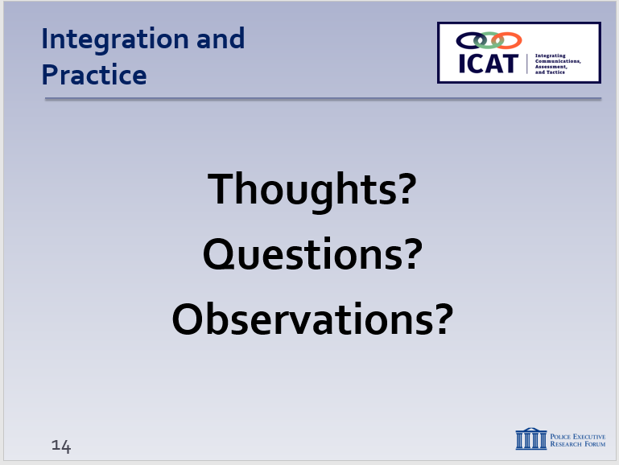

  - Video case study review
    - Additional thoughts?
    - How does the Critical Decision-Making Model fit into the video case studies we reviewed (any of them)?
  - Scenario review
    - Discuss general impressions of the scenarios – challenges, skills used, etc.
      - No judgments
      - Open discussion
      - Everyone should offer feedback
    - In general, avoid specific critiques of individual officers or teams
      - That should be done in the debrief during/ immediately following those officers’ scenario
  - Lessons learned from this module and entire ICAT Training Guide (can record on easel pad)
    - Ask each student to identify one new thing he or she learned
    - Or, one skill set he or she plans to focus on in the future
  - Review any specific agency policy considerations
  - Distribute class evaluations

