Title: Operational Tactics
Recommended Time: 2 hours (not including possible scenario-based training exercise)
Primary Audience: Patrol Officers
Module Goal: Through classroom instruction, discussion, exercises, and a video case study, the student will learn additional skills to safely and effectively respond to and resolve critical incidents involving subjects who are armed with weapons other than a firearm. Using the Critical Decision-Making Model, students will explore pre-response, response, and post-response considerations, and focus on both their individual actions and teamwork. (Note: agencies may also choose to run a scenario-based training exercise at the end of this module or as part of Module 6, Integration and Practice.)
Required Materials: Digital presentation (Power Point); lesson plan; easel pad and markers (For scenario-based training, safety equipment/weapons and role player)
Learning Objectives: At the completion of this course, students will be able to:
  - Demonstrate critical pre-response and response requirements for critical incidents.
  - Explain use of the Critical Decision-Making Model (CDM) in responding to and managing a critical incident.
  - Demonstrate and explain key tactical expectations and roles when responding to a critical incident as a team.
  - Explain concepts such as “tactical pause,” “distance + cover = time,” and “tactical repositioning.”
  - Apply appropriate tactical considerations to suicide-by-cop situations.
  - Participate in an effective after-action review of a critical incident.
  - Use the CDM to explain key post-response expectations following a critical incident.

Recommended Time Allocation
 | Unit | Recommended Time  (minutes)
1 | Learning Activity–1 (Assessment) | 20
2 | Pre-Response Considerations | 15
3 | Effective Response Tactics | 30
4 | Learning Activity–2 (Video Case Study) | 30
5 | Post-Response Considerations | 15
6 | Learning Activity–3 (Scenario) – Optional*
7 | Recap and Discussion | 10
Total |  | 120

* These estimates do not include the time needed to conduct a scenario-based training exercise. Agencies that choose to run a scenario at the end of this module (as opposed to running all of their scenarios in Module 6) will need to budget in additional time here.

Table of Contents

- Learning Activity–1 (Assessment) 4
- Pre-Response Considerations 5
- Effective Response Tactics 9
- Learning Activity–2 (Video Case Study) 15
- Post-Response Considerations 19
- Learning Activity–3 (Scenario #2) – Optional 22
- Recap and Discussion 22

Overview: Responding to and successfully resolving critical incidents require not only strong crisis recognition and communications skills, but also sound tactics and teamwork. All three must work in unison. Good crisis intervention and communications skills coupled with flawed tactics, or sound tactics paired with poor crisis intervention/ communications, are unlikely to produce the desired result of a safe resolution through voluntary compliance.

Particularly in situations involving persons in crisis, tactics must support, complement, and enable the crisis intervention and communications approaches to take hold and succeed. It is also critical that officers work as a team in these situations. Team members must be willing to take on specific roles and ensure they are supporting (and not interfering with) the roles of other team members.
Because every incident is different, teaching specific tactics for situations that are so unique and context-dependent is impossible. There is no detailed, one-size-fits-all approach. This module focuses on a number of sound tactical concepts that can be applied to most incidents that do not involve an immediate firearm threat. While the nature of the threat may require immediate action in some circumstances, defusing the situation and gaining voluntary compliance should be the goals in all other situations.
Instructor Notes

SLIDE #1
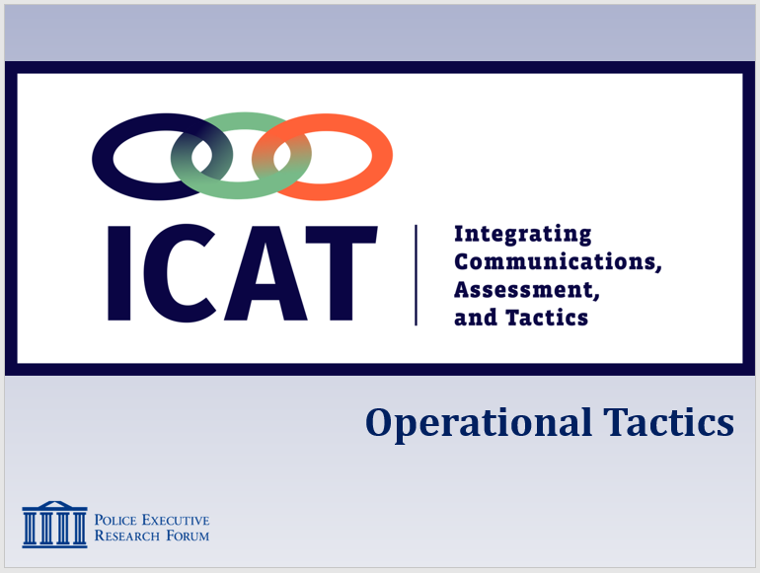

SLIDE #2
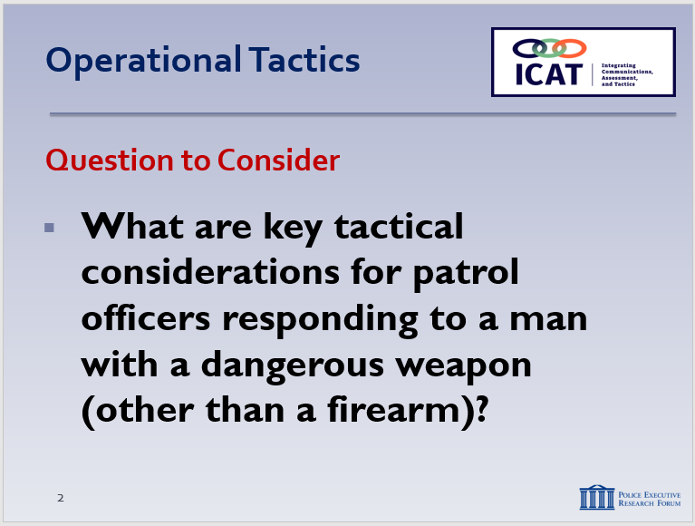

SLIDE #3
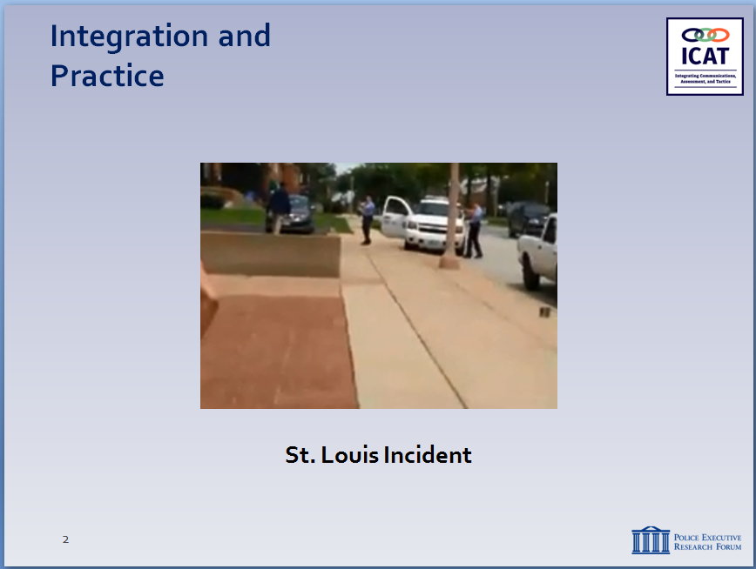

- Learning Activity or Group Discussion – 1 (Assessment)
Activity: Video Assessment Group Project or Class Discussion
Activity Time: 20 minutes
Activity Learning Objective: An assessment exercise that serves as an introduction to the Operational Tactics module
Required Video: St. Louis Video Suicide by Cop video
Facilitator Instruction: Break the class into small groups or have a large class discussion. If broken into small groups, provide each group with markers and easel pads.
Play St. Louis Video: This is the same scenario from Module #1 except that you will be playing the full version.)
Following the Video: Students will have 10 minutes to brainstorm and chart some of the key tactical considerations and teamwork approaches of the patrol officers responding to a critical incident that involves a man with a knife. If broken into groups, each group will delegate a spokesperson who will present the findings to the class.
Instructor Notes

SLIDE #4
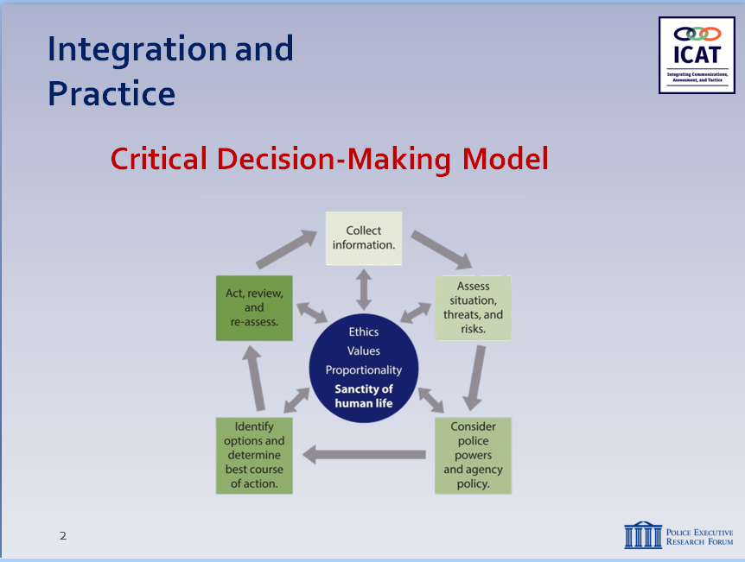

SLIDE #5
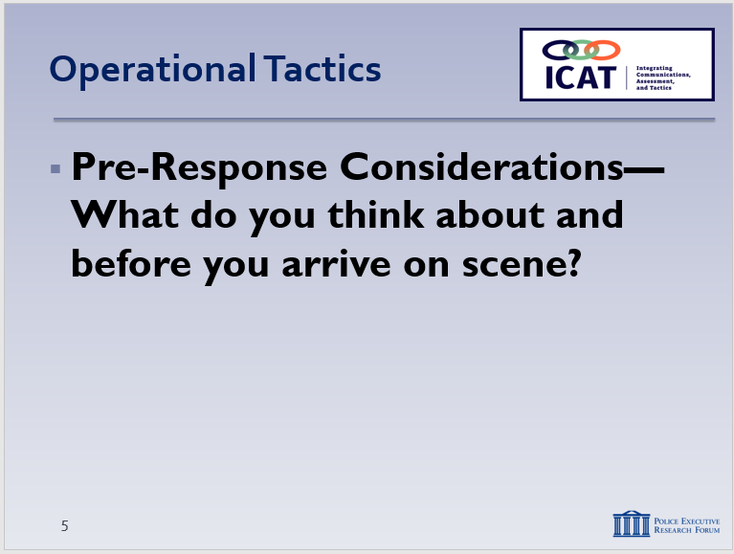

Discussion Question: What are the key things you want to know heading to the scene and the steps you plan to take once you arrive?
Discussion Question: Given what we know from the dispatcher and what you’ve learned from this training, how can we better respond tactically to incidents like this?
- Incorporate the CDM in your thought process and response.
- In previous modules, we learned about crisis recognition and tactical communication now we’re going to talk about tactics.

- Pre-Response Considerations
Information is the life’s blood of any tactical response. As detailed in Step 1 of the Critical Decision-Making Model (see Module 2), it is essential that responding officers collect as much information as possible (from Dispatch and others) while en route to a critical incident. It’s also important for responding officers and supervisors to share information among themselves, establish a team mindset, and develop a game plan ahead of time, whenever possible. Of course, circumstances will always dictate tactics, and officers must be prepared to act immediately if needed. But if they have the chance to “slow the situation down,” officers should use that time to their tactical advantage.

Note

This primary purpose of the following video is to illustrate how the information collected and transmitted during the pre-response phase—before officers arrive on scene—can impact how officers respond.

Remind students that the video is not meant to judge or second-guess the officer’s actions or render a grade. Rather the video illustrates the real-world challenges that officers face. The video is intended to generate discussion on how these challenges can be handled as safely and effectively as possible.

There will be tactical elements in the video that students will likely have issues with. Allow students to air their concerns, but try to keep the discussion focused on how information affects the initial response.
Instructor Notes

SLIDE #6
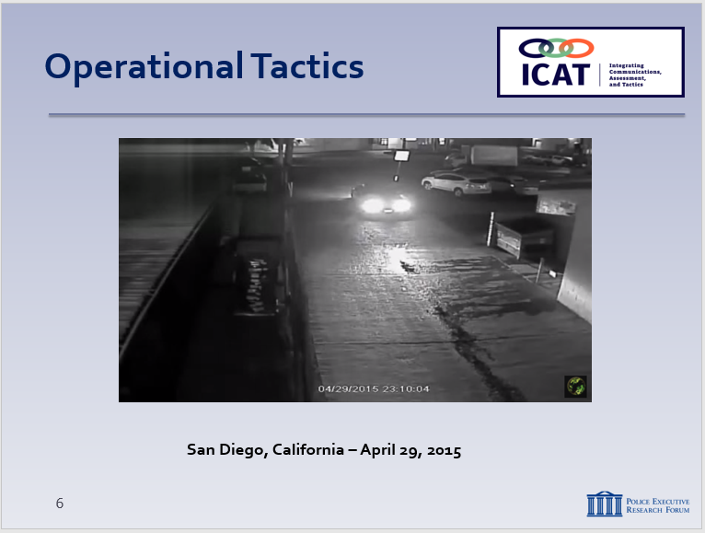

  - The following is a video clip from an incident that illustrates the importance of information collection during the pre-response phase
    - Play video of responding officers and STOP the video at the 2:55 mark
    - Discuss the video:
      - What information did the responding officer receive from the dispatcher?
        - Suspect with a knife threatening others
        - Officer does not know the exact location of the suspect, but
        - He has a physical and clothing description
        - There is no victim being actively harmed at the time
      - How did the officer tactically approach the suspect?
        - The officer pulled right up on the subject and got out of his car
    - Resume the video and stop at the 3:20 mark
      - How fast did the incident happen?
        - Very quickly. The officer used force immediately after exiting his patrol car.
      - What are some additional strategies and tactics that the responding officer could have used to give himself more time and collect more information?
      - The subject was actually holding a pen.

    - 21-ft rule
      - As a quick follow up to the discussion, the officer stated that the reason why he shot the suspect was because he was less than 21 feet away from him, at that time.
      - As a follow up question, is 21 feet an inflexible line of demarcation in shoot/don’t shoot situations?
Instructor Notes

SLIDE #7
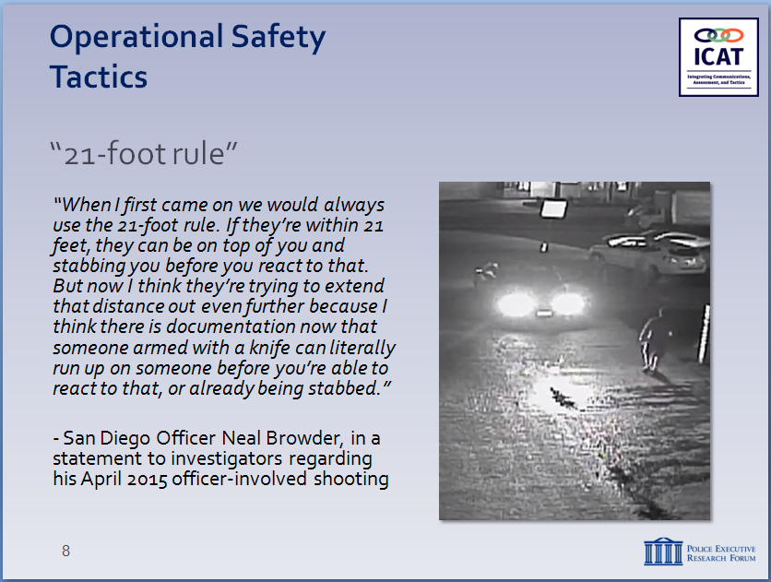

SLIDE #8
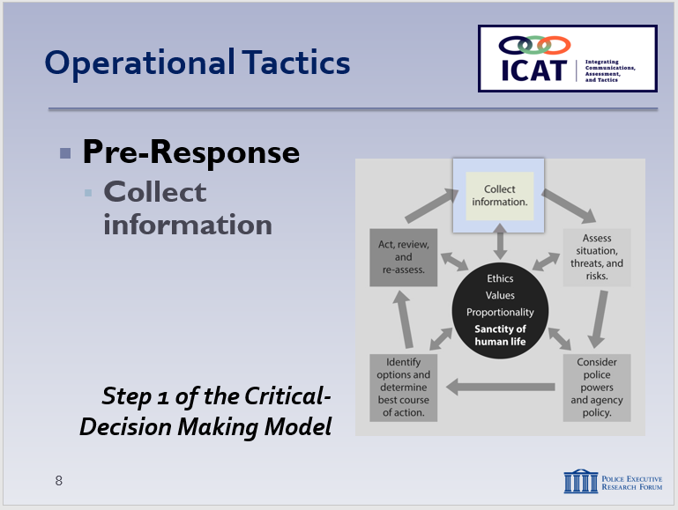

      - Isn’t there some gray area, depending on the circumstances?
      - Using this scenario as an example, what can officers do tactically to give themselves more space and time to collect information, process the information, and act?

  - First pre-response consideration: Collect information
    - Step 1 of the Critical Decision-Making Model
      - Information from Dispatch
      - From fellow officers/supervisors
      - From your own training and experience
      - Trying to separate facts from assumptions
    - Try to determine if this is a criminal case or a crisis call.
      - How will you approach the incident differently?
    - Begin to think through your response before entering the scene
      - Reinforces readiness – guards against complacency (officer safety issue)
      - Helps officers “transition in their mindset”
      - Begins to place you in a winning situation
    - Ensure your equipment is ready–lethal and less-lethal
Instructor Notes

SLIDE #9
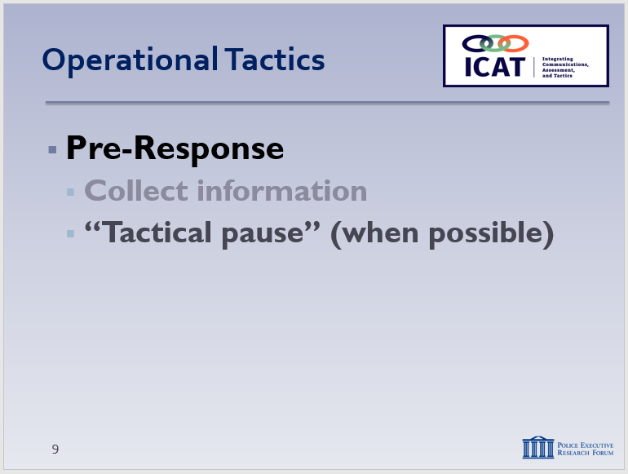

“Tactical pause” is a concept developed by the Palm Beach County (FL) Sheriff’s Office. For more background, see https://policeforum.org/assets/guidingprinciples1.pdf, p. 55.

For some agencies, this may require a shift in priorities – from an emphasis on response time to ensuring a more planned and coordinated approach (even if it takes a little longer).

SLIDE #10
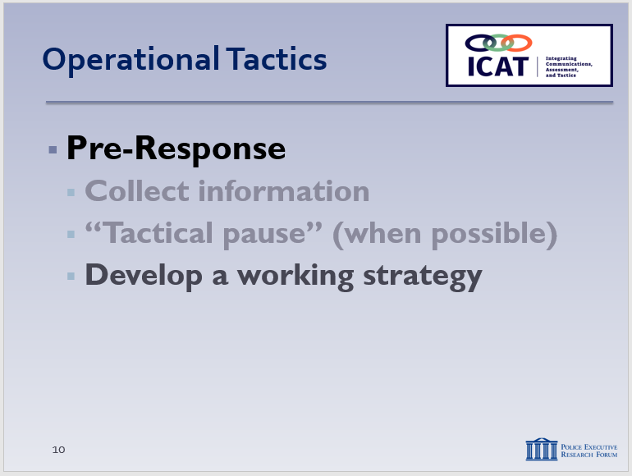

SLIDE #11
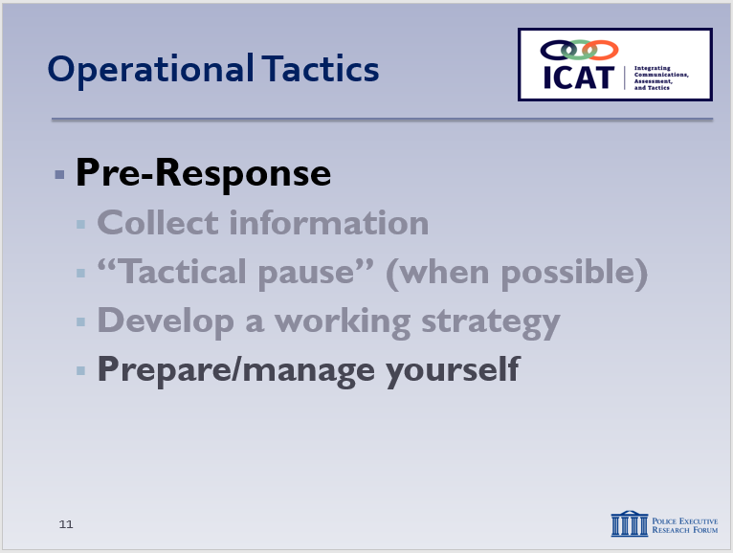

See also, Module 3, p. 19 for additional information on this topic.

  - Take a “tactical pause” (when possible)
    - In general, time is on the side of first responders
      - Some incidents will require immediate response
      - Nothing prevents you from doing that
    - When immediate response is not needed … “tactical pause” allows responding officers to huddle up (in person or over the radio), share information and begin developing a strategy (including team roles)
      - If supervisor is available, even better
      - Create the team mindset before you get on scene
      - Begin to establish team roles – contact and cover, “eyes on,” etc.
    - Allows you to think more clearly and objectively
    - Approach the situation more methodically
  - Begin developing a working strategy
    - Step 2 in the CDM
    - Playing out “what if?” scenarios
    - Three possible outcomes on any encounter that you need to be prepared for:
      - Fight
      - Flight
      - Voluntary compliance through communication – this should be your goal whenever possible
    - Think about how to minimize risks, maximize safety
  - Prepare/manage yourself
    - Need to manage yourself before you can manage others
      - By successfully controlling your own thoughts and behaviors, you can positively affect the outcome of many situations (remember the “Emotional Contagion” concept)
Instructor Notes

Some observable effects of fear-induced psychophysical arousal:
- Increased muscle tension, especially in neck and shoulders
- Increased breathing rate; shallower breaths
- Rapid eye movements; eyes are opened wide and have a flattened appearance – “tunnel vision”
- Auditory exclusion
- Perspiration; skin flushed, especially in the face
- Tremors (shaking); loss of fine-motor skills
- Rapid, pressured speech; yelling or frequently interrupting
- Teeth clenched, jaw set
- Dry mouth, repeatedly licking lips
- Amygdala Hijack (emotional redlining)

SLIDE #12
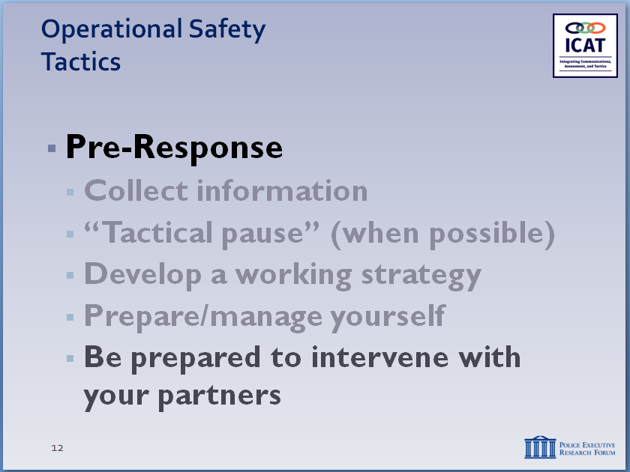

The New Orleans Police Department has a model peer intervention program called EPIC: Ethical Policing Is Courageous. Agencies may consider incorporating EPIC as an additional module in ICAT. For information, see http://epic.nola.gov/home/.

SLIDE #13
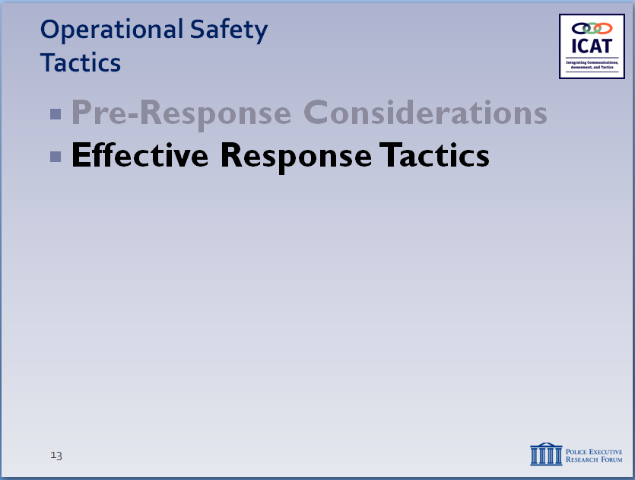

      - Understand that your emotions/reactions can cause some situations to escalate – check your ego
      - Separate your reactions from those of others
      - When you become angry or escalate unnecessarily, you lose credibility and control
      - Maintaining control of yourself = maintaining control of the situation
    - Understand how your body will react in a stressful situation (subject may be experiencing same reactions)
      - Helps you prepare
      - Helps you de-escalate
      - Can help save your life and the lives of others
    - State of awareness
      - A physical and mental process
      - Combines tactical awareness (mechanical) + state of mind (mental)
      - As your focus on the threat intensifies, your awareness tends to decline
      - Mental conditioning to maintain awareness
    - Watch out for your partners too
      - Be aware of their reactions to stressful situations
      - Be prepared to intervene if necessary
- Effective Response Tactics
Circumstances always dictate tactics. That’s why it’s important to take the time to accurately analyze and understand the circumstances you face. A person with a knife or blunt object attacking someone will trigger one set of tactics designed to quickly neutralize the threat. The same person with the same knife or blunt object pacing up and down and not actively threatening anyone presents a different set of circumstances, which will require a different response. Information gathering, teamwork and flexibility in considering different options are key to identifying and executing the most effective and safest tactical response.
Instructor Notes

SLIDE #14
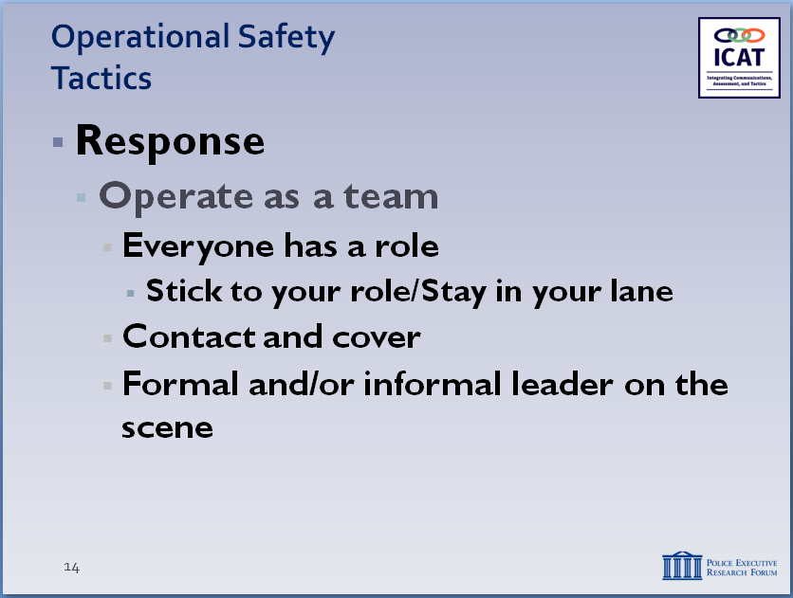

SLIDE #15
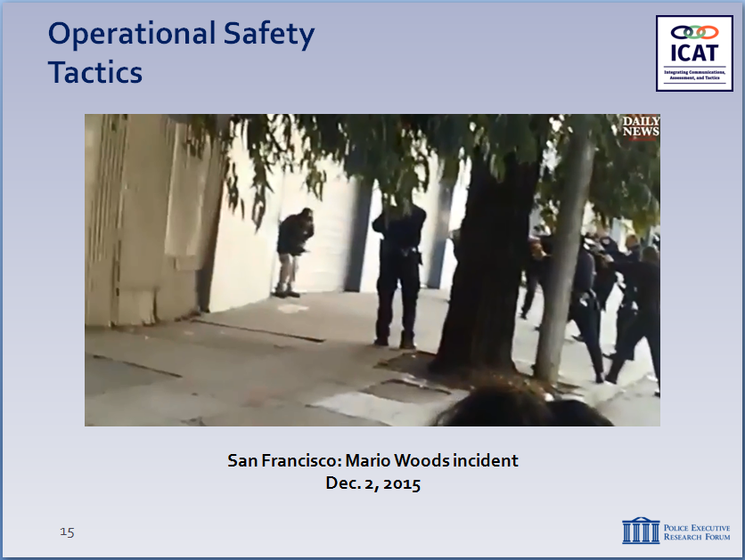

Optional Note for the class: “Keep in mind that we’re not condemning these officers, we’re critiquing the tactics”

Ask participates why do they believe every officer had their gun drawn and pointed at the suspect? Do these incidents demand better communication, establishment of roles, someone taking charge?

Some of the video was shot by middle school children riding a public bus.

  - Operate as a team
    - Everyone has a role – everyone plays that role
    - If only two officers
      - Establish contact and cover roles
      - Identify these roles ahead of time, when possible
      - Stay in your lane
    - One officer speaks
    - Otherwise, confusing for the subject and the team
      - Be flexible – situations are dynamic, so be prepared to switch roles
    - If additional officers, then additional roles:
      - Less-lethal cover
      - Inner/outer perimeter
      - Scene management/containment
      - Internal communications, coordination
      - Scribe
    - If no supervisor, then senior officer/informal leader needs to step up and direct the team response

  - San Francisco: Mario Woods incident
    - Set up video
      - December 2, 2015
      - Mario Woods, age 26, matched the lookout of the suspect who committed a stabbing earlier in the day, hospitalizing the victim
      - Officers approached him at a bus stop near the location of the stabbing
Instructor Notes

SLIDE #16
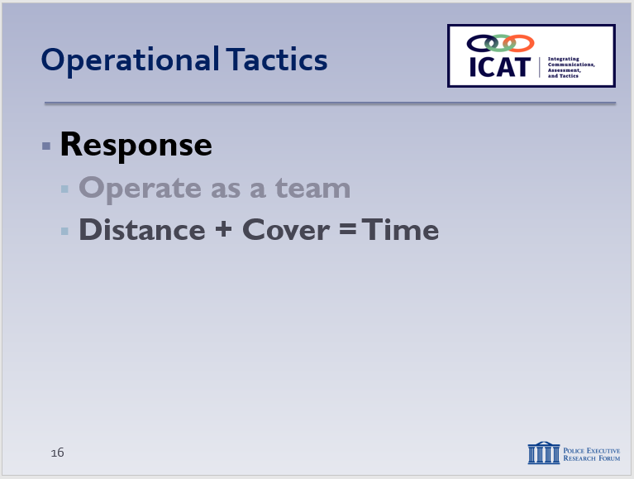

Spend some time emphasizing the importance of D+C=T. Many of the most questionable shootings involve officers who closed the distance, didn’t use cover, and didn’t take advantage of time.

Concern of many patrol officers: we don’t have “all day.” Agencies need to adjust policies and priorities to give officers time to manage these situations and attain a safe and successful outcome. At a minimum, patrol officers should be encouraged to “buy” enough time to allow for other, specialized resources to arrive on scene.

      - Woods pulled a knife out of his pants pocket saying something to the effect of, “you’re not taking me today”
      - Woods ignored commands to drop knife, said “kill me,” and began walking away.
      - Officers followed and called for backup
      - Officers shot Woods several times with a bean bag shotgun (SFPD doesn’t authorize electronic control weapons) and OC spray, which did not affect Woods
    - Show video
    - Discuss tactical issues
      - Lack of supervision – who’s in charge?
      - Lack of a game plan – instead, firing squad approach
      - Threat assessment – what was he doing with the knife? Who was he threatening?
      - Communications – who was the contact officer?
      - Internal communications among officers
      - Did “crowding” the subject cause him to start walking?
      - Scene/crowd management
  - Distance + Cover = Time
    - Key benefits
      - Officer safety – distance and cover offer you protection
      - Create time to consider options
              - In close quarters, you have very few options
              - When pressed for time, you have fewer options
              - But when you have distance, cover and time, you have more options available, plus more time to evaluate and execute them
    - “Dynamic inactivity” – pushing the “pause” button
      - When there is no reason to rush in and take action
      - Use that time to communicate, strategize, get more resources
    - How long will we let this situation go? As long as it takes barring an immediate threat that must be addressed
  - First impressions
    - How do you want to start the interaction?
    - Circumstances and the nature of the threat will dictate your initial response
    - If possible and appropriate, start “low”
      - Easier to “move up” if necessary
      - More difficult to de-escalate if you start “high”
Instructor Notes

SLIDE #17
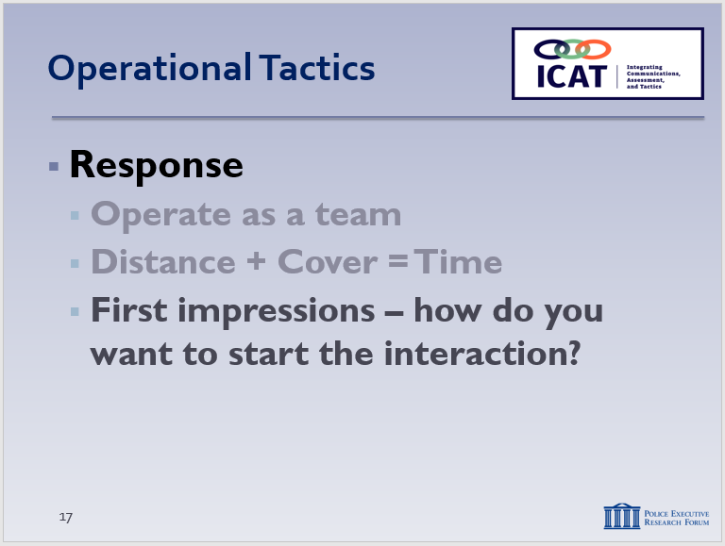

SLIDE #18
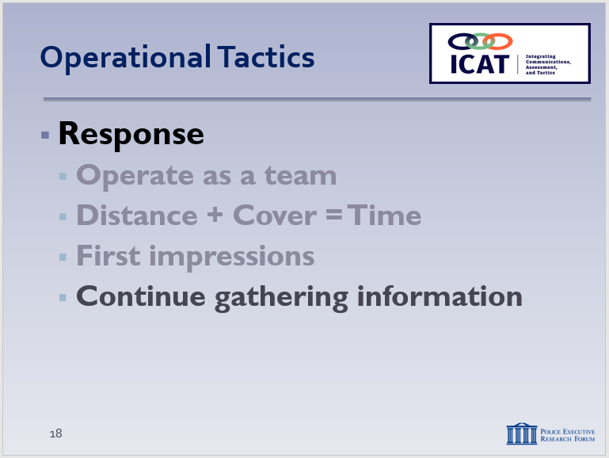

Remember, active listening and open-ended questions

    - Where have you started if you come in with your firearm drawn?
      - Is “low ready” or less lethal an option?
  - Continue gathering information
    - From …
      - Victims and witnesses
      - Your own observations
      - The subject (often the best source of information about what is going on)
    - Information collection is an ongoing process that helps you refine your threat assessment
      - Analyze subject’s means, ability, opportunity, intent
      - When all four elements are present with an immediate danger and no escape = jeopardy.
Instructor Notes

SLIDE #19
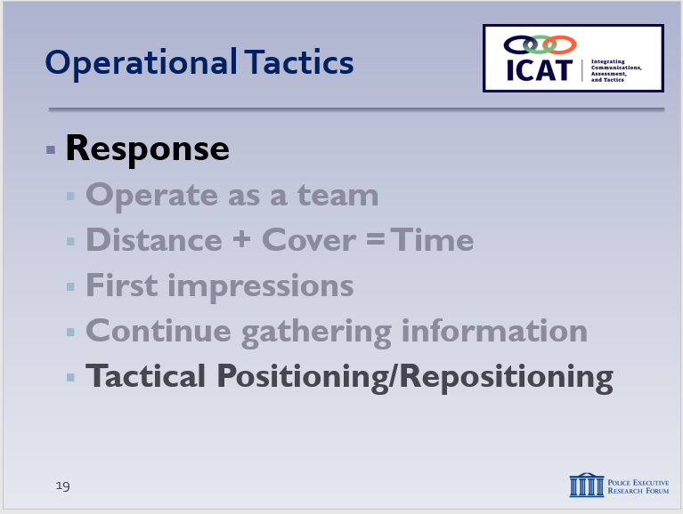

Get on the balcony so you can observe the dance floor.

SLIDE #20
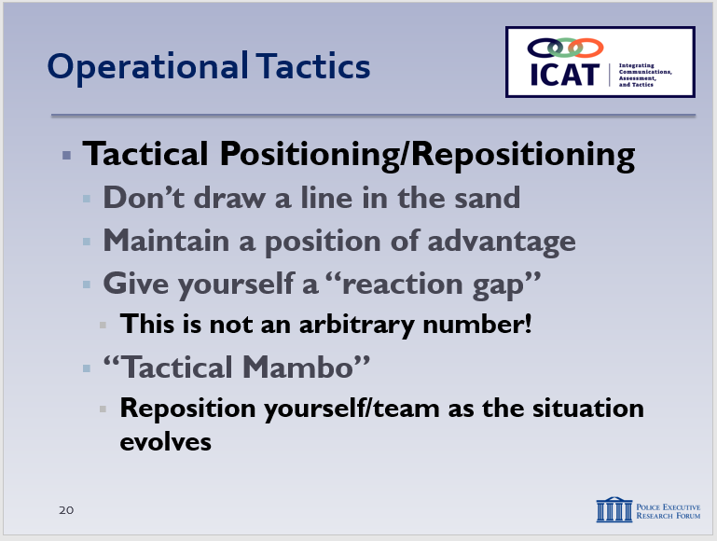
For edged weapon offenders, Police Scotland uses an approach called CUTT:
- Create distance
- Use cover
- Transmit information (to Dispatch)
- Tactically reposition as needed
You may get pushback from some students about “retreating.” Emphasize that we’re not talking about running away, but rather getting to a safer position with distance and cover. You’re still in charge – just from a safer position.

      - Negating one or more those elements of the threat should be the goal

  - Tactical positioning/repositioning
    - Individual officer
      - Presence/stance/posture
      - Don’t “draw a line in the sand” (unless public safety imperatives absolutely demand it)
      - Maintaining a position of advantage (using distance and cover) – even if that means repositioning
      - “Reaction gap” or “zone of safety”
        - Not an arbitrary number (e.g., no “21-foot rule”) – will always depend on circumstances
        - Regardless of the size of the “reaction gap,” maintaining it supports officer safety, gives you more options to resolve the situation
        - May need to increase the gap to provide more reaction time
        - Unnecessarily closing the gap can reduce your options, put you at risk
    - “Ebb and flow” of the team
      - As the situation evolves, the team may need to reposition as well (NYPD calls this the “Tactical Mambo”)
      - Coordination, teamwork and discipline are critical
      - Be careful about not back up into a corner – be tactically sound at all times
      - Properly “containing” the scene will eliminate the risk of unassociated person(s) making a static scene “dynamic” due to intrusion
Instructor Notes

SLIDE #21
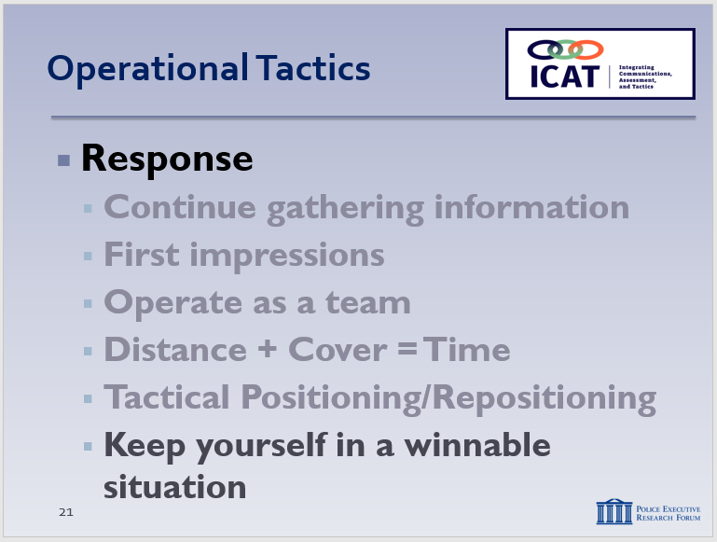

SLIDE #22
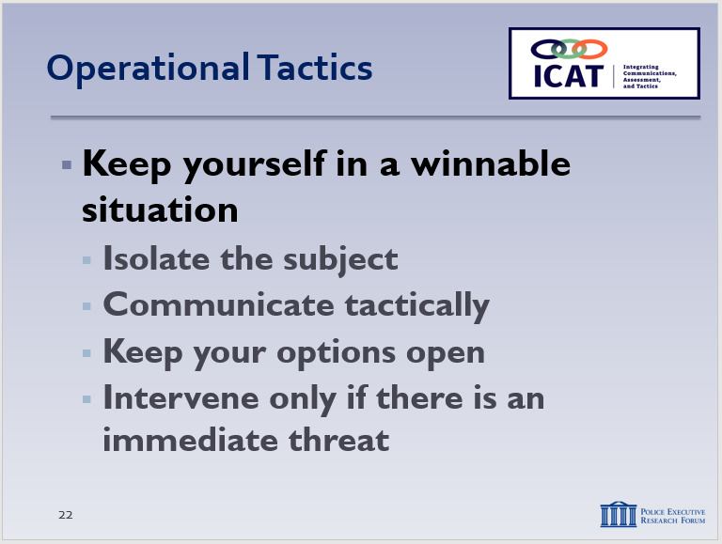

SLIDE #23
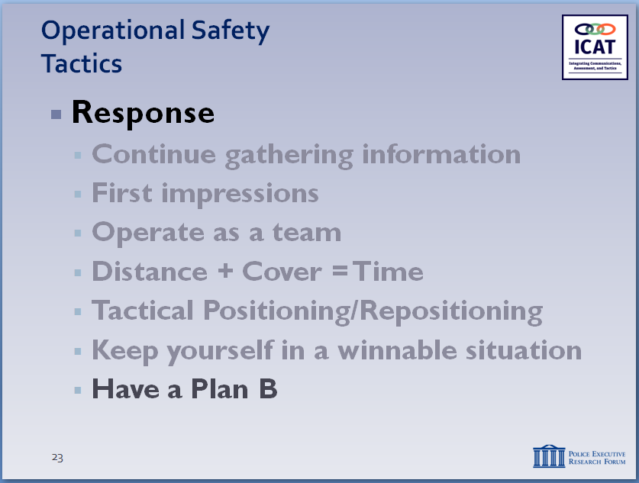

SLIDE #24
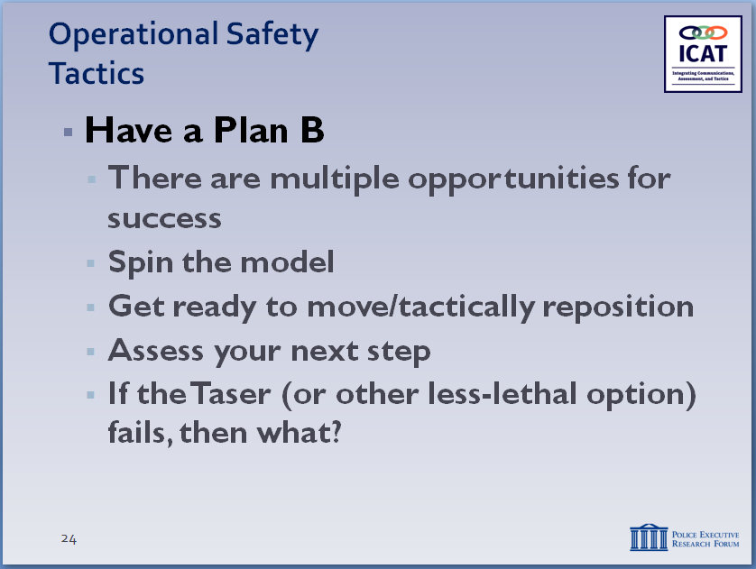

The idea of “spinning” the Critical Decision-Making Model is important here. If the initial plan doesn’t work, then that information becomes part of your decision-making during the next spin of the model.

SLIDE #25
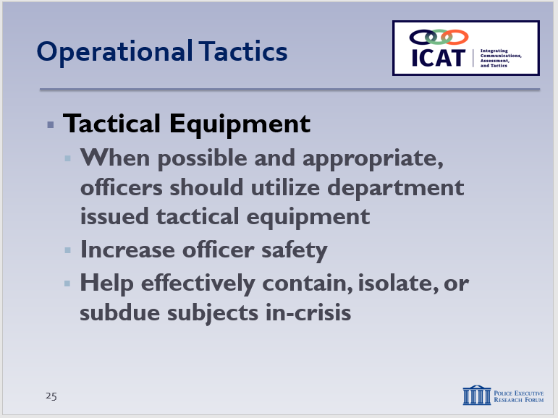

      - Continue to communicate with the subject even as you reposition
  - Keep yourself in a winnable situation
    - Isolate, contain, hold, and assess
    - Call out for additional resources
    - Use tactical communications
    - Identify options and develop a plan
    - Intervene only if there is an immediate threat to life/safety
    - Another way to look at this: don’t put yourself in an unwinnable situation through your actions (such as closing the distance or rushing the action if you don’t have to)
    - Have a Plan B.
      - Remember: you don’t have to succeed on first try – multiple opportunities for success
      - Spin the model
      - Get ready to move
      - Tactically reposition yourself depending on the dynamics of the situation
      - Continue to assess your next step
      - If the Taser/other less-lethal options fails, then what?
  - Tactical Equipment
Note: Instructors should tailor this material to the equipment that your agency has or is planning to acquire.
    - When possible, officers should utilize any department issued equipment in order to increase officer safety, and safely subdue, contain, or incapacitate the subject.
Instructor Notes

SLIDE #26
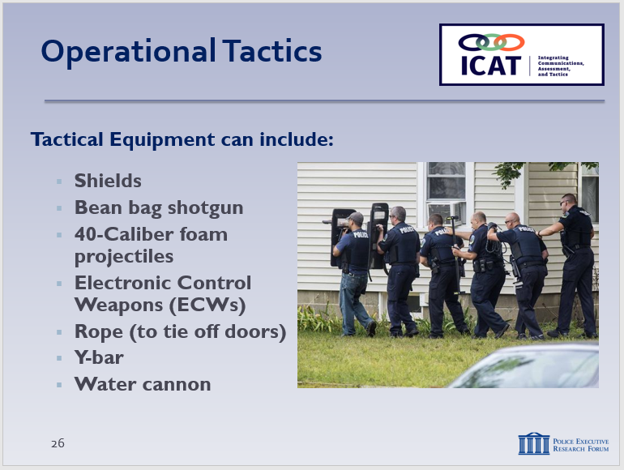

Optional video: The Burlington Police Department has placed new tactical equipment including shields and rope in patrol officer vehicles in order to safely resolve potential deadly use of force situations.
http://www.burlingtonfreepress.com/videos/news/2017/10/23/burlington-police-use-old-tools-new-tactics-calm-confrontations/106840420/

SLIDE #27
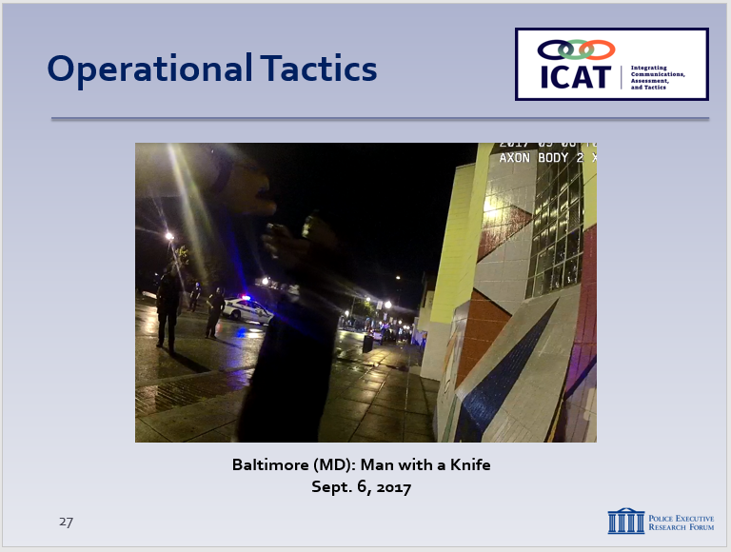

Note: Another option is the Camden New Jersey video. This can be found at: https://www.youtube.com/watch?v=MqH4E9UXX1o

    - Non-lethal tactical equipment can include:
      - Shields
      - Bean Bag shotgun
      - 40mm foam projectile
      - Electronic control weapon
      - Rope (to tie off doors)
      - Y-Bar
      - Water cannon

- Learning Activity–2: Video Case Study
Note
This video case study is to illustrate how one agency used some of the principles covered in this Module to manage a dynamic encounter with a man with a knife. During this case study, try to keep the focus on the tactics of the individual officers and how they operated as a team. Include elements of the Critical Decision-Making Model, as appropriate.

A few reminders:
- Set up the video ahead of time; provide background and context.
- Remind students that the video is not meant to be a “good” or “bad” video; the purpose is not to judge or second-guess the officer’s actions or render a grade. Rather the video illustrates the real-world challenges officers face. The purpose is to generate discussion on how these challenges can be handled as safely and effectively as possible. We are not suggesting this was the only possible course of action in this case.

  - Set up the video
Instructor Notes

    - Baltimore, MD – sparsely populated downtown area
    - September 6, 2017 – at night
    - Several officers responded to the scene of a man with a knife. Suicide by cop: The subject asked officers to kill him despite their efforts to de-escalate the situation.
  - Start the video
    - Stop at 2:00
      - What do we have so far?
(Call about a man with a knife. Once on-scene, officers find out that the subject wants officers to shoot him—suicide-by-cop)
      - What are the threats/risks?
(Knife is visible. What’s he doing with the knife? Any aggressive movements?)
      - How were the officers on-scene communicating when the officer on BWC arrived?
(They established a dialogue with the subject. But didn’t “draw a line in the sand.” Patience—didn’t force the issue.)
    - Restart – stop at 6:40
      - What has changed in the last few minutes?
(The primary [contact] officer was able to establish a conversation with the subject)
      - What are some of the important things the primary officer has communicated to the subject?
(Introduced himself, asked open ended questions, maintained the conversation, and reaffirmed that they aren’t going to shoot the subject despite the threat of a knife.)
      - What are the other officers doing?
(They have allowed the primary officer to start and maintain a dialogue without interrupting him; also followed primary officer’s directions)
      - Distance and cover
(Was it adequate, given the threat?)
      - Communications
(By contact officer? Officer-to-officer?)
    - Restart – stop at 10:40
  - Has the threat/risk changed?
(He’s now mobile – need to consider others in the area, but plenty of officers on scene.)
  - Teamwork
(Contact and cover? Do they have lethal and less-lethal cover? Tactical repositioning.)
  - Distance and cover
(Was it adequate, given the threat?)
  - Communications
(By contact officer? Officer-to-officer?)
    - Restart – play until end
Instructor Notes

      - What are the important things the primary officer has communicated to the subject?
(He communicated empathy, has gotten his name, continued to ask open ended questions, continued to reaffirm that they are not going to shoot the subject)
      - What are the important things the primary officer has communicated to the other officers?
(Has asked them to step back and go across the street)
Instructor Notes

SLIDE #28
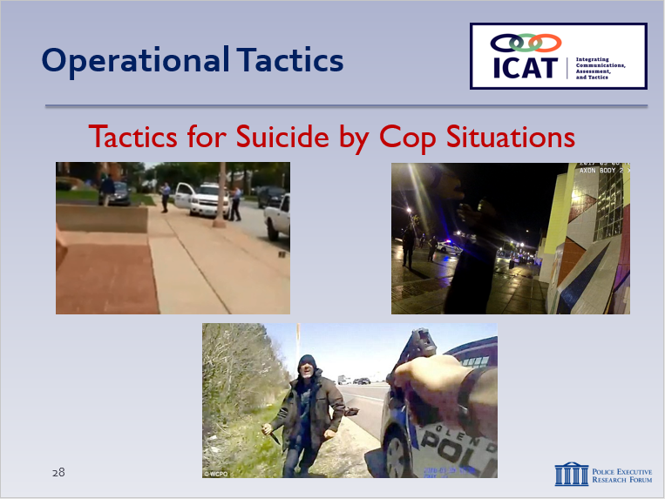

SLIDE #29
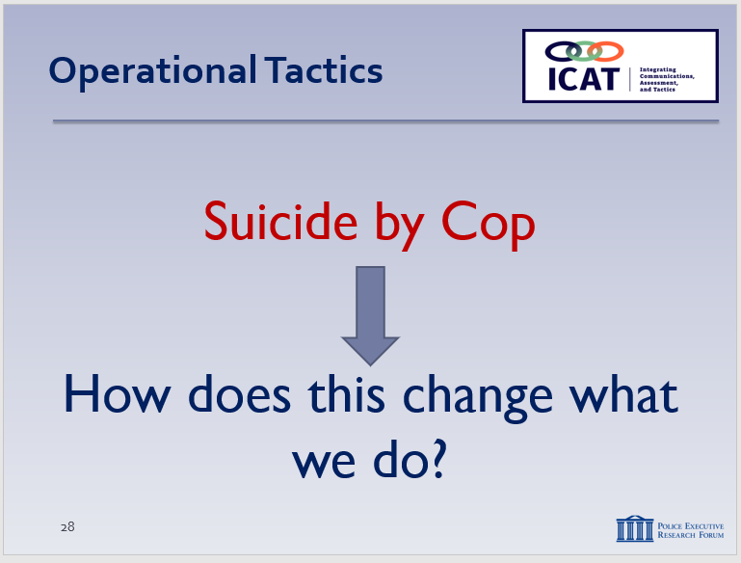

      - The subject stopped, responded to the officer, and eventually handed him the knife (after folding it up).
    - Questions? Comments? Observations?
      - Positive outcome (no one killed or hurt)—was it worth the time and effort?
      - Anything you might have done differently? In terms of tactics? Or communications?
      - Did they put themselves in a winnable position?
      - Did you see the other officers congratulating the primary officer?
  - Tactics in Suicide-by-Cop Situations
    - Think about several of the videos that we have seen (Baltimore, St. Louis, Glendale, Coeur d’Alene).
    - How does the suicide-by-cop aspect change what we do tactically?
      - Recognizing a situation as a suicide by cop attempt is the most important factor
      - If you have properly recognized the attempt, it shouldn’t fundamentally change the way you tactically respond.
      - As with any other situation, officers should create distance, establish communication, and attempt to make a connection with the subject in crisis.
    - Here is a review of three signs that a scenario is a suicide by cop attempt:
      - The subject will voluntarily enter into a confrontation with law enforcement
      - The subject will communicate their suicidal intent to law enforcement or the 911 call-taker

Instructor Notes

SLIDE #30
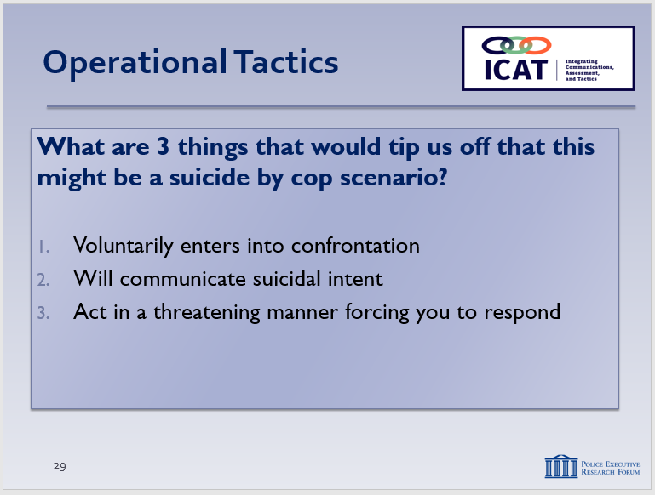

SLIDE #31
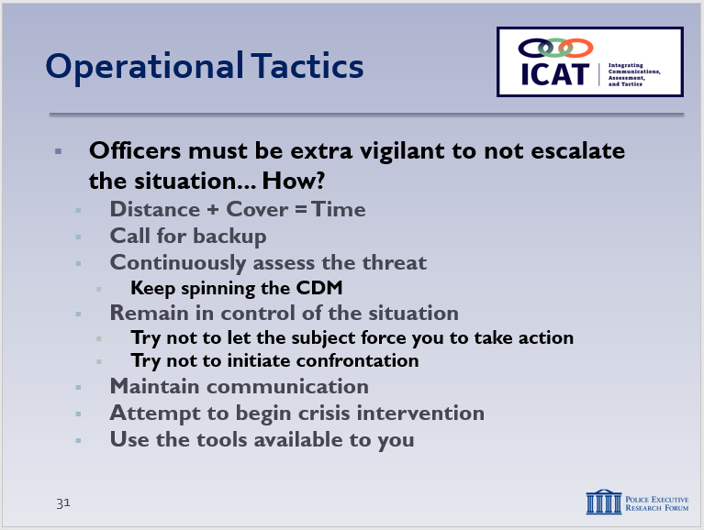

      - The subject may act in a threatening manner, forcing officers to respond.
    - Pay attention to the information the dispatcher has relayed and/or the information that the subject and/or others are communicating.
    - Remember, 81% of suicide by cop attempts are spontaneous. The suicide attempt is in response to law enforcement intervention.
    - This means that officers need to be extra-vigilant about not escalating the situation. How?
      - Create distance and find cover (D + C = T)
        - Example: In the Glendale, OH suicide-by-Cop video, the officer consistently created distance.
      - Call for backup
      - Continuously assess the threat (keep spinning the CDM)
      - Remain in control of the situation.
        - Try not to let the subject dictate the action
        - But also try not to initiate confrontation
      - Maintain communication
        - Example: In the Baltimore, MD man-with-a-knife video, the officer maintained communication with the subject the entire time.
      - Attempt to make a connection to begin crisis intervention
Instructor Notes

SLIDE #32
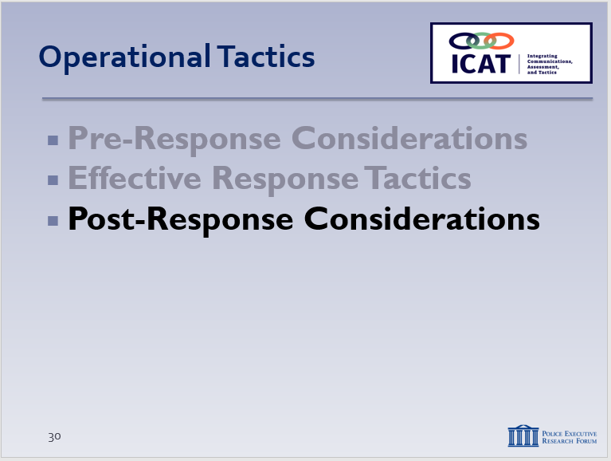

Note: If your agency has its own AAR process, then it should be covered/emphasized here.

SLIDE #33
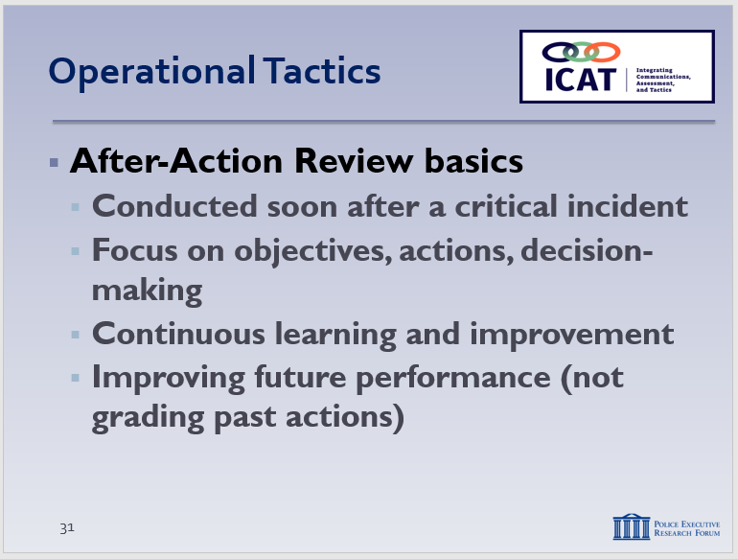

One caveat from an officer wellness perspective: if the incident was highly traumatic or life-threatening, officers may not benefit from an immediate AAR. In these situations, officers will likely have gaps in memory right away, and they may not be able to be objective or emotionally capable of handling the process. Memories will generally consolidate and the officer will be better able to report on the details of the incident after a night of sleep.

Obviously, laws and agency policies governing when officers involved a critical incident provide statements must be respected.

      - Utilize the tools available to you

      - Post-Response Considerations
Critical incidents can involve a number of possible actions and outcomes: voluntary compliance, arrest, referral to mental health treatment, and/or use of some level of force. Accurately describing the incident in detail is crucial for the integrity of the investigation and for transparency with the public. It is important for everyone involved in a critical incident to be part of the After-Action Review (AAR) process. The debriefing should cover not only the actions taken but also the policies/procedures and decision-making behind those actions. By fully capturing both strengths and shortcomings, agencies can continuously improve the response to future incidents. The Critical Decision-Making Model provides a useful structure for the AAR process.
  - Basics of After-Action Reviews
    - In general, AARs are conducted almost immediately after a critical incident (though minor incidents could reviewed the following day at roll call)
    - AARs focus on incident objectives, policies/ procedures, actions taken, and decision-making
    - AARs are used to identify strengths and weaknesses exhibited during the incident
    - AARs are not “Monday morning quarterbacking”
      - Instead, part of a continuous learning and improvement process
      - No one, regardless of rank, position or strength of personality has all the answers
      - AARs maximize the ideas and experiences of a wide range of people
    - Sole purpose of AARs is to improve future performance – they do not grade past “success” or “failure”
Instructor Notes

SLIDE #34
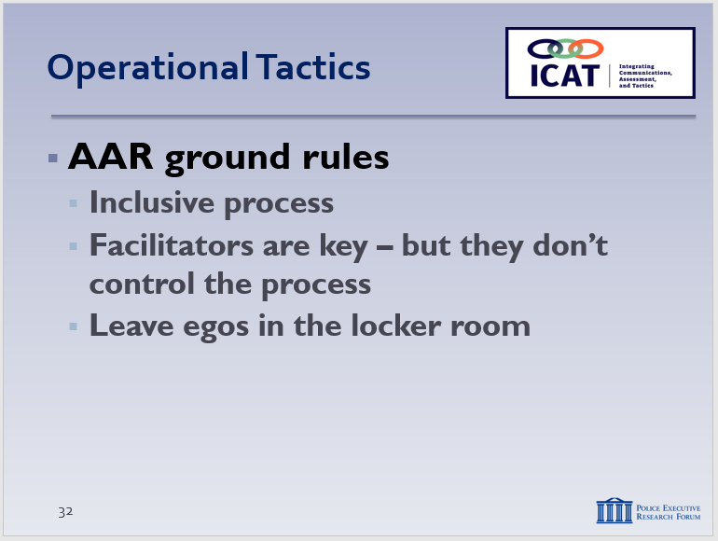

Agencies should be flexible in how and when they conduct AARs, and the AARs should be proportional to the nature of the incident being reviewed. If the incident is relatively minor, the AAR could be conducted the next day during roll call. If the incident is more serious, the AAR should be conducted immediately afterwards, before the personnel involved leave the scene. Specialized units and patrol may have their own separate “hot washes” later on, but the full group should meet and conduct an AAR right away.

SLIDE #35
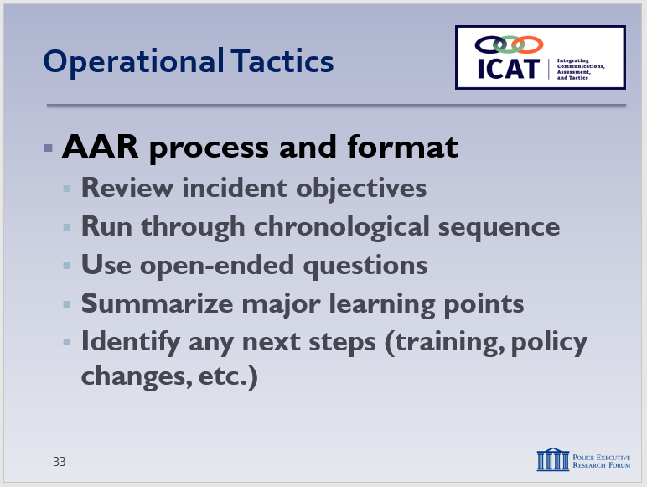

Again, exposure to this information could be a “trauma trigger” for officers who were involved in a very traumatic incident. It may not necessarily be productive to force officers to listen/watch and relive the incident right away.

  - Some AAR ground rules
    - The process must be inclusive
      - Anyone who has an insight, observation or question
      - Any information that can identify and correct deficiencies and/or sustain strengths
    - Facilitators are central to the process
      - Ask open-ended questions to elicit information
      - Still, the AAR belongs to the users, not the Facilitator
    - Leave egos out of the AAR process
      - No “thin skins”
      - Participants must feel free to express honest opinions
      - Articulated in a professional and respectful manner
    - Professional disagreement during the AAR process is not only expected, but encouraged
  - AAR process and format
    - Facilitator reviews incident objectives
    - Facilitator guides participants through chronological sequence of what occurred
      - Establishes what information the participant had prior to beginning of the incident
      - Establishes “ground truths” for what occurred (understanding that participants’ perceptions may be skewed by other inputs during the incident)
      - If possible, participants should access video, CAD/radio files and other objective information
    - Using open-ended questions, Facilitator engages participants in a discovery learning process
Instructor Notes

Another caveat: Officers involved in a traumatic/life-threatening situation should have mental health services available during the AAR, and hopefully a trusted peer support officer, police psychologist or other mental health professional to provide support if the AAR leads officers to struggle with their role in the incident.

SLIDE #36
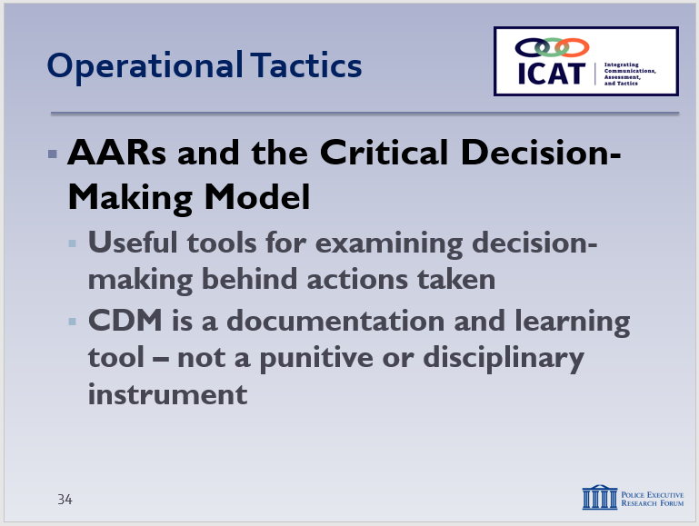

      - What actions were taken and why?
      - What was done well?
      - What could have been done better?
      - Did the officer(s) properly assess the threat, use sound tactics, and render first-aid (if needed)?
    - Summarize and next steps
      - Major learning points
      - Additional individual training (if any)
      - Institutional retraining (if any)
      - Possible policy changes
  - AARs and the CDM
    - The Critical Decision-Making Model is a useful tool for examining the decision-making behind actions taken during critical incidents
      - What information did the officers ask for and receive? Was information collection ongoing throughout the event? (Step 1)
      - How did officers assess the situation, threats and risks? Did that assessment change as new information came in? (Step 2)
      - Did the officers consider their police powers and agency policies? What adjustments, if any, did they make? (Step 3)
      - How did the officers identify and narrow their options? Did they select the best course of action? (Step 4)
Instructor Notes

SLIDE #37
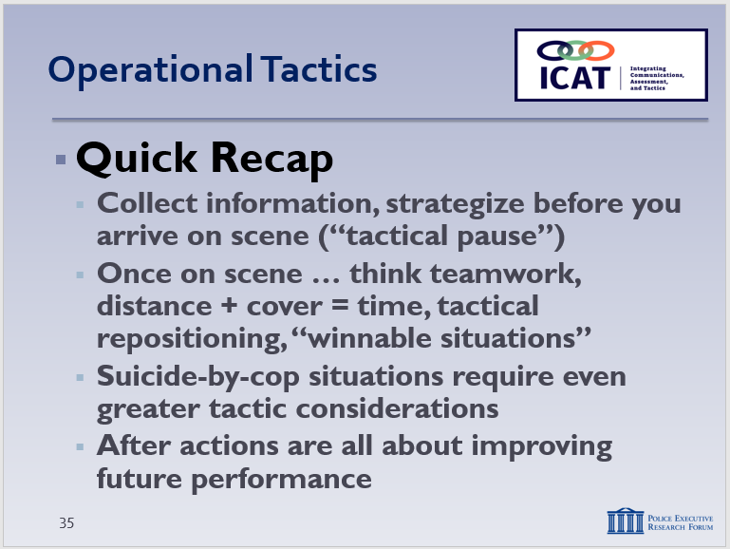

      - After acting, did the officers review and re-assess? Did they “spin the model” if needed? (Step 5)
    - In the context of AARs, the CDM is an important documentation and learning tool – not a punitive or disciplinary system.
- Learning Activity–3 (Scenario #2) – Optional

If the timing and sequencing of your class allow, consider running Scenario #2 at this time. Detailed instructions are in Module 6, pp. 14-17. Otherwise, the scenario can be run later.
Activity: Tactical Response Scenario-Based Exercise
Activity Time: 60-120 minutes (depending on the number of students)
Activity Learning Objective: Utilize and apply the tactical response skills covered in Module 5, plus the concepts and skills from earlier modules
- Recap and Discussion

  - Quick Recap
    - Key pre-response considerations – before you arrive…
      - Collect information – know what you’re getting into
      - “Tactical pause” – use time to strategize
      - Prepare/manage yourself – and your partners
    - Once on scene …
      - Consider first impressions – start low if possible
      - Work as a team – have a role, play that role
      - Distance + cover = time – time = options
      - Tactical repositioning – creating a reaction gap
      - Keep yourself in a winnable situation
    - Suicide-by-cop situations require even greater tactical vigilance
    - After action reports are about improving future performance, not judging past actions
Instructor Notes

SLIDE #38
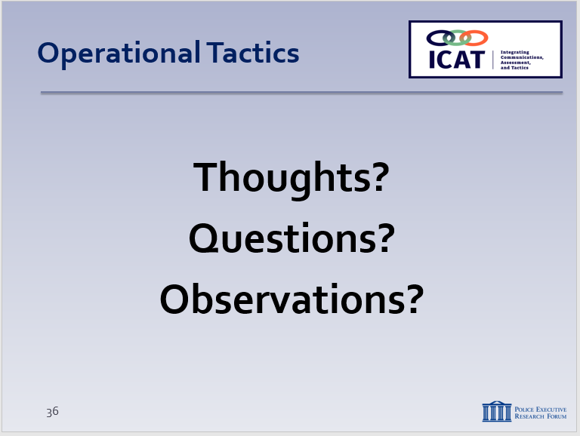

You could go back to the information collected in Learning Activity–1 and ask the class if they have any different thoughts on what makes a good tactical response.

  - Any final lessons learned? (can record on easel pad)
    - Ask each student to identify one new thing learned
    - Or, one skill set he or she plans to focus on in the future
  - Review any specific agency policy considerations not previously discussed (as appropriate)
  - Distribute class evaluations of the module (if appropriate)

